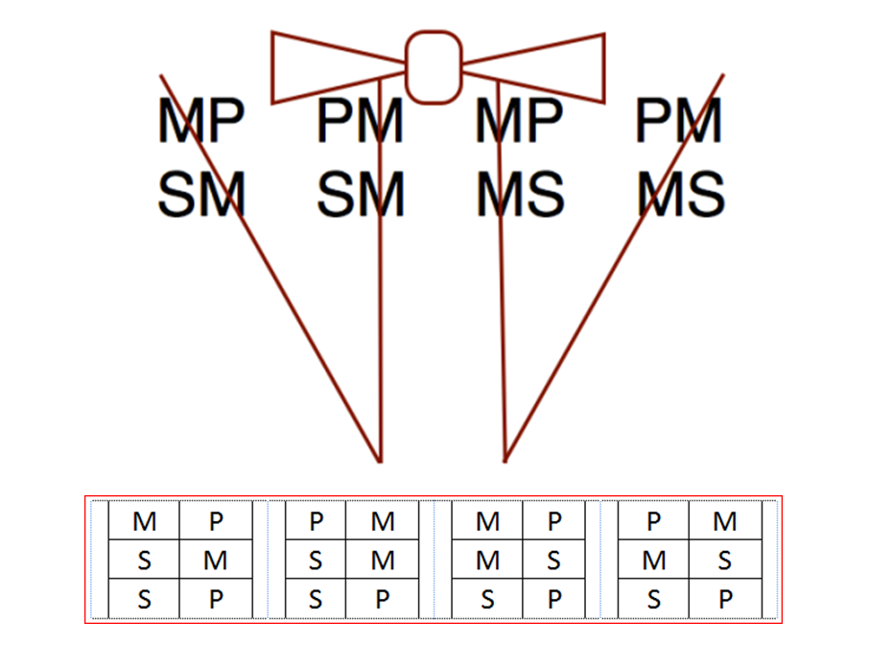

Exercise:
Name the mood, figure, and draw a Venn diagram, for each of the following categorical syllogisms:
1. All ruminants are mammals. All cattle are ruminants. Therefore, all cattle are mammals.

2. No pharmacists are lawyers. Some realtors are lawyers. Therefore, some realtors are not pharmacists.

3. All existentialists are metaphysicians. Some pragmatists are not existentialists. Therefore, some pragmatists are not metaphysicians.

4. No predators are ruminants. All sheep are ruminants. Therefore, no sheep are predators.

5. No figs are coconuts. No dates are coconuts. Therefore, no dates are figs.

