mgmmm
Mmm
mmm
mm
ill
table of Contents
President’s Message 2
Overview 3
Institutional Strategic Planning 17
1994 —1995
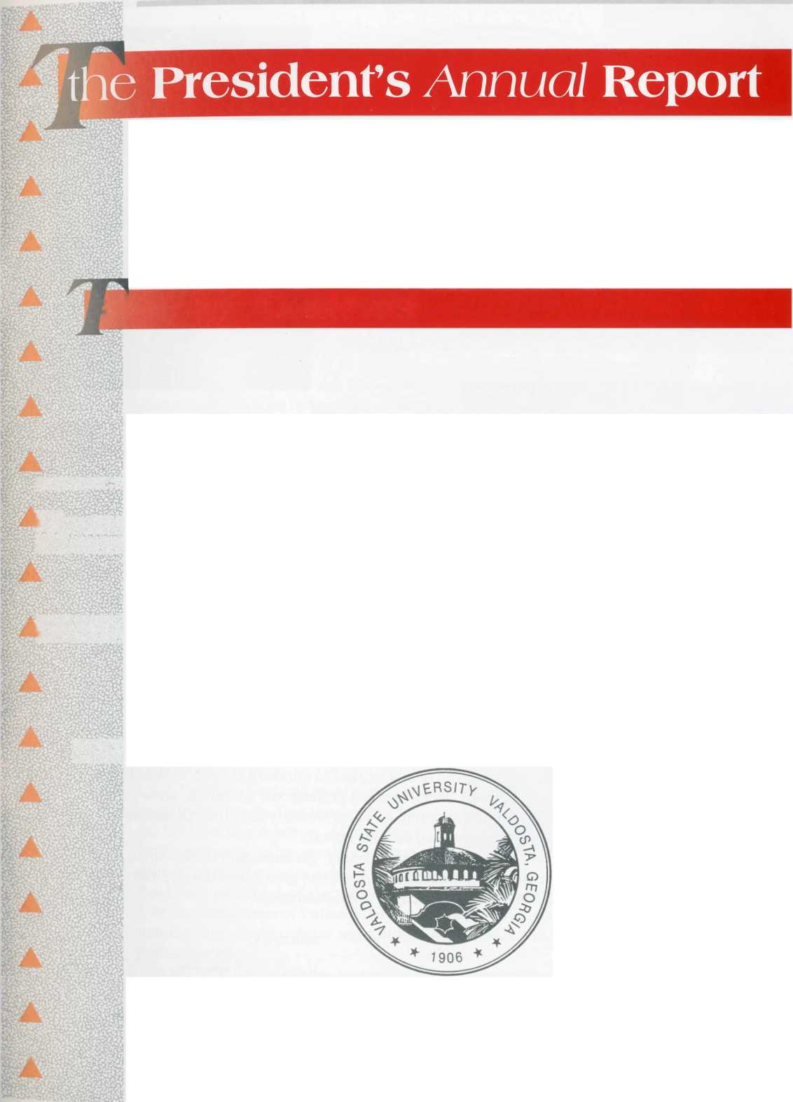
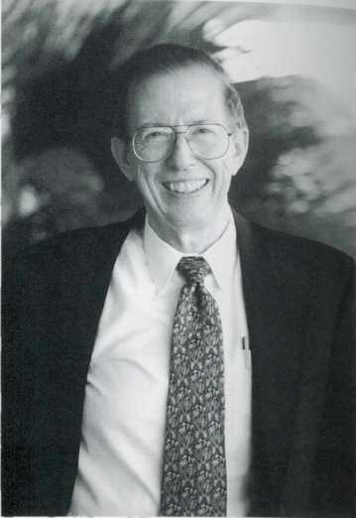
dear Alumni and Friends of VSU:

Valdosta State’s second year as a Regional University was a tremendous success. Enrollment reached an all-time high each quarter. After extensive input from every segment of the campus, the University’s Mission Statement and Institutional Goals were revised. The PEW Charitable Trust Roundtable was used to study and clarify all aspects of the institution’s operation. The fiber optics network was extended to all segments of the campus and “lighted up,” creating a truly outstanding data network system. During the year, over 200 micros were received and installed, making available 1,700 for use in 15 student laboratories and in faculty offices.
The application of technology enabled the institution to improve its service to the entire region while reducing costs. Although there was an 8.7 percent increase in off-campus enrollment, the faculty reduced off-campus travel by over 40 percent (to 62,000 miles). The University successfully offered the first Postsecondary Options courses by distance learning and continued to offer the entire undergraduate degrees in business and nursing by the same method.
In all aspects of its operation, the University worked to nurture a diverse student body, maintain a positive balance between liberal arts and professional education, serve its region responsibly, and provide an appealing setting in which students can grow. Optimism and anticipation continued to be the prevailing campus attitude.
We realize that we must provide much of the training, guidance, and leadership to our region if it and the entire state are to realize their optimum growth and development. The challenge is a great one, but one that is exciting and exhilarating.
Sincerely,
Hugh C. Bailey
President

The Odum Library remained the center of the University’s
intellectual life. During the year it added 4,496 volumes and
expended $647,982 for materials. The total collection grew to
1,406,989 items. Barcoding was completed, and the circulation
model became fully operational. The door count for the main
library increased by 8.7 percent to 401,435 persons. There was a
14.9 percent increase in interlibrary loans. Users spent 7,200
hours searching 10 databases provided by the local network.
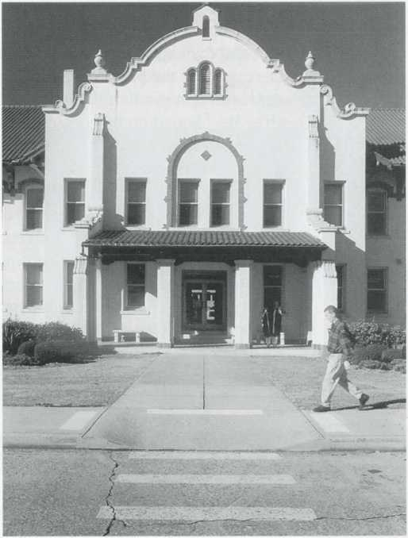
The Office of Business and Finance
continued to improve its services, working
especially to comply with the recommenda-
tions of earlier audits. The Office of Finance
added an employee in each of two growing
areas, Grants and Contracts Administration
and Bank Reconciliation/Special Projects.
VSU banking services were awarded to
NationsBank, which will provide a free
checking account and ATM card for each
student.
At the close of the year, the Personnel
Division moved to a larger, renovated
facility in Ashley Hall. The Division was
instrumental in completing equity increases
for classified employees and began micro-
filming personnel files to improve access
and save space. A program of employee-
funded, Long Term Care was introduced as
an additional benefit.
All Auxiliary Services areas experienced a
record year. For the first time since 1989,
the Division was debt free. All Auxiliary
facilities were wired internally for data and
connected to the campus network. The
Bookstore Director was elected President of the National Association of College stores.
In the Department of Public Safety, the student-staffed Security Unit completed a formal training program. Hardware and software were installed to implement full computerization of police reports.
In FY 95 Plant Operations undertook several important renovation projects, notably 25,000 square feet of space in the University Center, and continued computerization of plant processes. Business Services hired new managers for Warehouse operations and Campus Mail, which handled 2,000,000 pieces of mail.
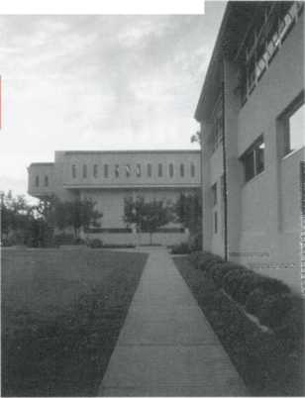

office of Internal Audits
During FY 95, non-resident tuition, ticket sales for the summer musical theater, fees for caps and gowns, financial aid, refunds, and local vendors records were audited. An extensive audit was done on the user access controls for the TI 1500 Computer System in the Business Office. The Internal Auditor periodically audited electronic fund transfers. Also audited were cash funds on campus, work formerly done by the Regents’ internal auditors. These audits resulted in improvements in accounting procedures and in internal controls.

university Advancement
The Office of Institutional Advancement set fund-raising
records as it dramatically upgraded the resources and programs
it provides the University. The Valdosta State University Founda-
tion and the University received $ 1,689,000 in gifts, a $302,000
increase over the previous year. The Development unit began an
aggressive program in Planned Giving and conducted its most
effective phonathon by contacting 38,000 parents, friends, and
alumni. Alumni Relations implemented a three-year strategic
plan, and Advancement Services significantly upgraded and
automated database management support for development and
fund-raising activities. CASE, the Council for Advancement and
Support of Education, gave University Relations two special
awards for producing and promoting the University’s First
Family Day and developing a campus shuttle bus system. Uni-
versity Relations produced the first magazine edition of the
Valdosta State University Alumni Bulletin, completed a record 1,278 publications and graphics projects, and expanded the University’s image by its marketing and media relations efforts.
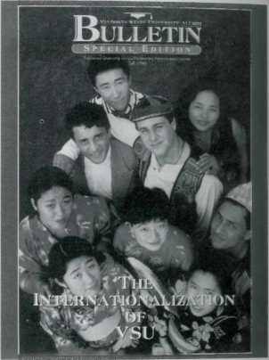

student Affairs
In FY 95 the Division of Student Affairs provided a wide range of services for the University. The Office of Career Planning and Placement implemented Resume Expert, an automated system which allows students to create up to four resumes on one disk and have them referred electronically to employers.
Cooperative Education had 153 placements, an increase of 33 percent from the previous year. Part-time J.O.B. placements increased from 327 to 340, another all-time record. Total student earnings generated from Co-ops, Interns, and part-time jobs exceeded $1,500,000.
The counseling staff served individually 742 students, an increase of 16 percent; 517 students participated in seminars and a variety of outreach activities. The Center received a rating of good to excellent from 89 percent of the students who regularly used its services.
4

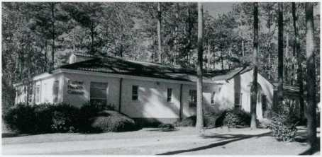
The Office of Financial Aid handled
a record number of applications and
distribution of awards. It is participat-
ing in the new Federal Direct Loan
Program, which should prove to be a
great benefit to students and be simpler
to administer.
The occupancy levels in Housing
exceeded that of the previous year by 4
percent and averaged 95.4 percent.
Revenue for FY 94 was exceeded by $300,000. Two hundred fifty-one educational and social
programs were presented in the residence halls with an attendance of 9,573.
A closer scrutiny of student discipline problems came with the creation of a Judicial Affairs
Office. The office was automated, and records management practices were streamlined and
computerized.
The New Student Orientation/InSight Program introduced some 2,000 students to the
campus. A retreat was developed for InSight Leaders to strengthen their ability to aid incom-
ing students.
The Office of Greek Life supported and advised twenty Greek organizations. Two new
fraternities, Sigma Nu and Kappa Sigma, were admitted to the campus.
An Outdoor Recreation Resource Center was established in the Intramurals Department,
enabling students to check out camping equip-
ment and receive information on outdoor activi-
ties. Over 18,000 individuals attended College
Activity Board sponsored events, and approxi-
mately 23,500 participated in informal recreation
activities, e.g., aerobics, freeplay gym, and
swimming.
The Farber Student Health Center had 18,640
patient visits during the year. By payment of their
health fee, students received unlimited clinic visits and most of the laboratory work and the
medications they needed.
During a successful year, Student Services conducted staff inservice for the Division of Student Affairs, sent five students to the 11th Annual MAP Conference, and staged an Educational Leadership Series to enhance cultural relations on a diverse campus.
The National Test Center administered 12,958 exams to 9,037 students, an 18 percent increase in students tested and 22 percent in exams given. At least 99 percent of all students use the services of the Test Center during their college careers.
The Faculty Senate met nine times during the academic year. It resolved nine issues and referred eight issues to specific committees. The Senate approved procedures for General Education assessment. A list of twenty-two Five-Year Goals for VSU and a new Mission Statement were approved.
Changes in the Bylaws moved the date of elections from April 15 to January 15 and authorized the Committee on Committees to choose the chairs and vice chairs of standing commit-
5
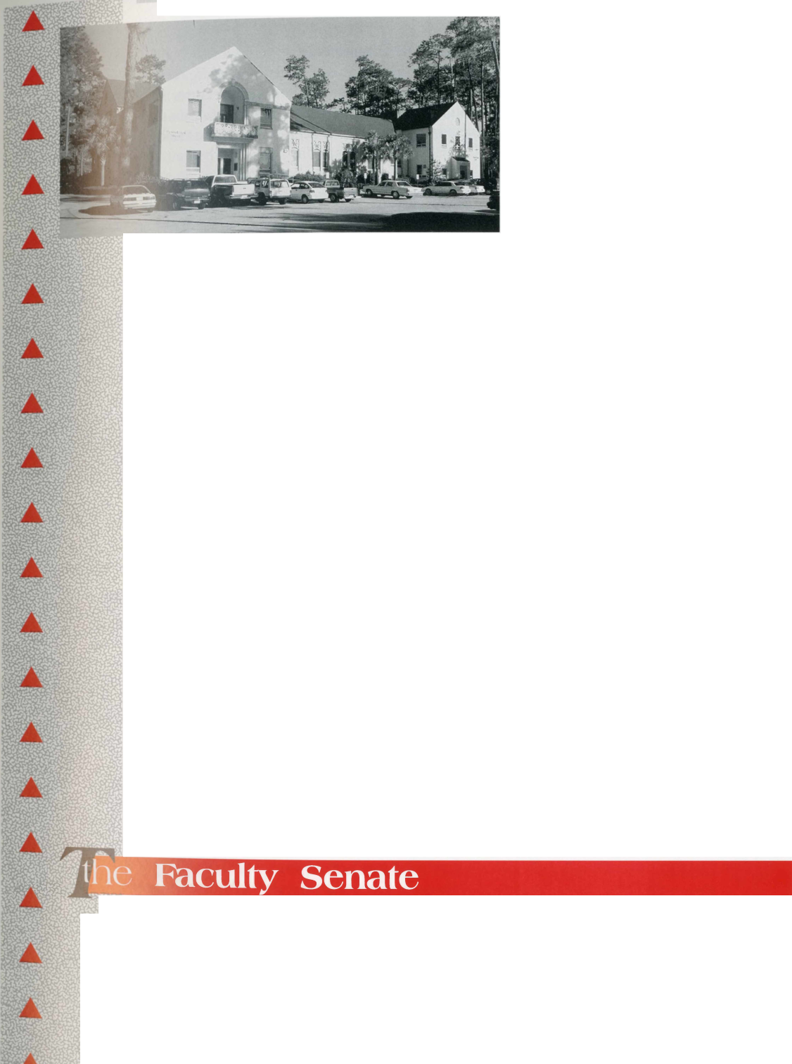
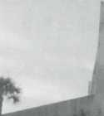
In FY 95 the College of the Arts made available the services of its Musical Theatre Festival personnel to organizations in 41 South Georgia and several North ^
Florida counties. The Valdosta Symphony Orchestra gave four home ^ and four regional concerts, a performance for the Georgia Chamber ^ of Commerce “Red Carpet Tour,” and four Youth Concerts for area — middle schools. The Symphony’s educational program included ^
thirteen string instruction classes, which enrolled over two hundred area students and three performances by the Valdosta Youth Orches- vL> tra. The Symphony was again named to the Touring Roster of the *
Georgia Council of the Arts, enabling arts presenters to obtain a fee subsidy when engaging the orchestra. In the summer, Valdosta Qs
State’s Jekyll Island Musical Theater Festival, the “State Musical ¹
Theater of Georgia,” presented 40 performances of three Broadway musicals for 12,000 patrons.
Over a two-year period, the enrollment of majors in art and art education has increased 32 percent, necessitating the addition of faculty and a Gallery Director. The Music Department added a Jazz Studies emphasis track in the Bachelor of Music in Music Performance degree and raised more than $20,000 for music scholarships. It provided more than 200 musical performances for University and civic functions.
tees. Elections were held, and assignments were made to all committees for 1995-1996 The Senate approved a Faculty Handbook, procedures for recommending faculty appoint ments, a campus-wide recycling program, and a policy statement on semester teaching loads It extended the African-American Studies special committee for a year but dissolved the Women’s Studies special committee since a director has been appointed to oversee the program.
Six of VSU’s 10 intercolle-
giate sports teams advanced to
NCAA post-season national
championship tournament play,
the school’s highest total ever.
VSU won the Women’s Gulf
South Conference All-Sports
Award and finished second in
the men’s competition. Senior
quarterback Chris Hatcher was
selected as one of the NCAA’s
Top 8 Honorees, won the Harlon Hill Award, and was named the CoSIDA Academic-All
American Player-of-the-Year. The Athletic Department will add its 11th sport, women’s
volleyball, in the fall of 1995.
6
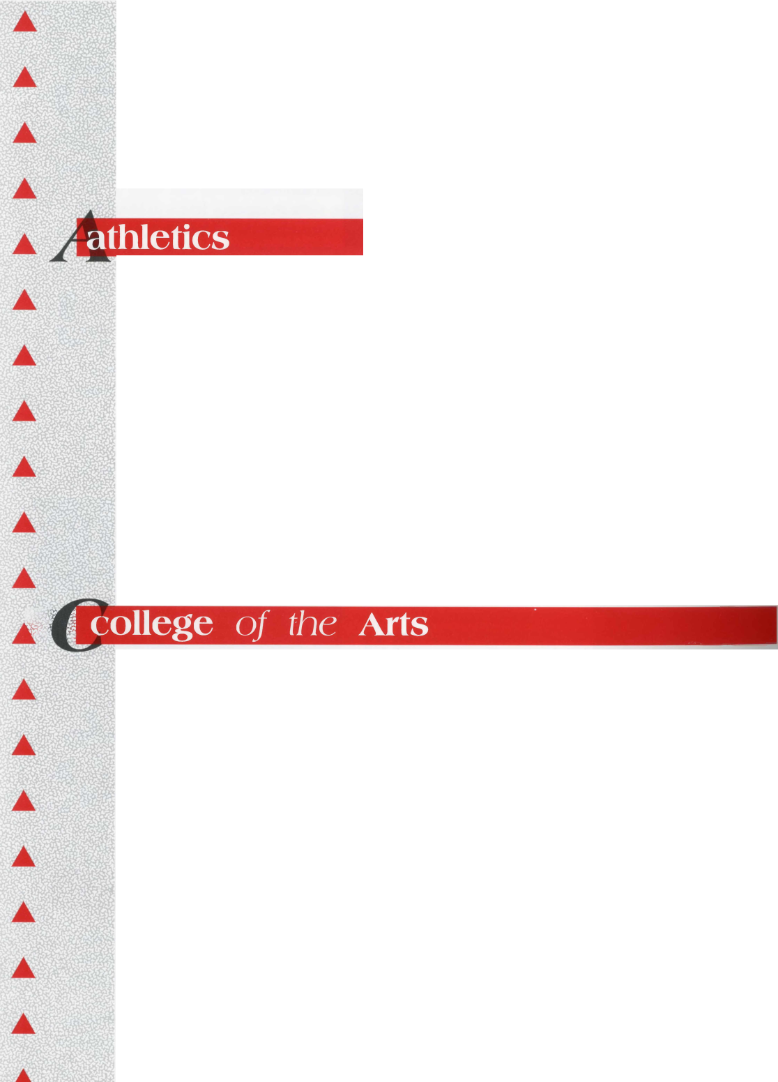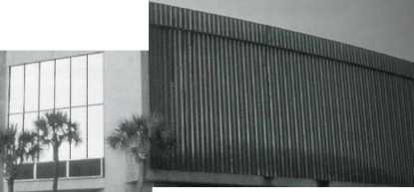
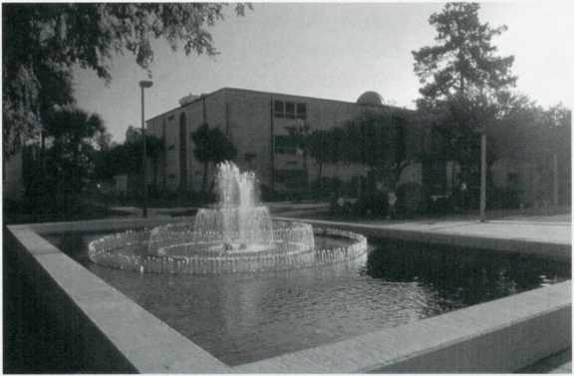
The Department of Communication Arts established a highly successful High School Debate Workshop and the Debate Tournament. Twenty-five VSU students, the most of any institution, were selected for the Host Broadcast Training Program to prepare for assistance in television production of the Atlanta Olympics. During the year, VSU Theater presented 67 performances, on- and off- campus, to an audience of more than 13,000. The department maintained television cablecasts on Valdosta TCI Channel 12, including original programming and a campus and community bulletin board.
During FY 95, Dr. Thomas E. Dasher continued as Acting Dean of the College, and Dr.
Mary Kay Corbitt as Acting Assistant Dean. Most departments developed Policies and
Procedures Manuals, including policies for summer school teaching. The College updated its
computer inventory providing at least a 386 computer, fully networked in each faculty office.
The Departments of History, Philosophy, and Sociology, Anthropology, and Criminal Justice
moved into new facilities, while others expanded into the space vacated. Each department
and program within the College completed a Vision Statement, assessing its current status
and goals for the next five years.
The A&S Council on Undergraduate
Research (CUR), affiliated with the
national CUR, met monthly and held a
Symposium at which 25 students
presented papers. The College of Arts
and Sciences and the College of Educa-
tion received funding from the Coca
Cola Foundation for a collaborative
effort to infuse technology into the
teaching of each discipline, especially
at the Core Curriculum level. Several
faculty continued their involvement
with the Pulp and Paper Initiative and
have received funding of over $75,000
for FY 96.
The Honors Program sponsored four Honors Forums, an Open House, socials, and an Honors reception at the President’s home. It published six issues of a newsletter, The Honora, which were distributed to faculty and 400 students. VSU faculty offered 16 Honors sections of courses in the Core Curriculum (as part of a two-year rotation of courses), four sections of the Honors Introductory Seminar, and three Honors Capstone Seminars. The program’s visibility was increased by students delivering the New York Times to faculty, staff, and students and by their participation in local and regional symposia/meetings.
'he Women’s Studies Program obtained membership in the National Women’s Studies Association, and Dr. Ana Victoria Soady was appointed as its Director. Two issues of The Women s Studies Newsletter were published and two luncheons held.


college of Business Administration
M
The College of Business Administration (COBA)
completed a comprehensive self-evaluation in prepara-
tion for an American Assembly of Collegiate Schools of
Business (AACSB) team visit. This review culminated
in the preparation of a Preliminary Self-Evaluation
Report submitted for external review.
Dr. David Campbell, Associate Professor of Market-
ing, served as a Fulbright Scholar at Nanjing University
in China during Fall Quarter. The school’s Strategic
Planning Quality Improvement Committee (SPQIC)
guided students, faculty, staff and the Business Advisory
Council in a revision of the COBA’s Mission Statement
which identified specific program objectives for the
undergraduate programs.
The COBA reached its research productivity goal,
with 84 percent of the faculty having three or more
contributions during the last five years. There were 84
publications and 19 presentations in 1994. Thirteen
faculty participated in a Teaching Portfolio Workshop
and prepared teaching portfolios. The Instructional
Improvement Quality Improvement Committee spon-
sored two internal workshops on teaching improvement during the year.
Twenty-five students graduated in June from the reactivated MBA Program; the second cycle of the program will begin in September, 1995.
The COBA Student Advising Center completed its second year of operation maintaining student records, remedial study skill classes, and five career planning and placement workshops attended by 111 Business students.
The South Georgia Institute provided an increased level of regional service through six contract research projects, quarterly regional economic forecasts and cost-of-living surveys, eight regional outreach programs, and special initiatives for Georgia’s basic industries programs.
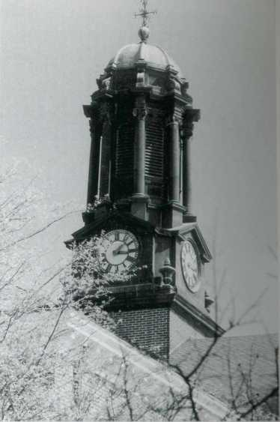

college of Education
The year 1995 was one of self-study as education faculty examined their programs from the perspective of national and state standards and implemented changes. At the departmental level, faculty used the Professional Standards Commission (PSC) standards to evaluate then training programs. Each teacher training program completed an approval application package for the PSC including objectives, a clearly articulated advisement sheet, and a matrix to address each PSC standard.
The Conceptual Framework Committee examined the current knowledge base as well as a variety of other sources and adopted, with modifications, the 10 Interstate New Teacher Assessment and Support Consortium (INTASC) principles for the initial teacher preparation

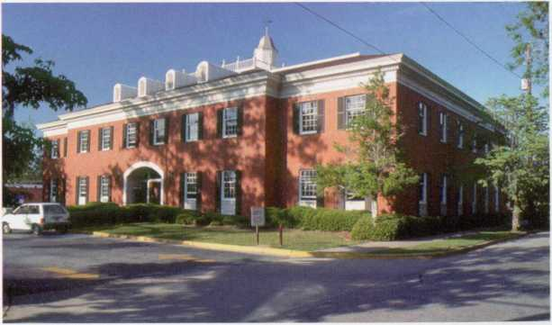
programs. The Assessment and Field
Experience Committees developed
assessment strategies for measuring
the INTASC principles in relation-
ship to course and field experience
requirements.
College of Education faculty were
involved in a number of activities in
FY 95. In addition to collaboration
with Arts and Sciences, a number of
activities are occurring with VSU’s
P-12 partners. Under a two-year Bell
South grant, VSU faculty will assist
first-year teachers in the P-12 schools. Another funded project will enable VSU to place
Macintosh computers in seven elementary schools, where they will be used to improve the
reading skills of disabled elementary age students through use of closed captioning video CD
disks. Collaboration with the League of Professional Schools and the University of Georgia
should greatly increase research activities with other P-12 partners. Projects funded by
Eisenhower and GIMS grants will address the improvement of instruction in mathematics
and science at the P-12 level.
A Health Fitness Program has been initiated and the accreditation of Sports Medicine Program reaffirmed for the next five years. The Speech and Language Pathology Program has adopted higher admission standards for its graduate program, which currently is at the maximum faculty-student ratio.
College of Education faculty increased research publications (65 percent), presentations (38 percent), service to professional organizations (21 percent), grant activities (31 percent) and service to the region (56 percent) from FY 94. As the College focuses on educational reform in the region, these increases should continue each year.
The College of Nursing admitted
92 undergraduate students, 24 RN/
BSN, and the largest number of
graduate students ever, 29. It
graduated 99 generic undergradu-
ate students, eight RNYBSN stu-
dents, and nine graduate students.
The new Nurse Practitioner track
of the Master’s Program was
implemented during Summer 1995
with eight students. Revised
admission criteria for the Master’s
Program were approved during the
year and implemented Fall Quarter, 1995. Efforts are continuing to obtain the Ph.D. in Nurs-
ing degree from the Medical College of Georgia via distance learning.
9
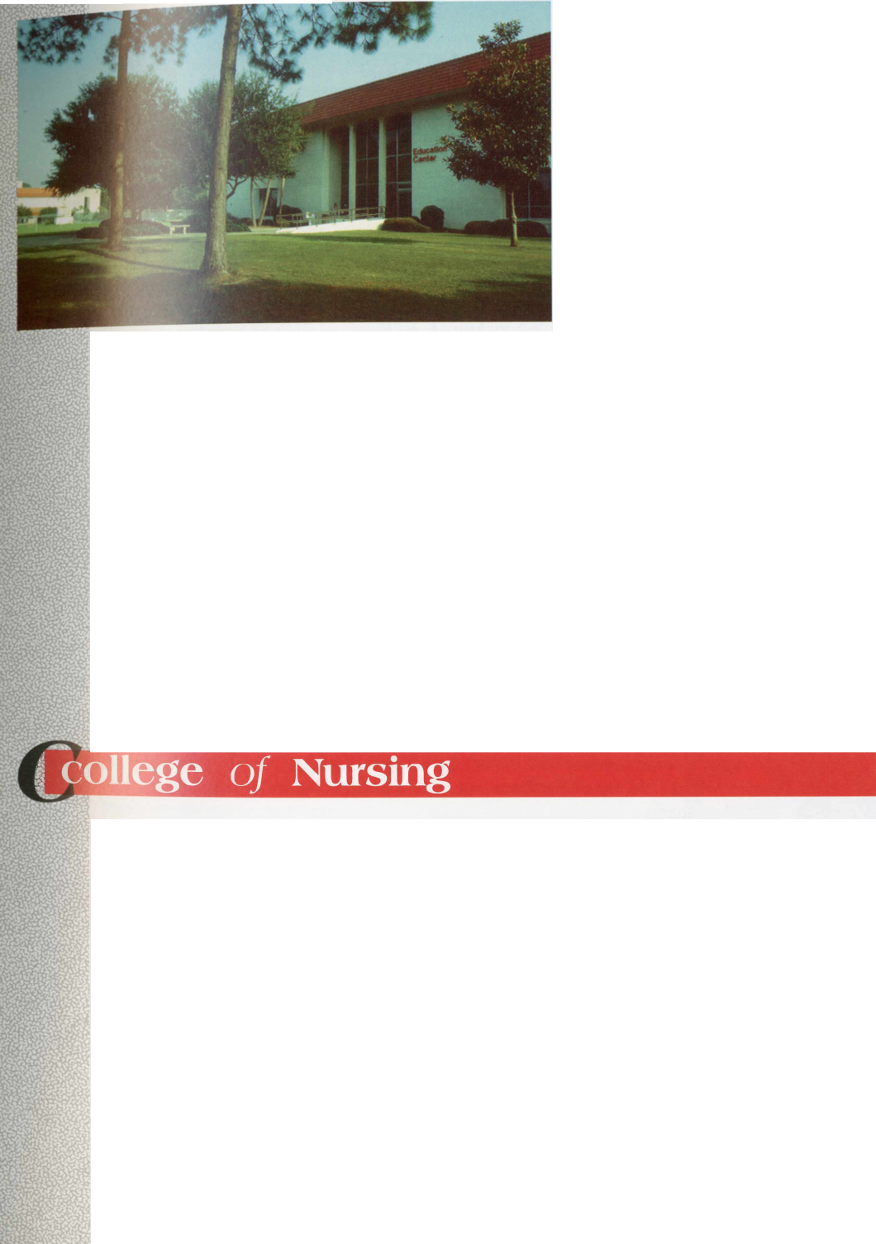
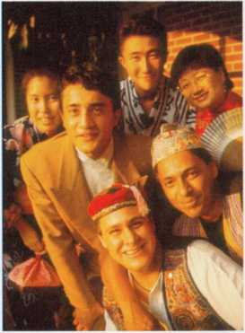

admissions

office of International Programs
International student enrollment increased by 22 percent from Fall 1993 (113 students
representing 41 countries) to Fall 1994 (136 students representing 49 countries).
A faculty exchange program was implemented with Syktyvkar
State University, which permitted the reinstitution of the teaching of
Russian language at VSU. An exchange agreement was also imple-
mented with Eszterhazy Karoly College in Eger, Hungary.
International Programs coordinated campus visits of 13 interna-
tional faculty, involved 14 VSU faculty and staff in international
experiences, and coordinated the International Visiting Scholar
Program for the second year.
it developed a five-week study tour in Belize funded by Fulbright-
Hays for K-12 teachers, expanded and improved the Model United
Nations Program, involving 27 student delegates, organized and
presented a five-part Spring Lecture Series on the Caribbean region,
and co-sponsored three successful summer study abroad programs.
The Admissions Office gave campus tours to 3,000 prospective students, parents, and visitors. It implemented new admissions standards for transfer, transfer developmental studies, and non-traditional students, and made significant progress in implementing the BANNER Student Data Base System.
In FY 95 the VSU Kings Bay operation received online registration capability and access to several VSU databases. A VSU Information Office was opened at Waycross College, and new undergraduate Early Childhood Education degree programs were established at Waycross and Kings Bay. One hundred sixty-one students were graduated from external degree programs, and there was an 8.7 percent increase in off-campus enrollment (from 1,669 in FY 94 to 1,814 in FY 95). In Fall 1994, an undergraduate Business external degree cycle was begun by distance learning at Bainbridge College, Waycross College, and South Georgia College, and an undergraduate Nursing cycle at ABAC, South Georgia College, and Waycross College.
m
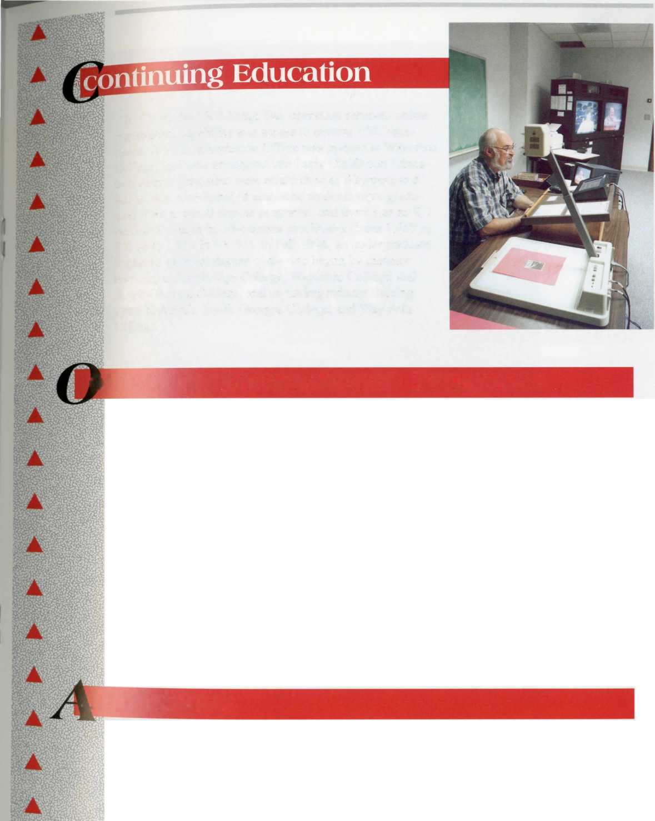
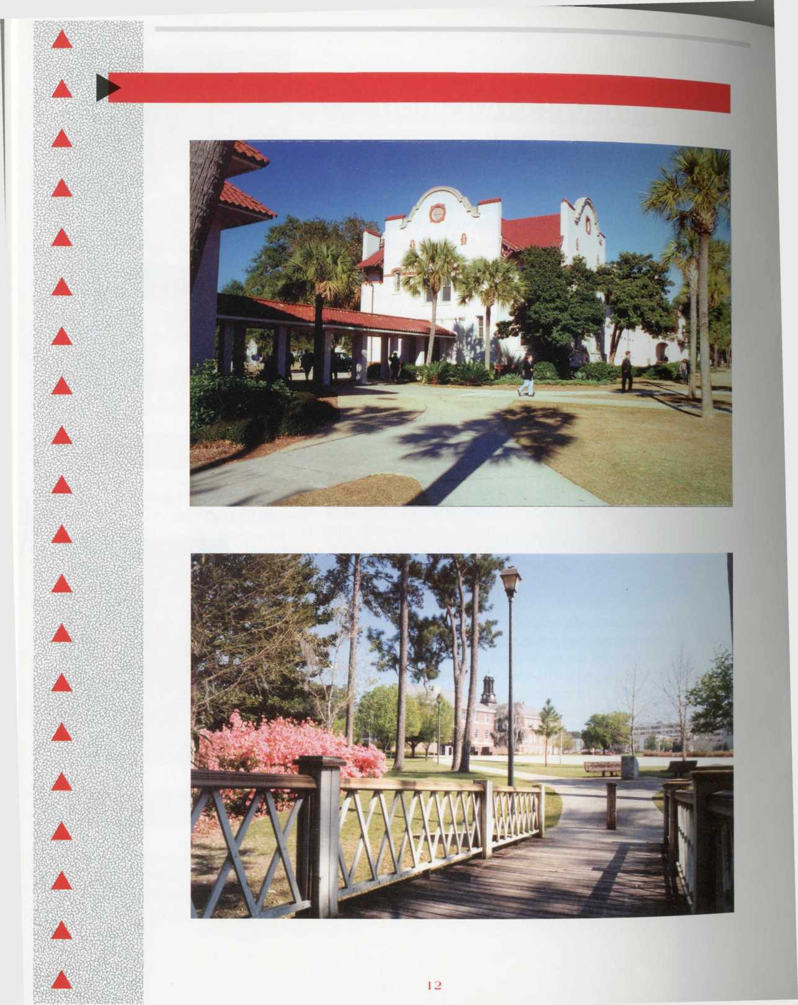

^ ,

new degree programs, institutes, centers, & divisions
During the year the Board of Regents approved the offering of the Ed.D. degree with majors in Adult and Vocational Education, Curriculum and Instruction, and Educational Leadership, and the Master of Social Work (M.S.W.) degree.
affirmative Action/Equal Opportunity
Employees
The total number of African-American employees grew from 215 to 222 and the total number of females from 492 to 550.
Changes in Race and Gender Composition, FY 1994-FY 1995

Blacks EEO
Category
Exec./Adm./Mgr.
Faculty
Prof./Non-Fac. Sec./Clerical Tech./Paraprof. Skilled Crafts Service/Main.
FY 1994
11
20
7
32
4
10
131
%of
Category
8.66
6.60
6.30
16.50
- 18.86 71.90
Employed FY 1995 15 20 7
36
4
9
131
%of
Category
10.90
5.60
6.60
- 8.80
16.36
71.90

Total
Women EEO
215
222
Category
Exec./Adm./Mgr. | 48 | 37.70 | 55 | 40.1
Faculty | 111 | 37.00 | 141 | 39.83
Prof./Non-Fac. | 63 | 56.75 | 59 | 55.66
Sec./Clerical | 173 | 89.63 | 192 | 87.27
Tech./Paraprof. | 9 | 23.60 | 12 | 26.66
Skilled Crafts | 1 | 1.80 | 0 | -100
Service/Main. | 87 | 47.80 | 91 | 50
Total | 492 |  | 550

13



Minority employment grew from 195 in FY 91 to 222 in FY 95.
ty E

Blacks EEO
Category | FY91 | FY92 | FY93 | FY94 | FY95 % of
 |  |  |  |  | Change
Exec./Adm./Mgr. | 10 | 9 | 12 | 11 | 15 36.36
Faculty | 12 | 15 | 18 | 20 | 20 0
Prof.Non-Fac. | 4 | 4 | 5 | 7 | 7 0
Sec./Clerical | 21 | 21 | 22 | 32 | 36 12.5
Tech./Paraprof. | 3 | 3 | 3 | 4 | 4 0
Skilled Crafts | 7 | 9 | 9 | 10 | 9 -10
Service/Main. | 140 | 122 | 127 | 131 | 131 0
Total | 195 | 183 | 196 | 215 | 222
Women EEO
Category
Exec./Adm./Mgr. | 31 | 27 | 38 | 48 | 55 14.5
Faculty | 91 | 92 | 98 | 111 | 131 18.01
Prof./Non-Fac. | 28 | 28 | 36 | 63 | 59 -6.3
Sec./Clerical | 126 | 124 | 138 | 173 | 192 10.9
Tech./Paraprof. | 8 | 8 | 9 | 9 | 12 33.3
Skilled Crafts | 0 | 2 | 1 | 1 | 0 -100
Service Main. | 84 | 75 | 78 | 87 | 91 4.5
Total | 368 | 357 | 398 | 492 | 540
New faculty were required to participate in workshops on teaching effectiveness. One of these sessions was devoted to diversity and cross-cultural and gender sensitivity. Discussions were held with departmental and administrative units on employment practices, and gender and racial balance was monitored by the Affirmative Action Office.
Faculty and staff participated in special conferences and workshops attended by women and minority professionals who were employment prospects.
The procedures developed for equal opportunity in employment were monitored to insure that minorities and women were considered.
14

Students
Minority enrollment grew from 2,104 students in FY 94 to 2,284 in FY 95.
inges in Minority Enrollment, FY |  |  | 1994-FY 1995
1 class |  | 1994 | 1995
 | Male | Female | Male | Female
Freshman | 146 | 266 | 160 | 298
Sophomore | 134 | 243 | 137 | 260
Junior | 98 | 219 | 111 | 236
Senior | 136 | 306 | 141 | 351
Trans. Und. Grad. | 14 | 23 | 15 | 12
Spec. Studies | 94 | 159 | 92 | 186
Graduate | 65 | 199 | 63 | 221
Dr. Candidates | 1 | 1 | 1
Totals by Sex | 688 | 1,416 | 720 | 1,564
Totals
% by Race
It grew from 1,732 or 17.3 percent of registrants in FY 91 to 2,284 or 19 percent of registrants in FY 95.

Changes in Minority Enrollment, FY 1991 -FY 1995
1991 1992 1993 1994 1995 Change
Number 1732 1683 1813 2104 2284 +552
Percent 17.3 16.31 17 18 19 +1.7%
In an effort to recruit African Americans, representatives of the University have participated in all recruitment fairs in Georgia and Florida, the Assistant to the President has visited many area minority churches, and the Assistant Director of Admissions has held recruitment sessions at high schools statewide, making special appeals to minority students.
These efforts have resulted in a significant increase in minority matriculation over the past five years. In addition, the University has supported programs that honor African Americans and other cultures. Examples include: a teleconference, “Beyond the Dream VII,” the play,
“A Raisin in the Sun,” presentations by Dr. Charles Finch and Darryl Van Leer, the annual Martin Luther King Commemorative program, a speech by Mrs. Juanita Powell Baranco, Chair of the Board of Regents, establishment of a minor in African American Studies, an African American Studies Film Festival, Black Awareness Week, and the staging of diversity seminars in the residence halls.
In FY 94, 199 African Americans received degrees (12.22 of the total conferred). In FY 95 the number was 200 (11.58 percent). In FY 91 the number was 149 (9.9 percent).


FY 1994
FY 1995
399
2956
Black All Others
FY91 FY92 FY93 FY94 FY95 Totals
149
1356
153
1282
184
1365
199
1429
200
1527
885
6959
Totals
Percent
1505
9.9
1435
10.66
1549
11.8
1628
12.22
1727
11.58
7844
11.28
Plans for Improvement
The Handbook on Recruitment of Faculty and Administrators has been revised and will be used to improve searches and screening to produce more qualified minorities and to protect the University against litigation. The Affirmative Action Office will work with search committees in applying the regulations. Before a search will be approved, a plan for advertising the position that indicates special efforts to include minorities and women must be developed.
Departments and other units with low participation rates for women and minorities will be required to submit justifications in those cases where these groups are not represented among new hires. Also, the Office of Affirmative Action and Minority Affairs will continue to conduct quarterly workshops on diversity issues, targeting the positive effects on the University. The Minority Advisement Committee, which meets quarterly, will continue to be a source of information and assistance in recruiting minority faculty, staff and students.
Infill
16

a I
a I

Mission Statement & Institutional Goals
During the year, the Institutional Planning Committee of the Faculty Senate composed of elected representatives from all sections of the University revised both the VSU Mission Statement and the Institutional Goals. Departments and administrative units submitted their institutional goals, which the committee combined and modified and submitted to all employees for rating as to priority and importance. This information was compiled and resubmitted to the units for examination. The final revision was sent to the President’s Cabinet and the Faculty Senate for approval. The Institutional Mission Statement was developed in the same way and followed the same review process. Both the Institutional Goals and Mission Statement were submitted to the Office of the Board of Regents for final review and approval.

Goal 1:
Exceed the eligibility criteria for university status in anticipation of becoming a regional university.

Status:
The goal was attained before July 1, 1993.
Implement an enrollment management program that will fully integrate the institution’s efforts in recruiting a diverse and quality student body and providing support services that will improve the retention and graduation rates.

Status:
In addition to the Advising Centers in the College of Business Administration and the College of Education, additional advising centers for undecided majors and nursing students will become operational in FY 1995.

Develop and implement a marketing plan that will enhance the image of the institution.

Status:
The strategic marketing task force is in the final stages of developing a theme for use in promoting the institution. The task force identified and targeted internal and external groups and selected events that will be used to promote VSU.

Provide opportunities for students to expand their educational experiences by offering minors and double majors.

Status:
Program minors were approved in African-American Studies and in Women’s Studies. Directors were appointed for both minors.
Develop a campus-wide interactive information technology system that will make VSU a regional center for applications of computer and communications in administrative services, data management systems, instruction, and research.

Status:
VSU completed a data system network for the 1,700 computers used by faculty, staff, and students.

Goal 6:
Develop new programs and alternative delivery systems that will meet the needs of the South Georgia region.

Status:
The doctoral degree with majors in Vocational and Adult Education, Curriculum and Instruction, and Educational Leadership was approved by the Board of Regents. The Master of Social Work was approved, and course offerings will begin September 1995. Distance learning was expanded to increase the number of class offerings.

Goal 7:
Use economic indicators and work force needs of VSU’s service area as a guide for program planning.

Status:
All new program offerings presented to the Board of Regents (e.g., environmental studies) were based on data and surveys related to the economic situation and work force needs of the region.
Provide for core curriculum and major requirements, the development of oral, written, critical thinking and computational skills; knowledge and understanding of the socio-cultural and physical universe; and artistic expression and appreciation.

Status:
Course revisions continued using assessment outcomes that focused on oral, written, critical thinking, and computational skills appropriate for the discipline.

Review and update the master plan which will serve as the basis for the development of facilities to meet instructional, research, service and extracurricular functions.

Status:
The architectural consultant continued to work on revisions to the master campus plan reflecting changes in the status and projections of growth within the University.
riTnTi]
Develop plans to distribute resources appropriate for performing the University’s educational, research, and service functions.

Status:
Data provided by the Office of Institutional Research and Planning were used efficiently to prepare FY 1996 Budgets.
a
Use affirmative action goals for each academic and administrative unit as a guide to diversify the campus.

Status:
The planned efforts of the administration resulted in an overall increase in the number of African-Americans in the following EEO categories: executive/administrative/manager increased from 11 to 15; African-American secretaries and clerical employees rose from 32 to 36. New women hires showed similar gains in the executive/administrative category from 48 to 55; women faculty from 111 to 141.
Enhance the quality of life in the region by providing educational, artistic, cultural, techno-
logical, and economic development activities and programs.
Us

Status:
The South Georgia Institute and the Teacher Center provided many activities that enhanced the educational and technological prospects for the citizens of South Georgia. ArtSouth presented more than 100 music and theater performances and art exhibits in the area. The Valdosta Symphony Orchestra gave four concerts at sites away from Valdosta.
Goal 13:
Substantially increase the ratio of external funding to state appropriations.

Status:
The number of proposals written and submitted for external funding increased 168 percent
over the previous year, while the number of proposals funded increased 126 percent.
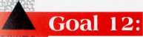

Goal 14:
Expand resources and services for professional, instructional, and faculty development.

Status:
The Center for Faculty Development awarded 161 grants to faculty in the amount of $74,562. The graduate school allocated $15,597 to assist faculty in initiating research and development activities.

Goal 15:
Use a formal planning process involving all employees.

Status:
Through institutional surveys, all employees were involved in determining the new Institutional Goals and Mission Statement. All administrative units and academic departments participated in a formal planning process.

Goal 16:
Provide career, personal, and academic counseling for all students.

Status:
An advising center was added for undecided students. The counseling center provides individual counseling to 742 students.

Goal 17:
Internationalize the curriculum, faculty, and students with dual emphases on intercultural education and the development of an intercultural orientation for the South Georgia region.

Status:
Bilateral exchange agreements were implemented with universities in Russia and Hungary, with a total of nine faculty participating in teaching exchanges. Russian language instruction was re-instituted, and special courses were offered in multicultural education by a visiting Australian scholar and in the dynamics of comparative environmental pollution by a Hungarian scholar. International student enrollment increased by 22 percent over the previous year.
A revised set of 22 priorities was adopted for FY 96, and next year’s report will describe how well they were met.
VSU has revised its strategic plan using the System’s strategic plan as a guide.

