Homework: Ch. 10

- An interesting method for exercising a dog is to have it walk on the rough surface a circular platform that freely rotates about its center as shown. When the dog begins walking near the outer edge of the platform how will the platform move, if at all? Assume the bearing on which the platform can rotate is frictionless. Justify your answer.

- Four objects start from rest and roll without slipping down a ramp. The objects are a solid sphere, a hollow cylinder, a solid cylinder, and a hollow sphere. Each of the objects has the same radius and the same mass, but they are made from different materials. Which object will have the greatest angular speed at the bottom of the ramp? Justify your answer.

- For each quantity below, record the abbreviation, the SI unit, and the unit abbreviation.
Quantity | Quantity Abbreviation | SI unit | Unit Abbreviation
Angular momentum
Moment of Inertia
Angular velocity
Linear velocity
Torque
Kinetic Energy
Radius

- While excavating the tomb of Tutankhamun (d. 1325 BC), archeologists found a sling made of linen. The sling could hold a stone in a pouch, which could then be whirled in a horizontal circle. The stone could then be thrown for hunting or used in battle. Imagine the sling held a 0.050-kg stone; and it was whirled at a radius of 1.2 m with an angular speed of 2.0 rev/s. What was the angular momentum of the stone under these circumstances?

- A seed is on a turntable rotating at 33.3 rev/min, 6.00 cm from the rotation axis. What are the seed’s acceleration and the least coefficient of static friction to avoid slippage?

- A merry-go-round rotates from rest with an angular acceleration of 1.50 rad/s². How long does it take to rotate through 2.00 rev and what is its final angular speed?

- A wheel has constant angular acceleration of α = 13.0 rad/s². During a certain 4.00 s interval, it turns through 120.0 rad. What is the wheels initial angular velocity? What through how many radians has the wheel turned at the end of the 4.00 s interval?

- A 140.0 kg hoop rolls along a horizontal floor so that the hoop’s center of mass has a speed of 0.150 m/s. How much work must be done on the hoop to stop it?

- A uniform rod rotates in a horizontal plane about a vertical axis through one end. The rod is 6.00 m long, weighs 10.0 N, and rotates at 240.0 rev/min. Calculate its rotational inertia about the axis of rotational and the magnitude of its angular momentum about that axis.

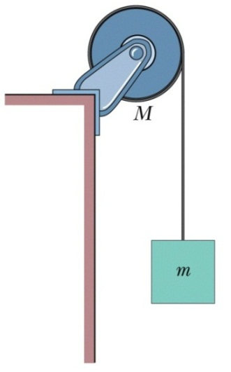
- A solid disk of radius R = 0.25 m and mass M = 5.0 kg is mounted on a frictionless holder such that the disk is free to rotate. A massless cord is wrapped around the rim of the disk with a block of mass m = 2.5 kg attached to the end, as shown in the diagram.
  - What is the moment of inertia for the disk?
  - What is the acceleration of the mass?
  - What is the angular acceleration of the disk?
  - What is the kinetic energy in the disk at time t = 2.0 s?
  - What is the angular momentum of the disk at time t = 2.0 s?

- A block with mass M = 1.7 kg sits on a horizontal frictionless track that connects smoothly with a frictionless vertical loop-the-loop track with radius R = 3.0 m. Initially the block is pressed back against a spring such that the compression of the spring is x = 25 cm with spring constant k. After the block is released from rest, it moves along with track and is just barely able to travel around the circular portion of the track without falling off.
- Determine the spring constant k.
- What is the magnitude of the block’s velocity at the top of the loop?
