Helping define the nature of a
“regional university ” in Georgia.

THE PRESIDENTS
ANNUAL REPORT
1993-1994
Table of Contents
President’s Message 2
Overview 4
Institutional Strategic Planning 16


PRESIDENT’S
MESSAGE
Dear Alumni and Friends of VSU:
At the stroke of midnight July 1, 1993, Valdosta State proudly became a regional university, and, during the first year in its new role, the University experienced a significant variety of positive changes. Continuous studies of the region’s needs, the resources of the University, and opportunities for faculty, staff, and student development resulted in numerous programmatic and operational changes and proposals for new initiatives. Progress continued to be made in attainment of the institution’s seventeen stated goals, and the assessment of outcomes relative to general education, the students’ majors, and administrative and academic support.
Perhaps the year’s most dramatic change was a notable increase in enrollment. Technology continued to be introduced in all aspects of University life. The campus fiber optics network moved toward completion and Distance Learning was increasingly used to deliver classes and services throughout the institution’s service region. The Odum Library and each of the Colleges continued to upgrade substantially their computing facilities. Faculty research, publication, and participation in scholarly activities were at an all-time high. A total of 4.7 million dollars was received in funded grants, an increase of 270 percent over FY 93. The VSU Foundation made dramatic progress in fundraising during calendar year ’93, and ’94 promises to be the most productive year in its history. International Programs made remarkable progress in increasing exchanges and other interrelationships of faculty and students with their counterparts throughout the world.

University status also contributed to a most successful faculty recruiting year. Fifty-four new faculty were in the class of ’94, and most departments reported extremely strong applicant pools and outstanding new hires.
Program development during FY 94 was at a fever pitch driven by enthusiastic faculty and administrators who view university status as an opportunity for new, innovative, and challenging program initiatives. The planning for health occupation programs, distance learning expansions, a doctorate in education, pulp and paper research, and the continued outreach services of the various centers and special funding initiatives throughout the University were hallmarks of FY 94.
By these activities, Valdosta State is helping define the nature of a “regional university” in Georgia. Your continued involvement in every aspect of our operations is vitally important to our success.
Sincerely,
Hugh C. Bailey President
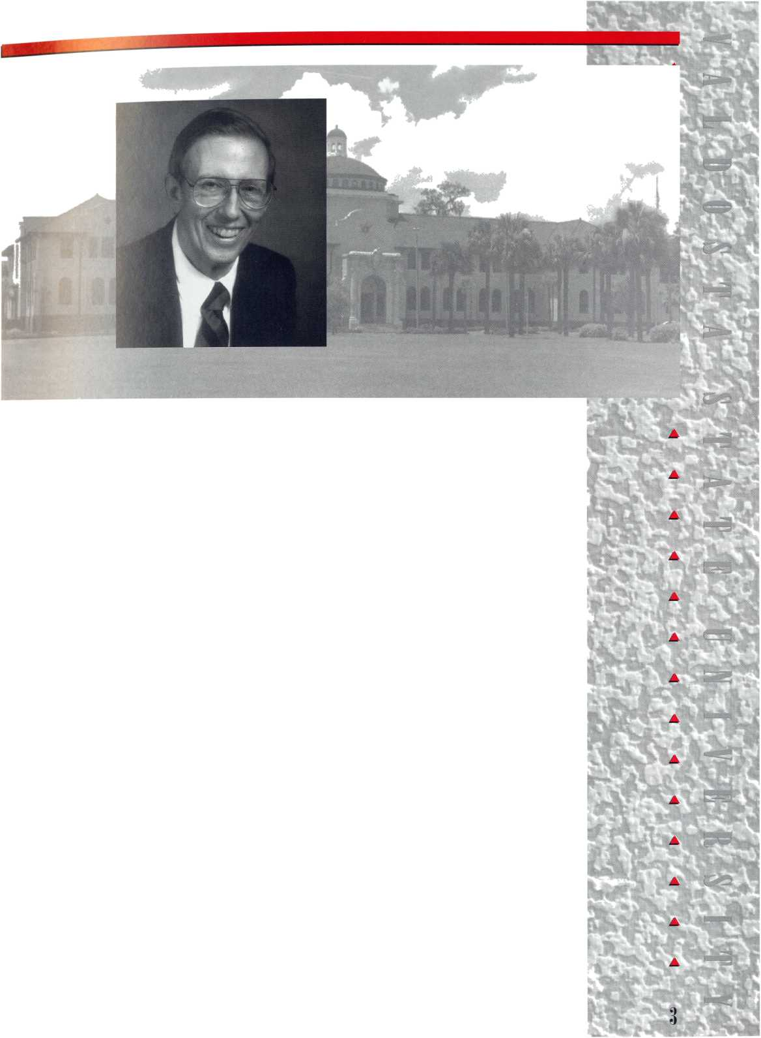

HE LIBRARY
The Odum Library marked the year with significant increases
in its collections and services to the VSU community. It added
7,998 volumes to the book collection bringing the total
to 372,960 hard-bound volumes. The entire collection,
including microfiche titles, grew 3.1 percent to
1,365,561 items, and $600,000 was expended on the
purchase of materials.
Circulation of materials from the main desk grew by 16 percent, and over 8,200 inter-library loans were received, processed and delivered.
The library provided 3,600 hours of reference service and point-of-use instruction to students, faculty, staff, and the general public. A barcoding project, which facilitates the issuance of materials, was 75 percent completed with the placement of 128,000 barcodes in books during the year. A CD Local Area Network, which will increase access to electronic resources in the library, was also installed.
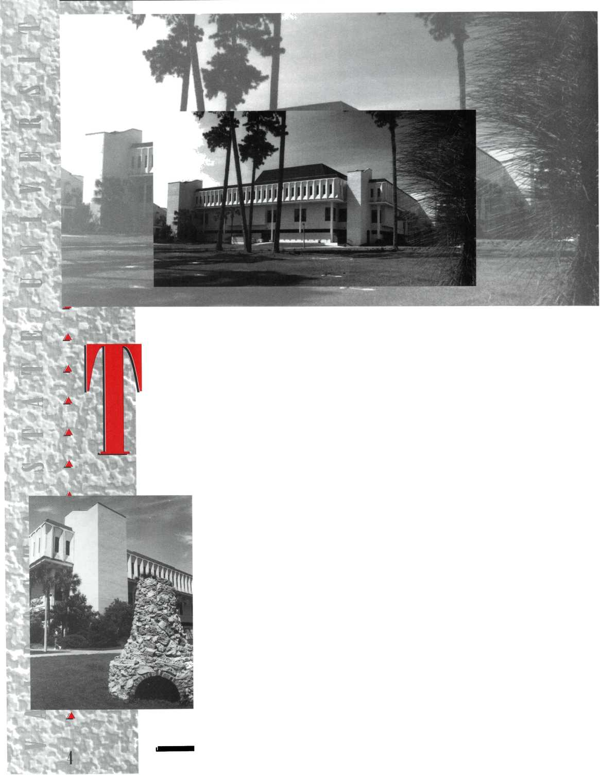


ALUMNI RELATIONS
Following successful University Celebration activities in more than 50 areas around the state, the Alumni Association undertook an extensive strategic planning program which should produce meaningful results. Homecoming, the VSU Ambassadors Program, spring receptions, and the Scholarship Luncheon all continued as successful activities.
ADVANCEMENT SERVICES
Significant improvements were made in the quality of the information the University has available on its various constituencies, the caliber of reports produced, and the fiscal management of the VSU Foundation. Solid progress has been made in finding “lost” constituents, promoting special events, and supporting University Relations’ special activities.
UNIVERSITY RELATIONS
The University’s new visual identity program, a dramatically enhanced publications program, and increased visibility in state and regional media highlighted the year’s accomplishments. Highly visible were the improvements in such key publications as the VSU Alumni Bulletin and Trailblazer. Myriad tours, special events, and exhibits were provided. The outline of a strategy for a marketing plan was developed, and work has begun in this important area.
Valdosta State Universitv Ahimni
Bulletin
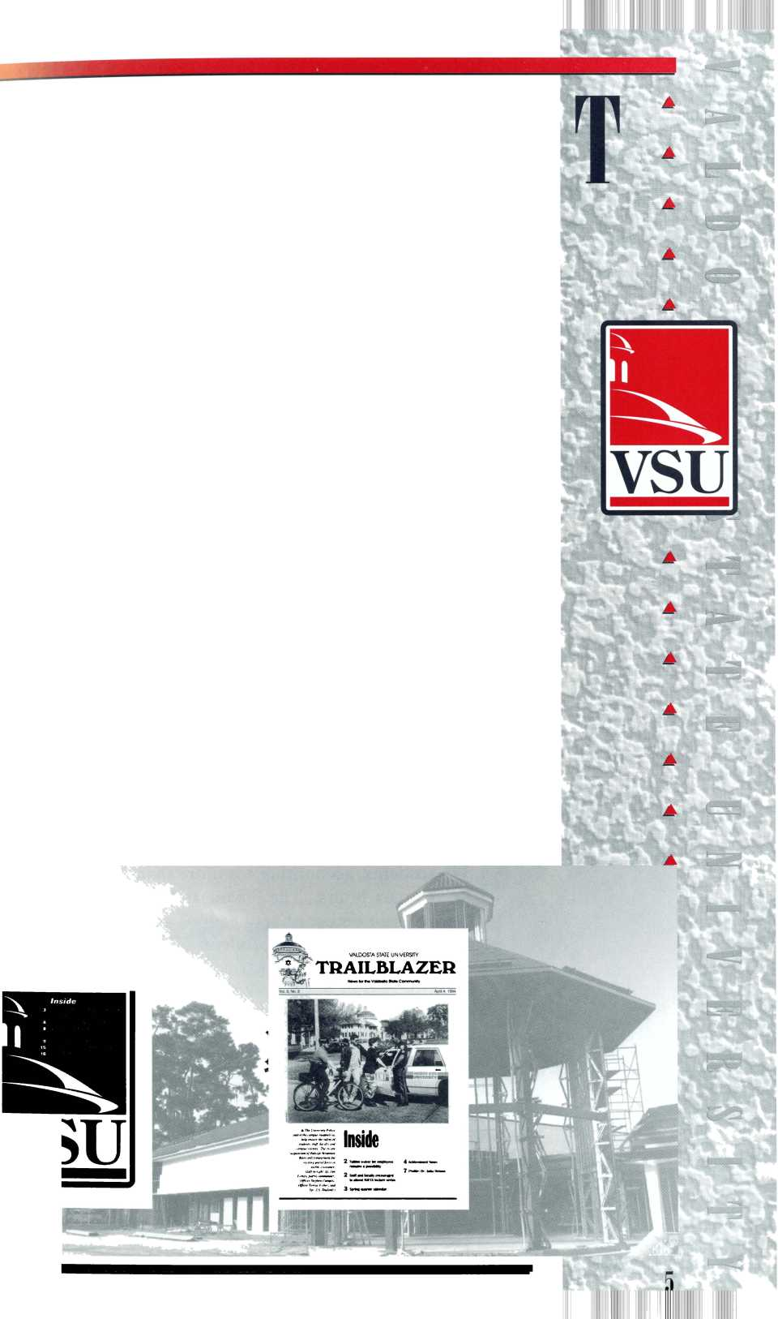
DEVELOPMENT
The VSU Foundation and the University received $1,287,000 in gifts in the calendar year 1993, the second best fund-raising year in the history of Valdosta State, surpassed only by 1989 when the majority of Mrs. Gertrude Odum’s magnificent bequest was received. This total was exceeded during the first six months of 1994, which appears poised to be the best fundraising year in the institution’s history.
The Division of Student Affairs worked unstintingly to
provide an atmosphere conducive to learning and the well-being
of those who matriculate at Valdosta State University.
The Office of Career Planning and Placement continued its
pattern of growth by developing new programs and services for
both students and alumni. The office posted 115,215 jobs during
the year. Eighty-five percent of the persons registered for
placement were employed, with 75 percent employed in fields
directly related to their area of study.
Cooperative Education made 115 job placements and 15
internship placements. Part-time J.O.B.S. placements increased
to 3,327, an increase of more than 200 percent over
the past two years.
During the academic year, the Counseling Center
provided individual and group counseling to 891
students, accounting for more than 2,400 client
contact hours. The Financial Aid Office processed a
record number of applications and awarded $24
million in grants to students in FY 94. The Pell
Grant recipients increased by 330, and some 500
students received over $500,000 in Hope Scholarship
funds.
The Office of Housing and Residence Life
increased occupancy levels, added full-time Residence
Hall Directors, and enhanced security measures in all
of its buildings. The Farber Student Health Center,
which offers comprehensive outpatient care to
students, had 19,342 student visits, including 610 by Governor’s
Honors Program students and staff during the summer of 1993.
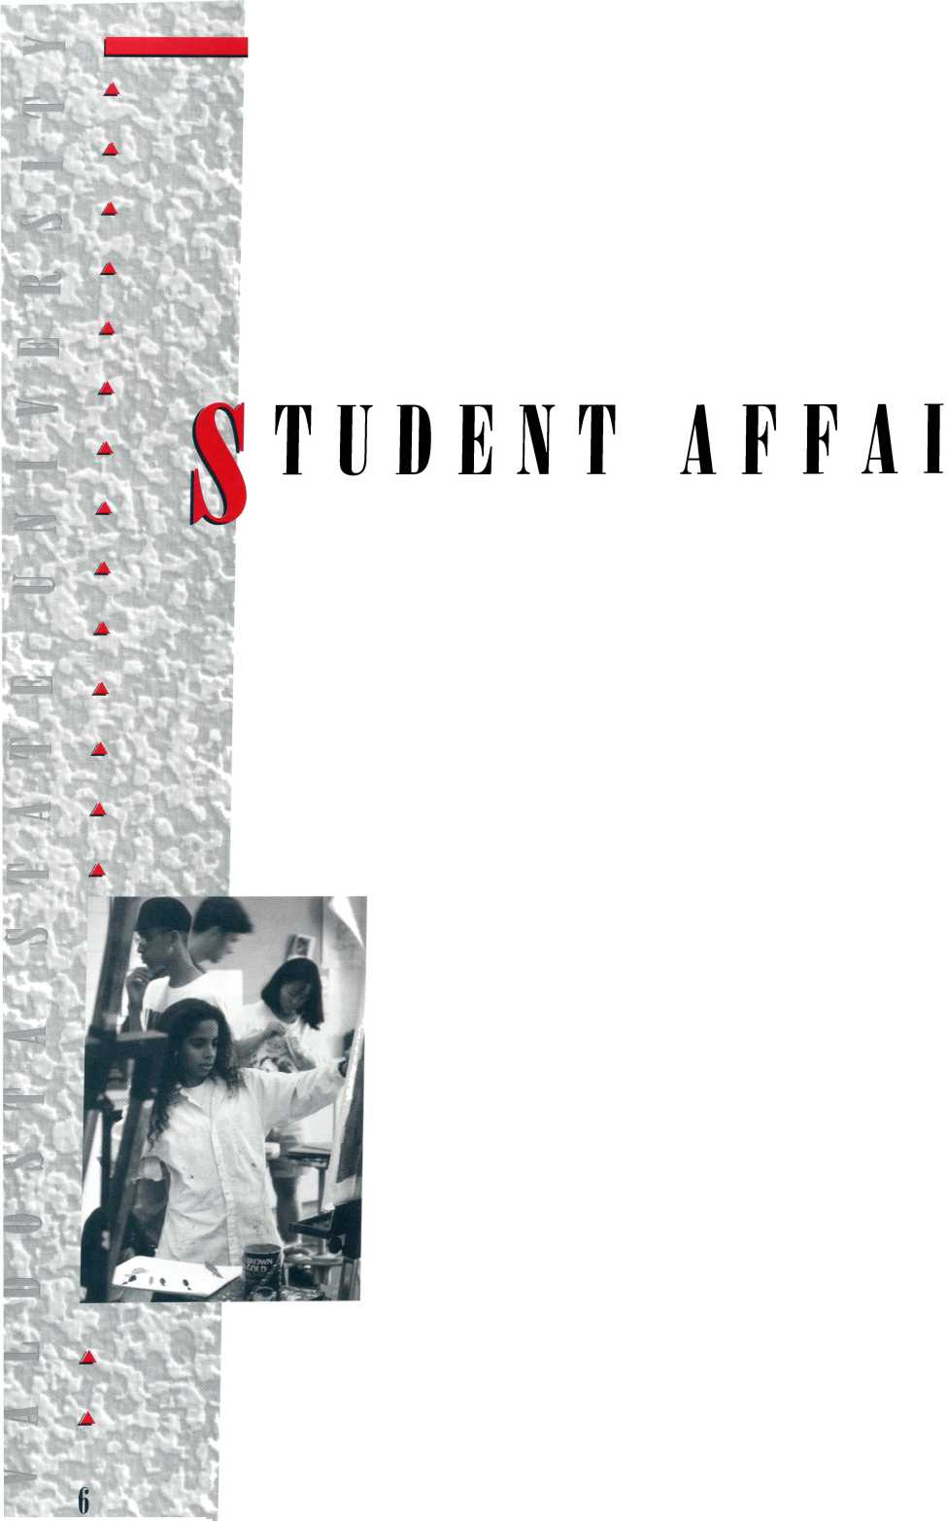


mUSmk
Fiscal Year 94 marked the Faculty Senate’s second full year of operation under its Bylaws. It met nine times during the academic year, resolved nine issues, and left six issues pending. A number of Senate Bylaws changes were proposed and approved, including the role of ex officio and student committee members and changing the quarter in which senatorial elections are to be held. The Senate approved the 1994-95 and 1995-96 academic calendars, the 1994-95 Senate calendar, and a new examination schedule, with a 36-hour deadline for final grade submission.
The Faculty Handbook Committee continued to work at a major revision of the Faculty Handbook. The Senate approved the extension of Women’s Studies and African-American Studies special committees for an additional year and all other Standing Committees as listed in the Bylaws.
ATHLETICS
The Athletic Department offered ten intercollegiate sports on the varsity level and moved toward its goal of becoming the top Division II program in the country both in competitiveness on the field and in the program’s graduation/persistence rate.
HIGHLIGHTS
^ Valdosta State won the Gulf South Conference (GSC)
championship in golf and women’s tennis and finished second in football, softball, and men’s tennis.
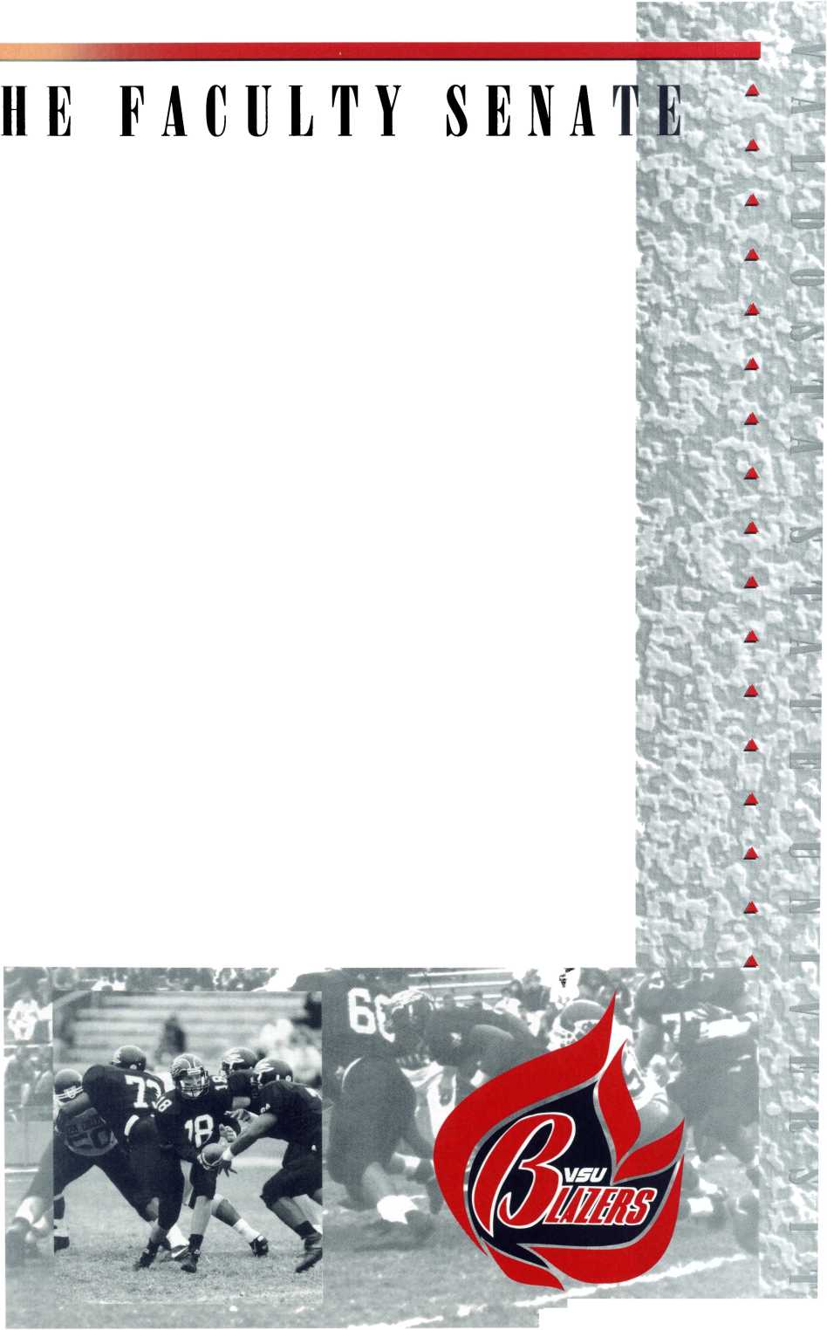


" It was represented in NCAA national level play by softball, women’s and men’s tennis, and golf. The softball team made the regional finals, the golf team finished sixth in the nation, and VSU junior Briny Baird won the Division II individual championship.
"Junior quarterback Chris Hatcher was named the GTE- CoSIDA Academic All-American Player of the Year and finished fourth in balloting for the Harlon Hill Award, given to the top Division II football player in the country.
"The football team finished the 1993 football season ranked 20th nationally in home football attendance in Division II.
"Coaches John Hansen (women’s tennis), Ronald Durante (softball), and Nicky Balanis (golf) were named GSC Coaches of the Year.
"Valdosta State hosted the conference softball and women’s tennis championships and the national baseball championship.


0llege

Of

Arts and Sciences
During FY 94, the College of Arts and Sciences grew in its production of credit hours from 160,633 to 179,260, 47.9 percent of those of the entire institution. Over the past five years, the College’s number of majors increased from 2,350 to 3,219, a growth of 36.98 percent. During FY 94, 18 new faculty positions were filled by the arts and sciences departments for fall ’94.
In winter ’94 the rapidly growing Biology Department had 550 declared majors, the largest number in the College of Arts and Sciences and the third largest in the entire University. State and federal regulatory agencies increasingly received input from the Biology faculty on matters relating to wetlands, ecological impact surveys, and rare and endangered species endemic to the Southeast.
In the English Department, the Writing Center logged almost 21,000 users of its tutorials/orientations, and the graduate program grew from 15 to 25 active students. Its faculty published 13 articles, 14 poems, and a short story and presented 20 conference papers.

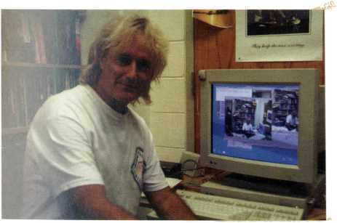
Programs Visiting Professorship, which was filled by Dr. OketeJ. E.
S h 1 roya, a well-known Kenyan scholar who taught African and
African-American history during FY 94.
The Mathematics and Computer Science Department
initiated a program in Computer Information Systems in fall ’93,
which immediately attracted almost 30 majors.
The Foreign Language/International Culture Center
provided resources for public school teachers and VSU students
through its library of audio/visual materials and pedagogical
literature.
The Philosophy Department increased offerings in the area
of professional and applied ethics and integrated research and
teaching through the Internet. The latter development led to
expanded subscriptions to an academic discussion list maintained
by the department and available through the Internet. It offered
nationally an electronically communicated topics course in
philosophy, accessible through e-mail and the Internet—“A
Virtual Classroom: The Electronic Agora.”
The Department of Physics, Astronomy and Geology is
participating in the re-installation of a telescope at Kitt Peak,
Arizona, by operating the telescope remotely with data
transmitted electronically. VSU students will soon have access
to a telescope at the best observing site in the country.
The Department of Political Science had an 18.5 percent
annual growth of the number of students in its MPA degree
program at Kings Bay and Moody Air Force Base.
The Department of Sociology, Anthropology, and Criminal
Justice was active in international activities through its summer
program in England and Scotland and various functions for six
visiting international visitors/scholars.
The VSU Honors Program, which recruited a new permanent
director after a national search, had its established rotation of
Honors courses filled to capacity.
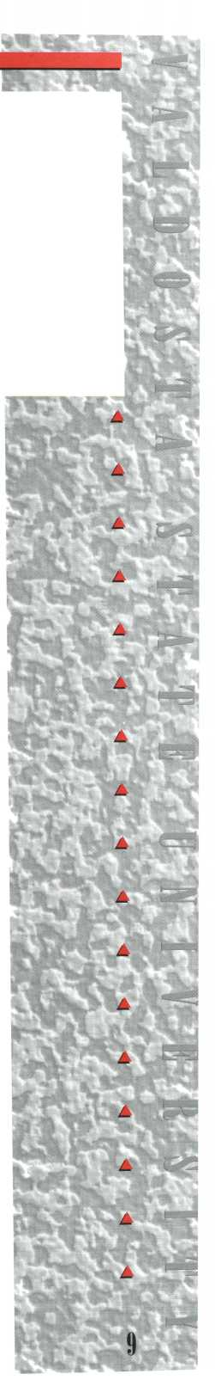

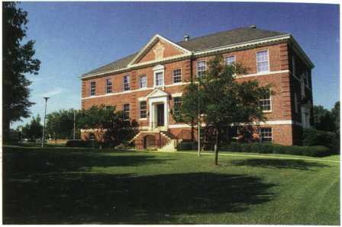

COLLEGE
OF BUSINESS ADMINISTRATION
The College of Business Administration had an increased enrollment, a development which ran counter to national trends for business schools.
The MBA Program was reactivated and was one of the first three programs nationally to be granted Candidacy Status by the American Assembly of Collegiate Schools of Business.

COLLEGE

OF EDUCATION
The Georgia Department of Education selection of the College of Education as an Educational Technology Training Center resulted in the receipt of over $750,000 of hardware, software, and financial assistance for implementing technology. The Education Center is becoming the educational technology center of Georgia. Six classrooms have been converted to model electronic classrooms, and the college has one of the few teacher training programs that provide pre-service and in-service teachers with access to the leading K-12 integrated learning systems.
After consultation with national experts and close collaboration between the College of Education and the College of Arts and Sciences, a preliminary doctoral program with
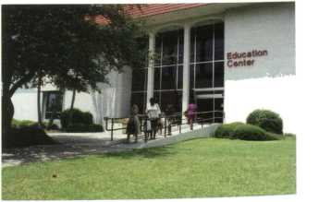

separate emphases on administration, adult education, curriculum and instruction was completed and submitted to the Chancellor’s Office.

COLLEGE
OF NURSING
The College of Nursing admitted 160
students, including 15 graduate students, and
conferred 77 undergraduate and nine master’s
More than 100 music and theatre
performances and art exhibits featuring the
work of Valdosta State University students
and faculty were taken to schools in the service area.
The Valdosta Symphony Orchestra (VSO) increased its number of annual performances from seven to ten, including four Youth Concerts for over 4,000 area middle school students. The Orchestra was named to the Touring Roster of the Georgia Council of the Arts for 1995-96, one of a very small group of orchestras chosen for such a distinction.
The Music Department’s accreditation by the National Association of Schools of Music was approved for a subsequent ten-year period.
deg
rees.
A
The Theater Department presented nine on-and-off-campus productions in 106 performances to audiences which totaled over 22,000. The Jekyll Island Musical Theater Festival, which was designated “The Musical Theater of Georgia,” presented 40 performances to 12,000 patrons.
11
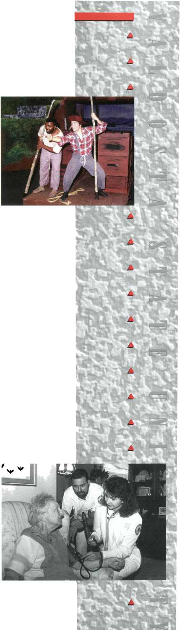

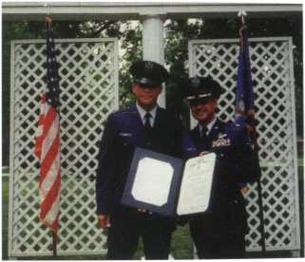
HE GRADUATE SCHOOL
Graduate enrollment increased every quarter during the year, rising to a total of 1,379 in the spring quarter of 1994. Minority graduate enrollment increased every quarter also, rising to a total of 167.
IVISION
OF AEROSPACE STUDIES
One cadet received an AFROTC four-year scholarship. Two others were each awarded three-year scholarships, and five students received $2,000 annual professional officer course incentive scholarships. Recruiting goals were developed for each ROTC unit for field training following the sophomore year. VSU’s goal was to send eight cadets to 1994 summer field training which it exceeded by sending 15.
OF INTERNATIONAL PROGRAMS
The Office of International Programs (OIP) has continued to aid departments and colleges in internationalizing the
curriculum, and it is emerging as a state and national leader in international educational exchange programs and similar initiatives. VSU became the first institution in Georgia to obtain membership in the International Student Exchange Program, (ISEP), a world-wide consortium of over 200 institutions.

In its second year of operation, the Office of Grants and Contracts increasingly offered assistance to faculty and staff. A total of $4,706,454 of funded grants were received from state, federal, and private sources, a 270 percent increase over the previous year.
The Public Services staff took full advantage of the new Regional Center for Continuing Education to expand dramatically the continuing education, professional development, and service opportunities at Valdosta State University. During FY 94 Public Services:
Renovated rooms and equipped a 20-station continuing education computer lab; ^{m}^^{h} Equipped a Distance Learning classroom in the Regional Center;
Developed logistics for offering Distance Learning classes at multiple sites;
Developed a communication system between Distance Learning instructors and sites;
Made 19 undergraduate programs available to Evening Program students.
GRANTS & CONTRA
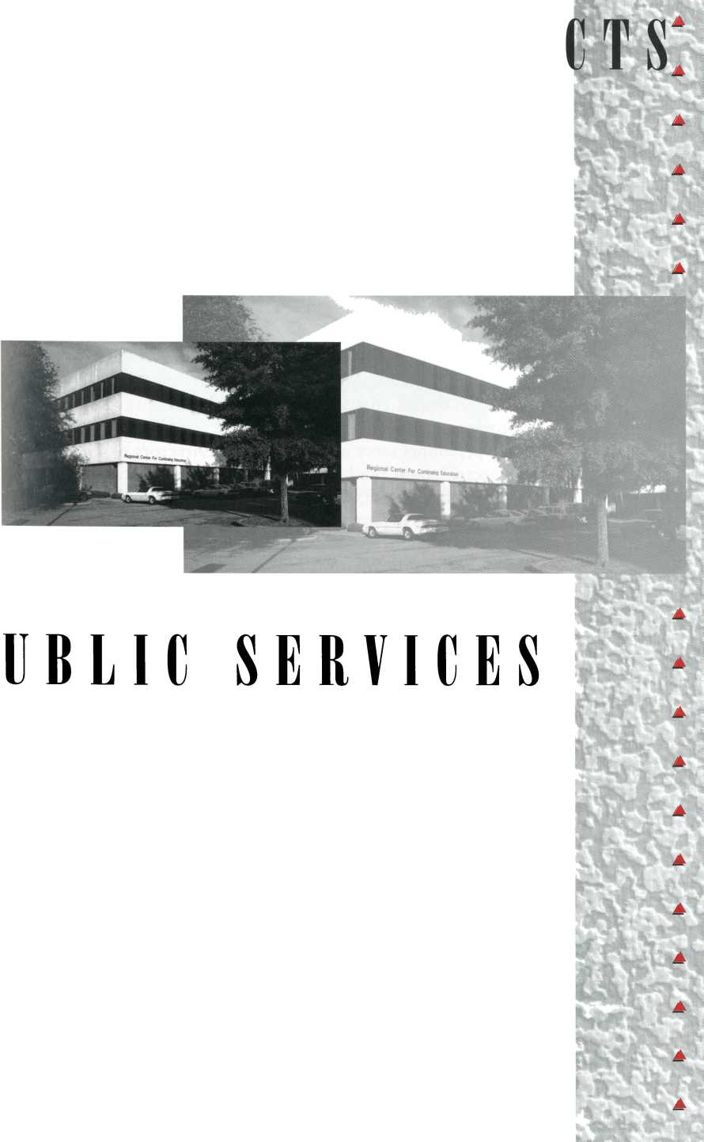

FFIRMATIVE
In FY 93 VSU had 1,813 cumulative, unduplicated black registrants which was 17 percent of all registrants. The number of black registrants increased in FY 94 to 2,104 or 18 percent of all registrants.
Valdosta State remained committed to the attraction and creative employment of a diverse work force and the enrollment and education of those minority and handicapped students who will profit from its services. To aid in attaining these goals, the Office of Affirmative Action and Minority Affairs:
Made an estimated 4,500 contacts with students in counseling, tutoring or meetings during the year;
^ Had personnel serve on the Board of Directors of Valdosta Project Change, the Levi Strauss anti-racism initiative;
>/ Purchased over $29,000 in Adaptive Assistive equipment for use in various departments to improve the teaching environment and accommodate students with special needs;
^ Implemented the Mentoring Program funded with a three- year grant of $100,000.
The University has assumed a leadership role in Distance
Learning, or two-way video/audio transmission. A number of
classes are offered at up to five sites;
counseling and advising are provided by this
medium. Last year, faculty were able to
reduce their off-campus travel by 20 percent
while expanding the educational
opportunities for the citizens of South
Georgia. There are two distance learning
classrooms in operation and plans have been
formulated for a third and a satellite uplink.
Because of VSU’s leadership, it was asked to
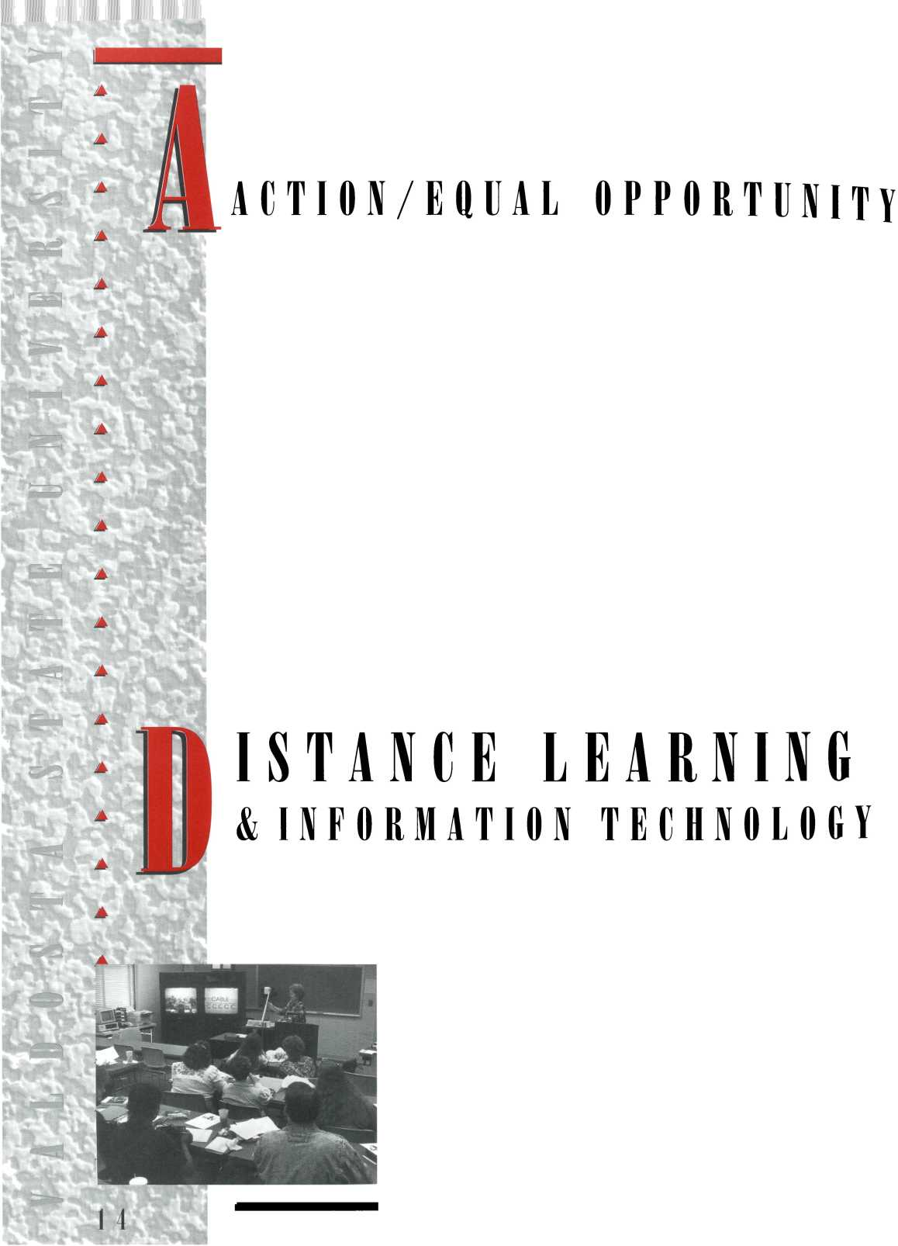
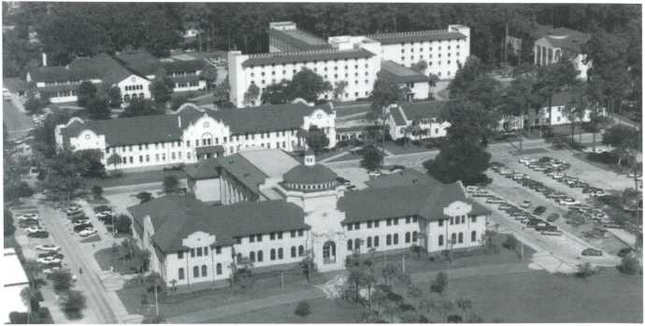
offer the first University System college courses for high school students via distance learning.
Technology has continued to be introduced at a rapid pace in all aspects of the University’s operation. The fiber-optic and copper wire campus-wide Ethernet data network is virtually completed. The University has purchased and installed a new Hewlett-Packard 9000 computer, one of the largest machines at a state institution, which affords the capacity and ability to do many new things.
VSU was selected as one of the first six System institutions to receive the Regents’ centrally procured Banner Student Information System and Financial Aid System. The systems will be operational in 9—10 months and will enormously improve the availability of data. As a result of a grant and matching funds from the lottery, $600,000 worth of Sun MicroSystem equipment has been received and placed in service.
15
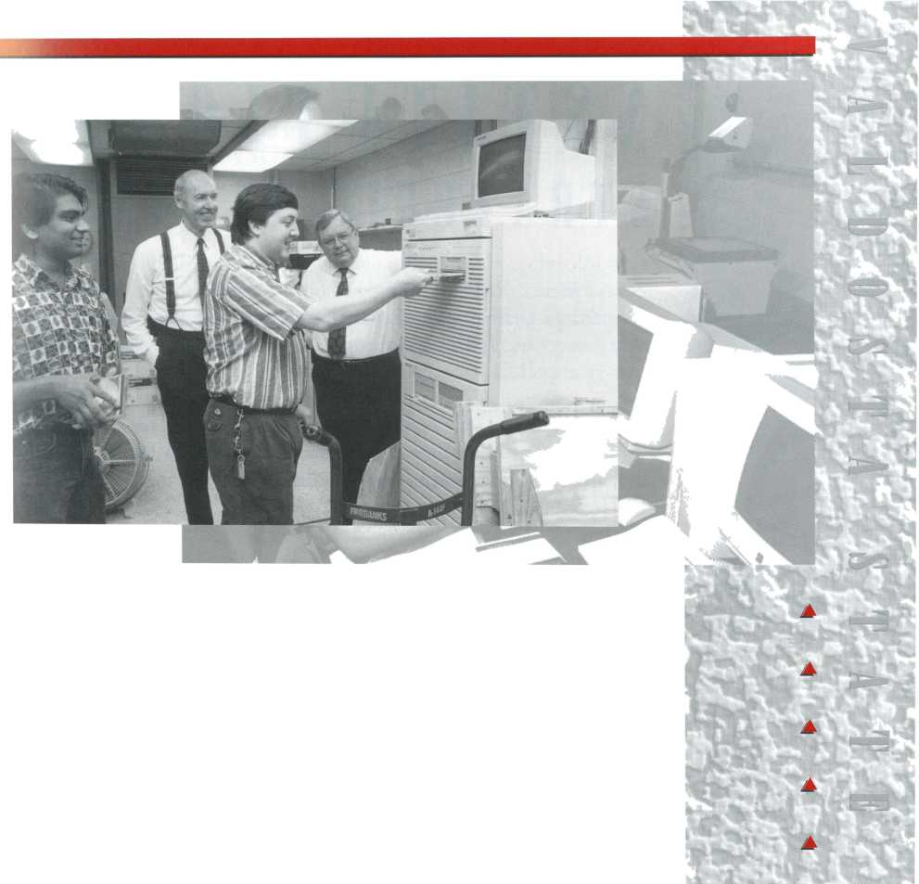
INSTITUTIOINAL

STRATEGIC PLANNING
As part of VSU’s Strategic Planning process, the University adopted 17 Institutional Goals that will be achieved during the next five years. This annual report covers the third year of the five-year cycle.
- GOAL 1
Exceed the eligibility criteria for university status in anticipation of becoming a regional university.

STATUS
The Goal was attained before July 1, 1993.
- GOAL 2
Implement an enrollment management program that will fully integrate the institution’s efforts in recruiting a diverse and quality student body and providing support services that will improve the retention and graduation rates.

STATUS
In addition to the Advising Centers in the College of Business Administration and the College of Education, additional advising centers for undecided majors and nursing students will become operational in FY 95.
- G 0 A L 3
Develop and implement a marketing plan that will enhance the image of the institution.

STATUS
The Office of University Development and the Office of University Relations continue to expand their services, and at the end of FY 94 a University Strategic Marketing Task Force was established.
- GOAL 4
Provide opportunities for students to expand their educational experiences by offering minors and double majors.

STATUS
Planning for the minor in African-American studies was almost completed. Many academic planning efforts concentrated on the development of new programs vital to the mission of a regional university, e.g., doctorate in education and health professions programs.

♦♦♦ GOAL 5

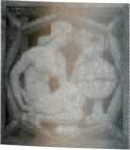
Develop a campus-wide interactive information technology system that will make VSU a regional center for applications of computer and communications in administrative services, data management systems, instruction, and research.

STATUS
Successes in the area of interactive information technology were staggering. VSU Distance Learning origination sites have allowed professors to reduce their off-campus driving by 20 percent while expanding off-campus course delivery. Use of the Distance Learning system for news conferences, academic advising, regional meetings, and professional development workshops has also demonstrated the importance of this new technology in fulfilling the regional university’s mission.
The Decision Center in the College of Business Administration, the Electronic Writing Lab in the College of Arts and Sciences, the Regional Technology Training Center in the College of Education, and the Computer Graphics lab in the College of the Arts have played important roles in moving toward attainment of this.

v GOAL 6
Develop new programs and alternative delivery systems that will meet the needs of the South Georgia region.

STATUS
A strong interdisciplinary team completed the preliminary proposal for VSU’s doctoral program in education and the final proposal for a master’s in social work. Preliminary work was begun on a master’s program in physical therapy. New program planning initiatives were begun in areas such as nursing, radio and television, and social work. All of these program developments address the regional university mission and clearly reflect the faculty’s commitment to provide critical educational and outreach services to the region.
❖

GOAL 7
Use economic indicators and work force needs of VSU’s
service area as a guide for program planning.

STATUS
The Office of Institutional Research and Planning and the South Georgia Institute have continued their instrumental role in providing critical data for program planning. Greater reliance on data from these units has significantly increased the probability of program acceptance by the Board of Regents.
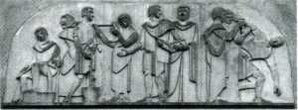
▲
w

A
A
A
A
17

- G 0 A L 8
Provide for core curriculum and major requirements, the development of oral, written, critical thinking and computational skills; knowledge and understanding of the socio-cultural and physical universe; and artistic expression and appreciation.
STATUS
The pilot testing of standardized assessment instruments was begun in FY 94 as part of the core curriculum/general education outcomes assessment program. Results of this and future testing will be used for the revision of learning outcomes, course content, and assessment methods.
- GOAL 9
Review and update the master plan which will serve as the basis for the development of facilities to meet instructional, research, service and extracurricular functions.

STATUS
The Campus Master Planning Committee was re-established to help the University meet the challenges of rapid growth. Building acquisition and renovation projects continued at a rapid pace because of the outstanding work of the Plant Operations Department and the VSU Foundation.
- GOAL 10
Develop plans to distribute resources appropriate for performing the University’s educational, research, and service functions.
STATUS
Budgetary accountability and data-based decision making were in greater evidence in FY 94. Academic planning and budgeting were more closely aligned through improved use of institutional data provided by the Office of Research and Planning.

❖GOAL 11
Use affirmative action goals for each academic and administrative unit as a guide to diversify the. campus.

STATUS
In a highly competitive market for women and minority faculty, in FY 94, VSU had a net gain of one new minority faculty member, and 41 of the 74 new faculty members were female.

- GOAL 12
Enhance the quality of life in the region by providing educational, artistic, cultural, technological and economic development activities and programs.

STATUS
The outreach services and activities of the variety of centers, projects, and special initiative funding programs help Valdosta State University maintain its prominence in the region. Many of these services are delivered through ArtSouth, the South Georgia Institute, the Teacher Education Center, the Child Care Center, the International Studies Program, the Odum Library, and the Regional Center for Continuing Education.
- GOAL 13
Substantially increase the ratio of external funding to state appropriations.

STATUS
FY 94 was another banner year for the procurement of external funds. Over $4,706,000 in external funding was obtained, which is a 270 percent increase from FY 93.
- GOAL 14
Expand resources and services for professional, instructional, and faculty development.

STATUS
The Center for Faculty Development and Instructional Improvement budget was increased by $20,000, thus expanding the professional development opportunities for faculty. Faculty evaluation and teaching portfolio workshops conducted by Dr. Peter Seldin sharpened the focus on the teaching mission of the University. In addition, direct support by the Office of Academic Affairs for conference attendance and presentation was given to 30 faculty members.
- GOAL 15
Use a formal planning process involving all employees.

STATUS
Greater clarity of focus and improved communication were realized by the Faculty Senate, Administrative Council, and Council on Staff Affairs in FY 94. Each participated in the initial review of the statements on mission and institutional goals. In addition, the Plan for Change Task Force completed its review of teacher preparation at VSU. The Task Force’s work culminated in the establishment of the Teacher Education Council, which will begin operation in FY 95.

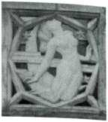
❖ GOAL 17
Internationalize the curriculum, faculty, and students with dual emphases on inter-cultural education and the development of an intercultural orientation for the South Georgia region.
STATUS
Dr. Okete Shiroya (History) served as VSU’s first International Programs Visiting Scholar, and several faculty members participated in exchange or travel programs to England, Scotland, Russia, Belize, and Mexico. Grant proposals were developed for international curriculum and exchange programs to support the continued efforts to expand the international components of the curriculum and outreach services in the South Georgia region.
❖ GOAL 16
Provide career, personal, and academic counseling for all students.
STATUS
The growth of the advising centers, the Office of Special Services, and the Minority Advising Program reflect the commitment to this goal. Further evidence can be found in the development of a grant proposal to expand campus substance abuse counseling services on campus. This grant was developed by representatives from a cross section of units including Student Affairs, Academic Affairs, and Business and Finance.

& GRAPHICS
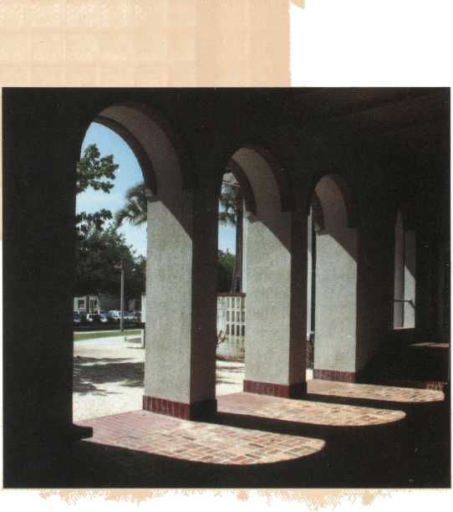
PUBLICATIONS
This annual report was designed by the Publications Unit of the Office of University Relations at Valdosta State University. Its publication was made possible by support from the Valdosta State University Alumni Association, Inc.

