Chapter 10
Example Problems

- A grindstone rotates at a constant angular acceleration α = 0.35 rad/s². At time t = 0.0, it has an angular velocity of ω₀ = -4.6 rad/s and a reference line on it is horizontal, at the angular position θ₀ = 0.0. At what time after t = 0.0 is the reference line at the angular position θ = 5.0 rev?

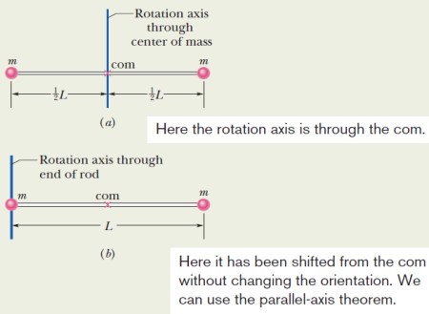
- The figure shows a rigid body consisting of two particles of mass m = 2.0 kg connected by a rod of length L = 15 cm and negligible mass.
  - What is the rotational inertia about an axis through the center of the mass?
  - If the rigid body is set spinning at 3.00 m/s, what is the kinetic energy of the object?

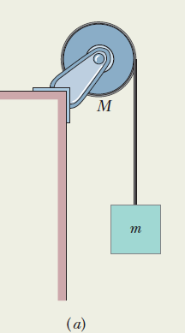
- In the figure a uniform disk, with mass M = 2.5 kg and radius R = 20.0 cm, is mounted on a frictionless, fixed horizontal axle. A block of mass m = 1.2 kg hangs from a massless cord that is wrapped around the rim of the disk and that the cord does not slip. Assume that the disk starts from rest at time t = 0.0 s and also let the tension in the massless cord be 6.0 N and the angular acceleration of the disk be -24 rad/s². What is its rotational kinetic energy at t = 2.5 s?

- Calculate the final speed of a solid cylinder and thin hollow ring that roll down a 2.00 m high incline. The two objects start from rest at the top of the incline. The have the same mass of 0.075 kg and same radius of 4.00 cm.

- Suppose an ice skater is spinning at 0.800 rev/s with her arms extended. She has a moment of inertia of about 2.34 kg·m² with her arms extended and 0.363 kg·m² with her arms close to her body. What is her angular velocity after she pulls in her arms? What is the difference in her rotational kinetic energy after she pulls her arms compared to before?

