Chapter 4
Example Problems
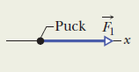

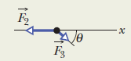

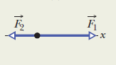
- Parts A, B, and C of the figure show three situations in which one or two forces act on a puck that moves over frictionless ice along an x-axis. The puck’s mass in m = 0.20 kg. Forces F₁ and F₂ are directed along the axis and have magnitudes F₁ = 4.0 N and F₂ = 2.0 N. Force F₃ is directed at angle of 30˚ and has magnitude F₃ = 1.0 N. In each situation, what is the acceleration along the x-axis of the puck?

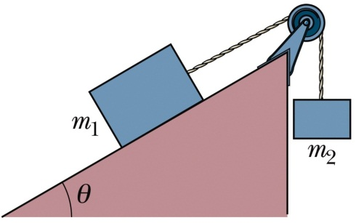
- A block of mass m₁ = 3.70 kg on a frictionless plane inclined at an angle of 30˚ is connected by a cord over a massless, frictionless pulley to a second block of mass m₂ = 2.30 kg. What are the magnitude of the acceleration of each block and the tension in the cord?

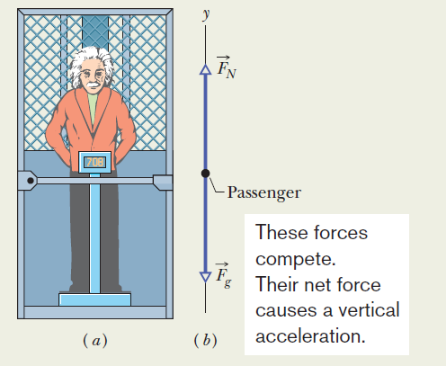
- In the figure, a passenger of mass m = 72.2 kg stand on a platform scale in an elevator cab. We are concerned with the scale readings when the cab is stationary and when it is moving up and down.
  - Find a general solution for the scale reading whatever the vertical motion of the cab.
  - What is the magnitude of the normal force if the car is accelerating at a constant 0.5 m/s²?

