Chapter 5
Example Problems
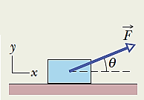
- In the figure a block of mass m = 3.0 kg slides along a floor while a force of 12.0 N is applied to it at an upward angle of θ = 30°. The coefficient of kinetic friction between the block and the floor is μ_{k} = 0.40. What is the normal force acting on the block and the magnitude of the acceleration?

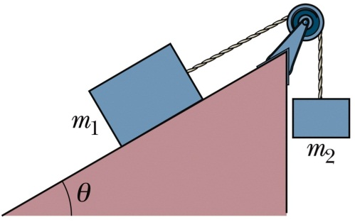
- A block of mass m₁ = 3.70 kg on a plane inclined at an angle of θ = 30˚ is connected by a cord over a massless, frictionless pulley to a second block of mass m₂ = 2.30 kg.
  - Draw the free-body diagram for the two block system.
  - Write down the equations of motion for each block.
  - What are the magnitude of the acceleration of each block and the tension in the cord if the coefficient of kinetic friction for the surface is μ_{k} = 0.25?

- A raindrop with radius R = 1.5 mm falls from a cloud that at height h = 1200 m above the ground. The drag coefficient C for the drop is 0.60. Assume that the drop is spherical throughout its fall. The density of water is 1000 kg/m³, and the density of air is 1.2 kg/m³. What is the terminal speed of the raindrop? What would be the raindrop’s speed just before impact if there was no drag force?

- One end of a steel rod of radius R = 9.5 mm and length L = 81 cm is held in a vise. A force of magnitude F_{app} = 62 kN is then applied perpendicularly to the end face at the other end, pulling directly away from the vise. The Young’s modulus and shear modulus for steel are 200.0 × 10⁹ N/m² and 79.3 × 10⁹ N/m², respectively.
  - What are the stress on the rod, the elongation ΔL, and strain of the rod?
  - If the force is now applied horizontal to the end face of the rod, what is the shear and the shear deformation Δx of the rod?

