Ch. 9 Worksheet
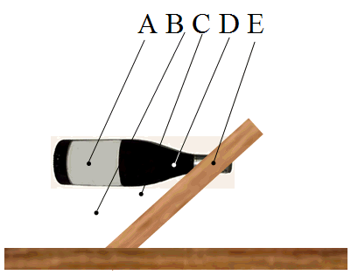
- Consider the object shown. A bottle is inserted into a board that has a hole in it. The bottle and board are then set up on the table and are in equilibrium. Which of the points indicated is the most likely location for the center of mass for the bottle and board system?

- Six identical bricks are stacked on top of one another. Note that the vertical dashed line indicates that the left edge of the top brick is located to the right of the right side of the bottom brick. Is the equilibrium configuration shown possible, why or why not?
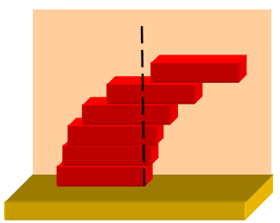
  - Yes, this is possible as long as the combined center of gravity of the blocks above a given brick does not extend beyond the right side of the brick below.
  - Yes, this is possible as long as the left side of each block is directly above the center of gravity of the brick directly below it.
  - Yes, this is possible as long as the center of gravity of the blocks above a given brick remains directly above the center of gravity of the blocks below that brick.
  - No, this is not possible because the center of gravity of the top two blocks extends beyond the right edge of the bottom two blocks.
  - No, because the center of gravity of the top block is to the right of the third block from the top.

- Which one of the following pictures best represents the forces that prevent the ladder from slipping while someone is standing on it?
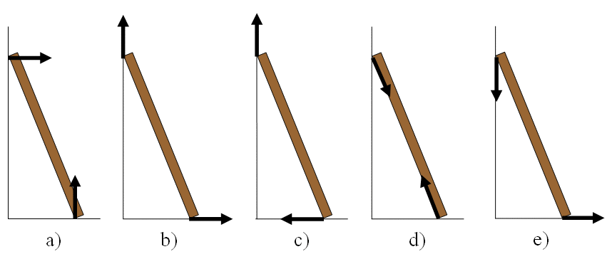

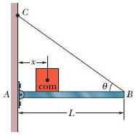
- In the figure, suppose the length L of the uniform bar is 3.2 m and its weight is 190 N. Let the block's weight be W = 320 N and the angle θ = 35˚. The wire can withstand tension of 450 N. What is the maximum distance x before the wire breaks? Assume that the hinge of the beam is frictionless.

