Ch. 4 Worksheet
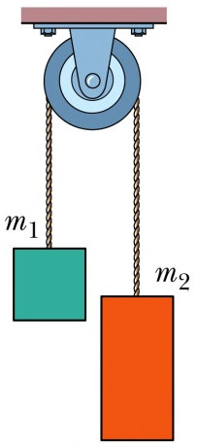
- Two blocks are connected by a cord that passes over a frictionless pulley. The arrangement is known as Atwood’s machine. One block has mass m₁ = 1.30 kg; the other has mass m₂ = 2.80 kg. What are the magnitude of the block’s acceleration and the tension in the cord?

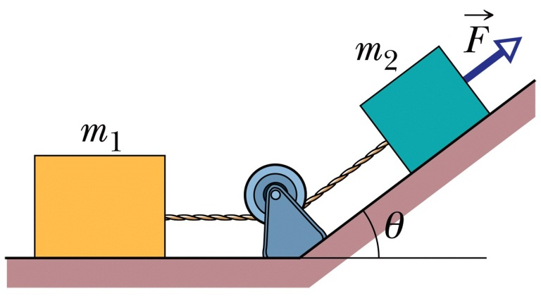
- A force of magnitude 12 N is applied to a box of mass m₂ = 1.0 kg. The force is directed up a plane tilted at an angle of 37˚. The box is connected by a cord to another box of mass m₁ = 3.0 kg. The floor, plane, and pulley are frictionless, and the masses of the pulley and cord are neglible. What is the tension in the cord?

