THE PRESIDENT’S ANNUAL REPORT
1992-1993

Table of Contents
President’s Message 2
Overview 4
Institutional Goals 10
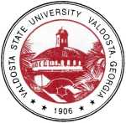
1

President's Message
Dear Alumni and Friends of VSU:
The 1993 academic year was a momentous one in the life of Valdosta State College. It was the last year before the institution became a regional university, a year in which record enrollments were attained each quarter and many changes occurred that made possible and aided in the transition. There was an air of expectancy and anticipation which pervaded the institution and contributed to the success of extensive endeavors in program improvement, planning, and regional service. A culmination of the year’s events came on the evening of June 30, 1993, in a celebration which exceeded the expectations of the most ardent campus enthusiast. Over 12,000 people joined in proclaiming the new regional university and in dedicating it to the service of South Georgia.
Among many notable developments throughout the year and one of the most outstanding was the continued application of advanced technology to many aspects of the College’s operations. A computerized classroom was established for journalism and composition classes as well as a new language laboratory for the Department of Modern Foreign Languages. Sun work stations were installed in the CAD-GIS Lab in the Department of Physics, Astronomy, and Geology. State-of-the-art equipment was installed throughout Pound Hall, the newly renovated Business Administration building. Gifts of computers, peripherals, related technology, and software were received by the School of
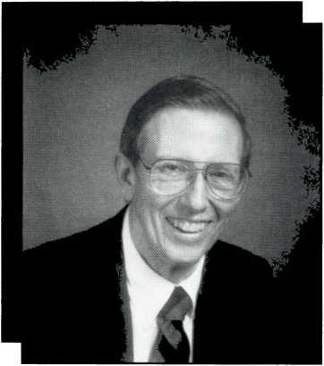
2

Education. The completion of the campus’s Fiber Optics Network
linked all the major buildings, greatly facilitating computer access.
On July 1, Governor Zell Miller dedicated the Georgia Education
Technology Training Center in the School of Education, the first of three
centers to be established at University System institutions. In our
opinion, with the establishment of this center, VSU became a state and
national leader in the use of technology in teacher training programs.
Technologically important also was the establishment on campus
of a Distance Education site with four remote sites at regional two-year
colleges. Twenty-five courses were taught during the year by 24
different instructors. In addition, the Distance Education Lab was used
for advising and communicating with students and colleagues in the
area. This development heralds far more extensive developments which
should come in FY 94.
Because of the cooperation of the Valdosta State Foundation, the
Office of Public Services occupied the major portion of the former
Georgia Power building, obtaining much needed space for developing
continuing education and other programs. The Department of Art was
accredited by the National Association of Schools of Art and Design,
becoming the third Department of Art in a University System institution
and the fourth in the state to obtain this distinction, and many other
achievements were attained in the various schools and other operating
units some of which will be chronicled in this report. We know you
have our pride in their achievements, and we depend on your
continued support as our new university emerges as an educational
leader.
Sincerely,
(
Hugh C. Bailey
President

3

The Library
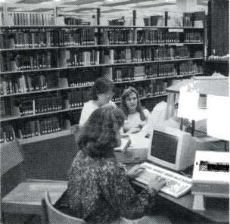
Odum Library—Use of the library collection was high, supported by the improved access afforded by its new on-line system, DRAGON.
Fiscal Year 1993 was a year
of transition for the Odum Library
as it initiated changes in the area of
electronic information to provide a
greater variety of services through
local area and national networks
such as Internet. The changing for-
mat of information will continue to
affect both services and personnel
in coming years.
Use of the library collection
was high, supported by the im-
proved access afforded by its new
on-line system, DRAGON. New ser-
vices and databases allow users
greater flexibility in searching for in-
formation in the library or by dial-in
from remote computers. Library
staff members have adjusted to
meet these new challenges by uti-
lizing new skills and knowledge. A
highlight of the year was the suc-
cessful completion of the official
Government Printing Office inspec-
tion of the Depository Collection,
which was rated high in all catego-
ries.
Circulation of materials increased 26 percent to 14,719, while audio-visual equipment use increased to 6,083 check-outs. The number of loan transactions continued to increase. The Odum Library is a net lender, with loan requests outnumbering borrowing requests by 30 percent.

Advancement
ALUMNI RELATIONS AND ANNUAL GIVING
A significant increase was achieved in alumni involvement through the celebration activi
ties and an improved Homecoming program. The Annual Fund raised $352,000, surpassing its $325,000 goal.
ADVANCEMENT SERVICES
A substantial improvement in alumni biographical records was made possible through publication of a new directory, and automation of the Foundation’s financial records was completed.
UNIVERSITY RELATIONS
A successful role in the University Celebration activities and an expanded effort in publications and media relations were highlights of University Relations’ work.
DEVELOPMENT
Successful conclusion of the Pound Hall Renovation Fund drive, which exceeded its goal of $500,000 was celebrated in February. A basic planned giving program was implemented and the Foundation enjoyed continued overall success in private gift support, which was $500,000 above previous levels.

Student Affairs
The Division of Student Affairs made a transition from inadequate to much-needed, newly renovated facilities, with the biggest improvement being additional space for Financial Aid. Because of the dramatic increase in loan applications, it was necessary to add three Financial Aid staff members during the year. The office became operational with the U.S.
4

Department of Education Electronic Data Exchange and can process need analysis corrections in 72 hours, instead of the three to four weeks previously required.
The renovated Testing area is one of the finest facilities in the University System, and, when computers now on order are delivered, it will become the first computerized test center in the system. Last year, the center administered 10,700 exams.
Valdosta State was chosen by the Educational Testing Service to be one of three national test centers in its Southeastern Region.
Newly renovated facilities enabled the Offices of Career Planning and Placement and Cooperative Education to be located adjacent to each other. J.O.B.S. placements grew dramatically, from 145 the previous year to 221 this year. Co-op had 131 job and 20 intern placements. Changes were made in marketing housing to incoming students, and special interest housing was introduced. By creating floors designated for wellness, open visitation, and quietness, retention was increased.

The Faculty Senate
During its first full year of existence, the Faculty Senate had the opportunity to test its operation under its new Statutes and Bylaws. The Faculty Senate met ten times during the academic year, including a special session devoted to the potential impact of university status.
Having matured beyond the

Athletics
- Basketball had an 89 percent attendance increase, the highest in the nation.
- Football, basketball, and baseball had record ticket sales.
- Sophomore tennis player Masa Oreskovic was selected as a member of the prestigious NCAA National Student-Athlete Advisory Committee, one of only 17 athletes nationwide.
- A five year plan for athletics was completed and initiated.
- The Blazer golf team finished 6th at the NCAA National Tournament.
development of its basic organiza-
tion and structure, the Senate has
been able to refine its operation
and better organize and track its ac-
tions. Concurrently, the Senators
and administrators have grown
more comfortable in
their mutual, coop-
erative relationships
as they work togeth-
er in developing a
great regional uni-
versity.
HIGHLIGHTS
- The football team finished
the season ranked number
20 nationally and tied for
second place in the Gulf
South Conference.
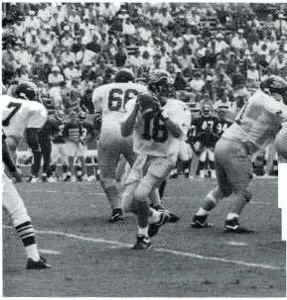

School of Arts and Sciences
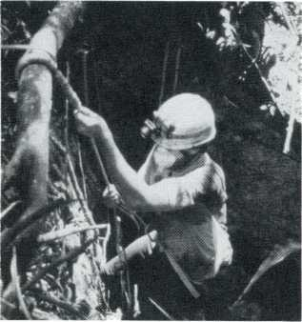
Dr. Philip Reeder, assistant professor of Physics, Astronomy, and Geology, preparing to rappel into the entrance of "Clinging Tree Pit," one of hundreds of caves used by the Maya.
- Biology majors had a
successful year in achieving
admission to professional and
graduate schools. Nine were
accepted into medical school, four
into dental school, five into
pharmacy, four into physical
therapy, four into optometry, and
nine into graduate schools. For the
first time, the department had a
student accepted as a graduate
student in medical illustration, one
of the most competitive of post-
baccalaureate programs.
- Enrollment in chemistry
classes in FY 93 increased each
quarter primarily because of the
increasing demand for chemistry
courses by nursing students. The
department has been granted an
additional full-time faculty position
for the academic year 1993-94.
- An assessment plan for
majors was inaugurated by the
English Department in the winter
quarter which includes an objective
test administered in the first course
in the major sequence, a capstone
course for all senior majors, and a
senior seminar.
- In the Department of
History, faculty members,
collectively, published one book,
had 19 articles published or
accepted for publication, wrote five
book reviews, presented four
papers and chaired a session at
professional meetings, and held the
editorships of two professional
publications.
- The Department of Mathematics’ Student Association of Computing Machinery Program
ming Team was awarded first place in Division 2 at the 1992 Southeast Regional Programming Contest in Jacksonville, Florida.
- In the Department of Modem Foreign Languages, each student station in the laboratory was equipped with an 8-inch video monitor, a SONY cassette player-re- corder, stereophonic headphones, and housed in custom-designed carrels. Additionally, a down-link satellite system was installed which permits viewing of programming in French, German, Japanese, and Spanish and participation in live interactive video workshops. The Foreign Language/Inter-national Culture Center provided resources for public school teachers and Valdosta State students through its library of audio/visual materials and pedagogical literature.
- Valdosta State is a charter member of the Regents’ Engineering Transfer Program with Georgia Tech. The program has grown steadily since 1987 to more than 100 students. The engineering curriculum at Valdosta State includes nine specialized engineering courses, from Introduction to Engineering to three-quarter sequences in Mechanical Engineering and Electrical Engineering.
- Dr. Philip Reeder and his colleagues discovered the ruins of a large Mayan city during their March 1993, excursion in Belize. This significant site, tentatively named IX CHEL, may prove to be the second largest Mayan city ever discovered.
- Valdosta State is a charter member of the Southeastern Association for Research in Astronomy (SARA), a consortium of five south-
6

eastern universities, which operates a telescope on Kitt Peak, site of the National Optical Astronomical Observatory. SARA, has completed the construction of a new dome and will operate its telescope remotely and transmit data electronically. By this means Valdosta State students have access to a telescope at the best observing site in the nation.
- The Department of Sociology, Anthropology, and Criminal Justice had a 6 percent increase in majors and an 8 percent increase in credit hours. The faculty published 15 articles/ reviews in professional journals and presented numerous papers at professional meetings.

School of Business Administration
- The School of Business Administration completed the $3-1 million renovation of Pound Hall converting it into a technological state-of-the-art facility.
- The School of Business Administration’s proposal to reactivate its MBA Program was approved by the Board of Regents and the program was one of the first three nationally to be awarded Candidacy Status by the American Assembly of Collegiate Schools of Business (AACSB).
- The South Georgia Institute continued its exemplary regional and economic development programs. Of special note were the SGI’s Workplace Education Project and Quality Management Initiative.
Other significant achievements included the continued publication of the South Georgia Regional Economic Forecast and work on the regional Cost-of-Living Survey.

School of Education
- The School of Education
continued to demonstrate its readi-
ness for university status by adding
new programs and technology, re-
ceiving accreditation of the Master’s
degree program in Speech-Lan-
guage Pathology, and writing a
number of successful grant propos-
als. The school received twenty
grants carrying awards of over
$700,000.
- The School received the
National Association of School Psy-
chologists’ re-approval for five years
of its School Psychology program.
VSU has one of three programs in
the state and 67 nationally to be ap-
proved.

School of the Arts
ArtSouth, the outreach program of the School of the Arts, continued to assist the academic departments in serving the region.
The Valdosta Symphony Orchestra increased its number of performances and string instruction in area schools. The Jekyll Island Musical Theater Festival, a program in cooperation with the Jekyll Island Authority, was named the “State Musical Theater of Georgia” by a law passed by the Georgia General Assembly and signed by Governor Zell Miller. Traveling art exhibitions
Pound Hall—The School of Business Administration completed the $31 million renovation converting it into a technological state-of-the- art facility.
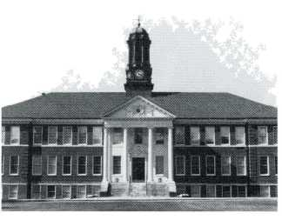
1

were placed in several regional locations and in the Office of the Governor of Georgia.

School of Nursing
Credit hour production for summer and fall 1992, and winter and spring 1993, was 9,530 credit hours. This represents a 28 percent increase over the 6,838 produced in 1991-92 and a 99 percent increase over the 4,294 produced in 1990-91.

The Graduate School

Division of Aerospace Studies
Cadet Rachel Saravia won the Armed Forces Insurance Scholarship for the academic year 1992-93 in national competition with students from more than 140 AFROTC units. Headquarters AFROTC recognized Cadet Michael Zrostlik as a Distinguished Graduate, placing him among the top 15 percent of all graduating cadets nationwide. Eight other junior and senior class cadets received Professional Officer Course scholarships equal to $2,000 annually during the winter and spring quarters of this year.
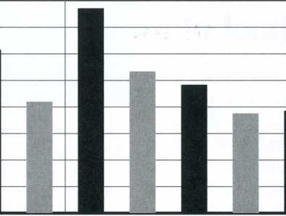

Office of International Programs
Graduate School applications and acceptance data for 1993:
Applications & Acceptance
Summer, 1992 Fall, 1992 ■ Applications
Winter, 1993 Spring, 1993
■ Acceptance
The Ph.D. was conferred by Georgia State University upon four students who were enrolled in the cooperative doctoral program.
Orientation activities were expanded and upgraded for an ever-increasing population of international students, a population which grew by almost 40 percent over the previous year. Four shortterm study abroad programs were organized, with enrollment in three of these totaling 68 students. Six faculty members traveled abroad on college-related professional missions. VSC took a step forward in formalizing its incorporation of international activity when guidelines governing faculty participation in exchange activities and guidelines for the organization of study abroad ventures were developed and ap-
8

proved. An important step in broadening exchange options for students occurred with the completion of application for membership in ISEP, a world-wide consortium of institutions for the exchange of stu- dents.

Grants and Contracts
There was an increase of S878,653 to a total of $1,730,961 in grants, contracts, and gifts for programs of instruction, research, and public service.

Public Service
- The Evening Program Committee approved four evening undergraduate Bachelor of Arts major concentrations, six evening undergraduate Associate of Arts major concentrations, eight evening undergraduate Associate of Arts minor concentrations, five evening undergraduate Bachelor of Business Administration major concentrations, an evening undergraduate Bachelor of Science in Education with a major concentration in Early Childhood, and the Core Curriculum Evening Rotation Schedule.
- In Continuing Education, the annual series of courses of the School-College Outreach Program of Enrichment (SCOPE) showed an enrollment increase of 14 percent
to 583 students. Course registrations reached 933, an increase of 19 percent. Forty-eight class sections were held.
Division of Students by Gender
- A wide variety of programs
and workshops was offered in co-
operation with different
departments of Valdosta State Col-
lege.
- Off-Campus Credit Pro-
grams. Three undergraduate
external degree program sequences
were completed: in Bainbridge
(Middle Grades Education), Tifton
(Early Childhood Education), and
Waycross (Nursing). Each quarter
the Off-Campus Program continued
to have graduates from the Albany
Marine Corps Logistics Base (B.S.Ed.
in Technical, Trade, and Industrial
Education). There were 115 gradu-
ates in external degree programs
from summer 1992 through winter
1993.

Affirmative Action/
Equal Opportunity
In FY 1992 there were
1,683 cumulative unduplicated
black registrants at VSC, or 16.31
percent of all registrants. The num-
ber of black registrants increased in
FY 93 to 1,813 or 17 percent of all
registrants.
Minority students contin- Black 1336
ued to persist and graduate at rates Asians
slightly higher than majority student- American Indian 13
dents. A number of factors
contributed to their success.
Among these were: a supportive
environment, special student-cen-
tered activities designed to foster
participatory relationships, the Mi-
nority Advising Program and the
recently formed Minority Achieve-
ment Program, and several
advising-counseling programs de-
veloped and implemented by
individual units at Valdosta State.
Division of Students by
Race
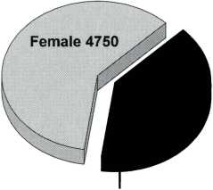
Male 3148
9
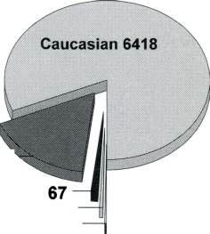
Institutional Strategic Planning
A^{s} part of VSU’s Strategic Planning process, the University adopted 17 Institutional Goals that will be achieved during the next five years. This annual report covers the second year of the five-year cycle.

GOAL 1
The College will exceed the eligibility criteria for university status.

Status
The College became a Regional university on July 1, 1993.

GOAL 2
The University will implement an enrollment management program.

Status
The Schools of Education and Business Administration initiated Advising Centers.

GOAL 3
The University will develop and implement a marketing plan that will enhance the image of the institution.

Status
The Director of University Relations was hired. As part of the transition to university status, a University Transition Task Force composed of faculty, administrators, staff, and community representatives was appointed. This task force began the process of
10

establishing the image of the new university, in part through the creation of a logo for the celebration of university status.
GOAL 4
The University will provide opportunities for students to expand their education experiences by pursuing minors and double majors.

Status
A new minor in Women’s Studies was initiated, and planning for a minor in African-American Studies was started.
GOAL 5
The University will develop a campus-wide interactive information technology system.
Status
The interconnection of all VSU facilities has almost been completed. All campus computers are connected to the campus network. VSU has interactive technology throughout the campus, including the academic areas. The Business School’s newly-renovated Pound Hall is a technologically state-of-the-art learning center, and the addition of four electronic classrooms and the Distance Learning origination site in the School of Education are examples of VSU’s extensive use of technology in the educational process.

GOAL 6
The University will develop new programs and alternative delivery systems that will meet the needs of the South Georgia region.

Status
The Distance Learning Project became well- established during the year. The School of Education and the School of Nursing provided credit classes for 272 students at off-campus sites in Way cross, Bainbridge, Tifton, and Douglas. Distance Learning classes in advising and student teaching techniques were offered to support the credit classes. In addition to the Distance Learning courses, Valdosta State professors travelled over 100,000 miles to deliver credit courses and programs to students in other South Georgia communities.
GOAL 7
The University will continuously study economic indicators and work force needs of its service area which influence decisions relative to program offerings.

Status
The South Georgia Institute continued to provide vital economic forecast data for the region. The data and the information provided by the Office of Institutional Research and Planning served as the primary sources for program planning needs assessment data.
The University’s core curriculum and major requirements will provide for the development of oral, written, critical thinking, and computational skills; knowledge and understanding of the socio-cultural and physical universe; and artistic expression and appreciation.
Status
A core curriculum survey was completed to determine the degree to which the skills, knowledge, and attitudes described by this institutional goal were

being attained. Departmental activities undertaken to achieve this goal include: the designation of VSU as the Southeastern Center for Critical Thinking Skills, the paper presentations made by sociology graduate students at the Georgia Sociological Association meetings this year, and the complete redesign of the Philosophy Department’s introductory course in logic and critical thinking.

GOAL 9
The University will continuously review and update its master plan.
Status
With the acquisition of Brookwood Plaza and the Georgia Power Building and the completion of the Pound Hall renovation, progress has been made in addressing the space shortage at VSU. The renovation of Powell Hall has helped the Division of Student Affairs to meet some of its space needs. The renovation of Brookwood Plaza is still a high priority for the University.

GOAL 10
The University will develop plans to distribute resources appropriate to perform its educational research and service function.

Status
Budget development and allocations for the Academic Affairs units are increasingly based upon departmental and unit progress toward achieving institutional goals. In addition, budgetary and programmatic requests based upon information provided by the Office of Institutional Research and Planning and the South Georgia Institute are becoming the accepted practice to request new programmatic funds.

Status
The goal was accomplished in that the level of funding for grants and contracts increased 197 percent (totaling over $1.7 million in new grants). This award total does not include the $500,000 in private donations raised for the renovation of Pound Hall.

GOAL 14
The University will expand resources and services for faculty, professional, and instructional development.

Status
Faculty development support has been quite strong in the areas of research and travel through grants from the Center for Faculty Development and Instructional Improvement and the Faculty Research grants.

GOAL 15
The University will adopt and require the use of a formal planning process involving all employees.

Status
The publication of the University System’s A Plan for Change has generated much interest at VSU. Taking quite seriously the charge to respond to the document, the Office of Academic Affairs established a task force to develop the University’s plans for addressing the needs and concerns outlined in the document.
GOAL 16
The University will provide adequate career, personal, and academic counseling for all students.
Status
The addition of the Advising Center in the School

of Education, a significant expansion of the Office of Special Services, and the continued effective work of the offices of Cooperative Education and Career Planning and Placement contributed to the achievement of this goa|,
GOAL 17
The University will continue the institutional focus on internationalizing the curriculum, faculty, and
students.

Status
The student and faculty study and travel abroad programs in England, Scotland, Russia, Belize, and various nations in Africa stimulated extensive interest in internationalization. Further efforts included the development of an African-American studies minor and the sponsorship of Dr. Ebele Eko, a Fulbright Scholar from Nigeria

