Chapter 3
Example Problems

- A circus clown is about to be shot out of cannon with velocity of 20.0 m/s at 30.0° into a pile of whipped cream a distance R away from the end of the cannon. Assume that the clown takes off and lands at the same height in the whipped cream.
  - How far away should the pile of whipped cream be placed in order for the clown to land safely in it?
  - How long would it take for the clown to reach the whipped cream?

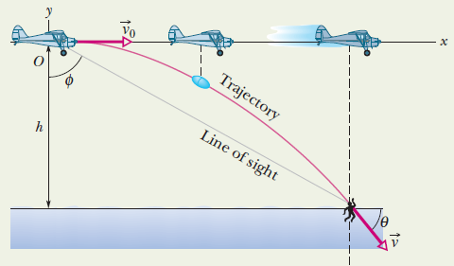
- In the figure, a rescue plane flies at 198.0 km/hr and constant height of 500.0 m toward a point directly over a victim, where a rescue capsule is to land. As the capsule reaches the water, what is its velocity?

- After failing his first physics test, a student standing on the grass in front of Nevins Hall, proceeds to throw his physics textbook into the air at ground level with an initial velocity of 4.5 m/s and an angle of 25º. Ignoring air resistance and assuming that the book remains closed during its flight, determine the following:
  - How far did the book travel horizontally, i.e. the range (R = x – x₀)?
  - How long did it take the book to hit the ground?
  - What is the magnitude and direction of the velocity of the book just as it hits the ground?
  - Not being satisfied, the student now takes the book to the top of Nevins Hall (h = 12 m) and throws it off with the same initial velocity (including angle). How far did the book travel horizontally now?

- You are a police detective examining the body of a man found 24.0 m from the bottom of a cliff 450 m high. Three witnesses come forward with conflicting stories:
  - The first witness claims that she saw the man run off the top of the building and leap into the air, which means he might have committed suicide.
  - The second witness claims the man just fell off the building, which indicates that it might have been an accident.
  - The third witness claims that the man was pushed off the building, which means that it was murder.
Was it most likely murder, suicide, or an accident, based on the witnesses statements and the evidence? Assume that a typical running speed a person is around 4.5 m/s and that when pushed a person can fall back at a speed of about 2.5 m/s.

