Chapter 11
Example Problems
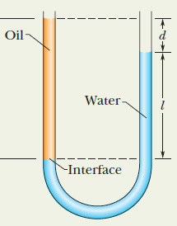
- The U-tube in the figure to the right contains two liquids in static equilibrium: Water of density 998 kg/m³ is in the right arm and oil of an unknown density is in the left. Measurements give l = 135 mm and d = 12.3 mm. What is the density of the oil?

- A manometer is used to measure the pressure in a tank. The fluid has a density of 850.0 kg/m³ and the manometer column height is 55 cm. If the local atmospheric pressure is 96 kPa, determine the absolute pressure within the tank.

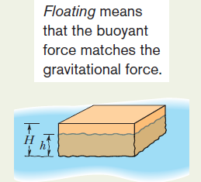
- In the figure, a block of density 900 kg/m³ floats face down in a fluid of density 1200 kg/m³. The block has a height H = 6.0 cm.
  - By what depth h is the block submerged?
  - If the block is held fully submerged and the released, what is the magnitude of its acceleration?

