Chapter 9
Example Problems

- A massless box is being pushed on by three people. The first person pushes with a force of 6.0 N at an angle of 30°, relative to the positive x-axis. The second person pushes straight down on the box with a force of 9.0 N and the third person pushes up on the box with a force of 18.0 N at an angle of 210°, relative to the positive x-axis. If these are the only forces acting on this box, is the box in equilibrium?

- A 2.0 m long rod sits on the x-axis of a coordinate system. One end of the rod is attached to a hinge at x = 0.0 m. A force of 10.0 N is applied perpendicular to the other end of the rod.
  - What is the torque on the rod?
  - If the force was applied half way down the rod and at an angle of 30.0° relative to the rod, what would be the torque on the rod now?

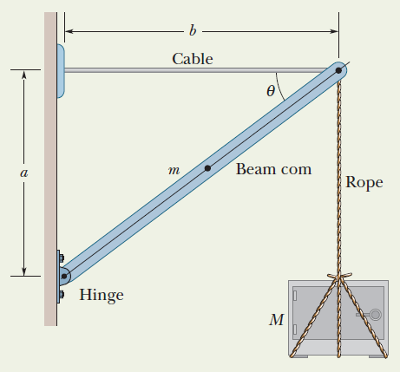
- The figure shows a safe of mass M = 430 kg hanging by a rope of negligible mass from a boom (a = 1.9 m and b = 2.5 m) that consists of a uniform hinged beam of mass m = 85 kg and a horizontal cable of negligible mass.
  - What is the tension in the rope?
  - What is the tension in the cable?
  - Find the magnitude the net force on the beam from the hinge.

