Ch. 5 Worksheet

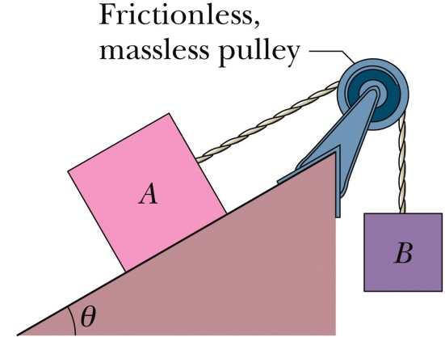
- A block A weights 102 N and block B weights 32 N. The coefficients of friction between block A and the incline is μ_{k} = 0.25. The angle is 40˚. Let the positive direction of an axis be down the incline.
  - Draw the free body diagrams for each block.
  - What are the equations of motion for each block?
  - What is the acceleration of block A if it is moving down the incline?

- A lead brick rests horizontally on cylinders A and B. The areas of the top faces of the cylinders are related by A_{A} = 2A_{B}; the Young’s moduli of the cylinders is related by Y_{A} = 2Y_{B}. The cylinders had identical lengths before the brick was placed on them. What fraction of the brick’s mass is supported by each cylinder?

Ch. 5 Worksheet

- A friend of yours is trying to solve the following problem. She shows you her solution and explains that she was told by her teach that she made three errors when she originally solved the problem. Determine what errors your friend made when doing this problem: (Answer should be 0.819 m)

A block of mass m₁ = 2.00 kg rests on a horizontal surface and is accelerate from rest by means of a massless horizontal cord that passes over a frictionless pulley to a hanging mass, m₂ = 3.00 kg. Assume the horizontal surface is has a coefficient of friction of μ_{k} = 0.100. How far has the hanging mass fallen when it reaches a speed 30.0 m/s?

