Ch. 6 & 7 Worksheet

- One model for a certain planet has a core of radius R and mass M surrounded by an outer shell of inner radius R, outer radius 2R, and mass 4M. If M = 4.1 × 10²⁴ kg and R = 6.0 × 10⁶ m, what is the gravitational acceleration of a particle at point R and 3R from the center of the planet?

- A cave rescue team lifts an injured spelunker directly upward and out of a sinkhole by means of motor-driven cable. The lift is performed in three stages, each requiring a vertical distance of 10.0 m. (a) The initially stationary spelunker is accelerated to 5.00 m/s; (b) he is then lifted at the constant speed of 5.00 m/s; (c) finally he is decelerated to zero speed. How much work is done on the 80.0 kg rescue by the force lifting him during each stage?

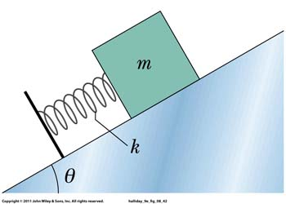
- A block of mass m = 2.00 kg is place against a spring on a frictionless incline with angle θ = 30.0˚. The spring, with spring constant k = 19.6 N/cm, is compressed 20.0 cm and then released. (a) What is the elastic potential energy of the compressed spring? (b) How far along the incline does the block slide before momentarily coming to a stop?

