Chapter 6
Example Problems

- A car is traveling around a curve at 25.0 m/s. If the radius of the curve is 500.0 m and the mass of the car is 900.0 kg, what is the centripetal force exerted on the car? What would be the minimum static coefficient of friction that will keep the car on the road without slipping?

- Curves on some test tracks and racecourses are very steeply banked. This banking with the aid of the tire friction and very stable car configurations, allows the curve to be taken at very high speed. Calculate the speed at which a 100.0 m radius curve banked at 65.0 should be driven if the road is frictionless.

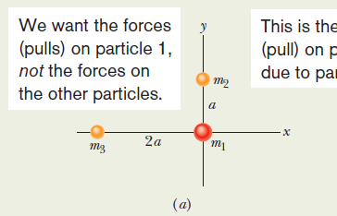
- The figure shows an arrangement of three particles, particle 1 of mass m₁ = 6.0 kg and particles 2 and 3 of mass m₂ = m₃ = 4.0 kg, and distance a = 2.0 cm. What is the net gravitational force 1, net (F_{1,net}) on particle 1 due to the other particles in unit vector notation and magnitude and direction notation with angles specified relative to the positive x-axis?

- Comet Halley orbits the Sun with a period of 76 years, and in 1986, had a distance of closest approach to the Sun, its perihelion distance R_{p}, of 8.9 × 10¹⁰ m.
  - What is the comet’s farthest distance from the Sun, which is called its aphelion distance R_{a}?
  - What is the eccentricity of the orbit of comet Halley?

