Chapter 8
Example Problems

- A block of mass 2.0 kg is sitting at the origin of a coordinate system. Another block of mass 5.0 kg is moving in the positive x-direction towards the first block at a speed of 10.0 m/s. After the two blocks collide, the velocity of the first block is measured to be 5.0 m/s. What is the speed of the second block after the collision? What is the impulse for the first and second block during the collision?

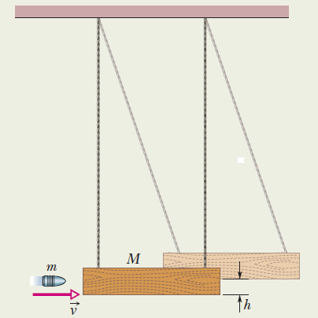
- The ballistic pendulum was used to measure the speeds of bullets before electronic timing devices were developed. The one shown in the figure consists of a large block of wood of mass M = 5.4 kg, hanging from two long cords. A bullet of mass m = 9.5 g is fired into the block, coming quickly to rest. The block and bullet when swing upward, their center of mass rising a vertical distance h =6.3 cm before the pendulum comes momentarily to rest at the end of its arc. What is the speed of the bullet before the collision?

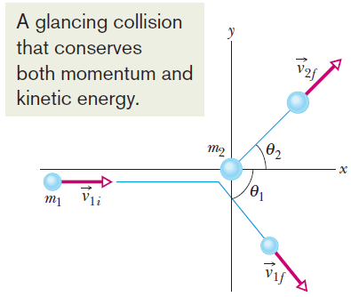
- In the figure, particle 1 is an alpha particle and particle 2 is an oxygen nucleus. The alpha particle is scattered at angle θ₁ = 64.0˚ and oxygen nucleus recoils with speed 1.20 × 10⁵ m/s and at an angle of θ₂ = 51.0˚. In atomic mass units, the mass of alpha particle is 4.00u and the mass of the oxygen nucleus is 16.0u. What is the final speed of the alpha particle?

