Chapter 7
Example Problems

- In 1896 in Waco, Texas, William Crush parked two locomotives at opposite ends of a 6.4 km long track, fired them up, tied their throttles open, and then allowed them to crash head on at full speed in front of 30,000 spectators. Hundreds of people were hurt by flying debris; several were killed. Assuming each locomotive weighted 1.2 MN and its acceleration was a constant 0.26 m/s², what was the total kinetic energy of the two locomotives just before the collision?

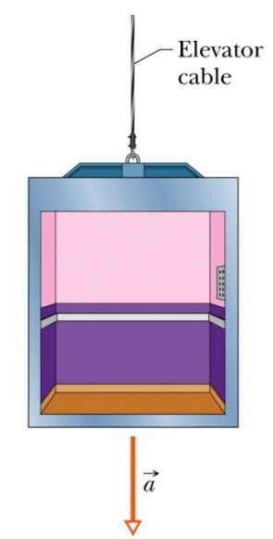
- An elevator cab of mass m = 500 kg is descending with speed v_{i} = 4.0 m/s when its supporting cable begins to slip, allowing it to fall with constant acceleration a = g/5.
  - During the fall through a distance d = 12 m, what is the work done on the cab by the gravitational force?
  - During this time, what is the work done on the cab by the upward pull of the elevator cable?

- A force of 2.0 N has been used to compress a spring by 3.0 cm. What is the potential energy stored in the spring?

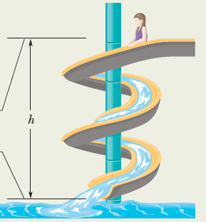
- In the figure, a child of mass m is released from rest at the top of the water slide, at height h = 8.5 m above the bottom of the slide. Assuming that the slide is frictionless because of the water on it, find the child’s speed at the bottom of the slide.

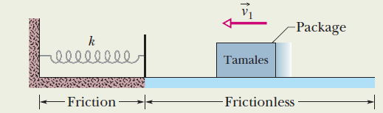
- A 2.00 kg package of tamales slides along a floor with speed v₁ = 4.00 m/s. It then runs into and compresses a spring until the package momentarily stops. Its path to the initially relaxed spring is frictionless, but as it compresses the spring, a kinetic frictional force from the floor, of magnitude 15 N, acts on the package. If k = 10,000.0 N/m by what distance d is the spring compressed when the package stops?

