Translating Sentences into symbolic language: Practice and Tips
Notice that with longer and more complex sentences, it helps to write down all the major connectives, and keep track of any major punctuations or breaks in the sentences:
Example:
Argentina will reduce unemployment and Brazil will cut taxes, or Colombia will support agrarian reform.
Argentina and Brazil, or Colombia
A and B, or C
(A • B) v C
…or using the alternative symbols: (A & B) v C

Here are all the symbols. I will upload this document into Blazeview so that you can use them by copying and pasting them. ~ • v ⊃ ≡ ¬ & → ⇔
Here are some exercises for you to try as well. The first few have multiple choice hints to help you:
1. Argentina will reduce unemployment if either Brazil cuts taxes or Colombia supports agrarian reform. (Remember that the “if” thing has to go in front of the horseshoe, to the left of the horseshoe)
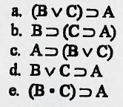
2. Both Argentina will reduce unemployment and Brazil will cut taxes provided that Colombia supports agrarian reform. (Check to see how “provided that” should work – is it an “if” or a “then”?)
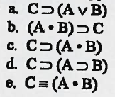
3. If Argentina reduces unemployment then if Brazil cuts taxes then both Colombia will support agrarian reform and the Dominican Republic will increase government spending.
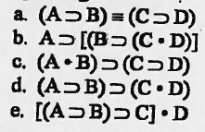
4. If Argentina’s reducing unemployment implies that either Brazil cuts taxes or Colombia supports agrarian reform, then the Dominican Republic will increase government spending.
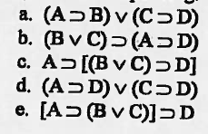
5. Argentina will reduce unemployment only if neither Brazil cuts taxes nor Colombia supports agrarian reform.
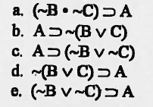
6. It is not the case that Argentina will reduce unemployment unless not both Brazil cuts taxes and Colombia supports agrarian reform.
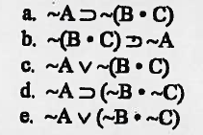
7. Argentina will reduce unemployment if and only if both Brazil and Colombia do not devalue their currency.
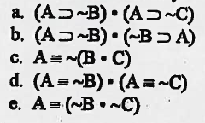
8. Argentina’s reducing unemployment is a sufficient condition for Brazil to cut taxes unless Colombia’s supporting agrarian reform is a necessary condition for the Dominican Republic to increase government spending.
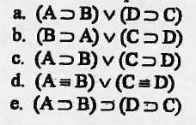
9. If Argentina’s reducing unemployment is a sufficient and necessary condition for both Brazil to cut taxes and Colombia to support agrarian reform, then the Dominican Republic will increase government spending.
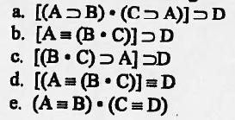

Below are exercises without any possible choices:
10. The sun is hot but it is not humid. (Be sure not to repeat the H for hot and humid.)

11. Mercedes will introduce a hybrid model only if Lexus and BMW do.
12. If John doesn’t pass then he will lose his scholarship and drop out of school.

13. If it rains and you don’t open your umbrella, then you will get wet.

14. Mariah Carey sings pop and either Lady Gaga sings rock or Diana Krall sings jazz.

15. If you don’t wake up on time then you will miss your interview, and you will not get the new job.

16. Either Taylor Swift sings country and Tony Bennett sings classics or Diana Krall sings jazz.

17. If Senator Mary Jones will make sure that the federal budget will be balanced, then partisan wrangling in Washington will end and there will not be any cuts in social security benefits.

18. If Amazon promotes gift cards, then either Macy’s or JCPenney puts on a fashion show.

19. Either Sonia Sotomayor or Antonin Scalia have a modern approach to the Constitution, but it is not the case that both do.

20. If the New York Yankees win the World Series and the New York Jets win the Superbowl, then New York fans will be overjoyed and New York fans will dance in the streets. (Choose your sentence letters carefully!)

