Homework: Ch. 9

- What is the difference between static and stable equilibrium?

- What are the two conditions required for an object to be in static equilibrium?

- An archer's bow is drawn at its midpoint until the tension in the string is 1.12 times the force exerted by the archer. What is the angle between the two halves of the string?
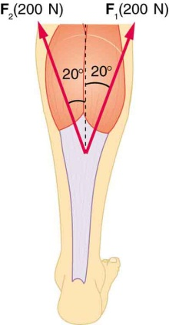
- The Achilles tendon of the posterior leg serves to attach the plantaris gastrocnemius and soleus muscles to the calcaneus bone. If the two muscles both exert a force of 200.0 N at an angle of 20.0° on the tendon, with what total force do they exert?

- The quadriceps muscles exert a force of 1250 N, which is carried by a tendon over the kneecap (patella) at the angle shown below. Find the direction and magnitude of the force exerted by the kneecap on the femur (the upper bone of the body).
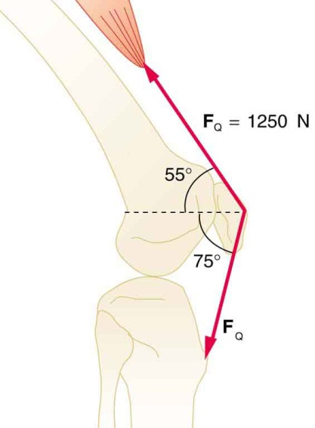
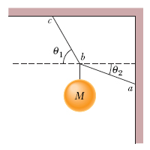
- The system in the figure is in equilibrium. The angles are θ₁ = 60.0° and θ₂ = 25.0°, and the ball has mass M = 6.00 kg. What is the tension in (a) string ab and (b) string bc?

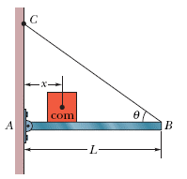
- In the figure, a thin horizontal bar AB of negligible weight and length L = 12.0 m is hinged to a vertical wall at A and supported at B by a thin wire BC that makes an angle θ = 35.0° with the horizontal. A block of weight W = 65.0 N can be moved anywhere along the bar; its position is defined by the distance x = 2.50 m from the wall to its center of mass. Find the tension in the wire, and the horizontal and vertical components of the force on the bar from the hinge at A. (Note: the positive x direction is to the right, and the positive y direction is up)

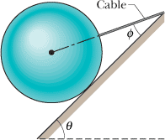
- A 25.0 kg sphere is supported on a frictionless plane inclined at angle θ = 49.0° from the horizontal. Angle φ is 26.0°. Calculate the tension in the cable

- What force must be exerted by the wind to support a 2.50 kg chicken in the position shown below?
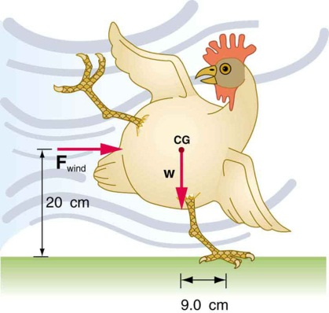

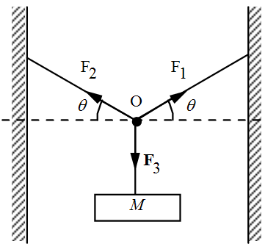
- A block of mass m is hung by three ropes of negligible mass. The system is in static equilibrium. The point O represents the knot, the junction of the three ropes. Assuming that F₁ = 2.00 N, θ₁ = 25.0º, and θ₂ = 15.0º, determine the following quantities:
θ₂
θ₁
  - What is the magnitude of F₂?
  - What is the magnitude of F₃?
  - In order for F₁ = F₂ = F₃, what must be the values of θ₁ and θ₂? Justify your answer.

- In the figure, a man is trying to get his car out of mud on the shoulder of a road. He ties one end of a rope tightly around the front bumper and the other end tightly around a utility pole a distance d = 50.0 m away. He then pulls sideways on the rope at its midpoint with a force F = 25 N, displacing the center of the rope 1.25 m from its previous position, and the car barely moves. What is the magnitude of the force on the car from the rope? Assume that the rope does not stretch.
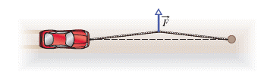
d

