Spectacular
Cookbook published by Valdosta State College Woman’s Club
Salad
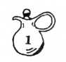
INTRODUCTION
This collection of recipes has been made possible from members of the VSC Woman’s Club and friends, each of whom have been generous with their treasures.
The contributors' names have been used as far as possible. Many recipes are not original and many have been revised.
We have printed all recipes submitted and there is possible duplication.
We sincerely hope you enjoy every one, and when you find an especially good one to your taste.... please pass it along to friends. Good food is only good when being enjoyed by the taster.
Valdosta State College Woman's Club 1983
Valdosta, Georgia
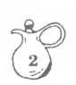
EXPRESSION OF APPRECIATION
The Members of the Board of the Valdosta State College Woman's Club, the compilers and publishers of this cook book, wish to publicly thank all those who contributed recipes, who assisted in compiling it and those who so generously gave of their time and talent to help this book become a reality.
THE CLARE PHILIPS MARTIN SCHOLARSHIP
Proceeds from the sale of this book will help fund the Scholarship established by the VSC Woman's Club honoring Clare Philips Martin. Mrs. Martin, wife of President Emeritus S. Walter Martin, was our first Honorary President and supports scholarship in higher education. This Scholarship was established in her honor and in appreciation of her past and present support.

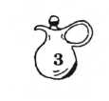
TABLE GRACE
Morning -
Father, to Thy children here,
Peace and grace and faith impart; Bless this home, bless all we love Keep us clean and pure in heart.
Noon -
We thank Thee now our Father,
For all things bright and good;
This home with all its blessings,
Our life, our health, our food.
Evening -
May we, dear Lord, Thy children be Kind, gentle, loving - more like Thee And while we now this food partake Bless us, we ask, for your sake.
Amen and Amen.
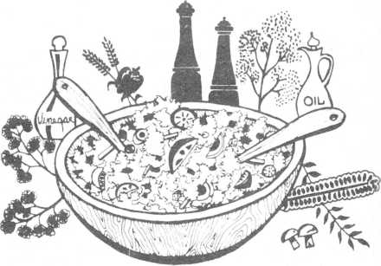
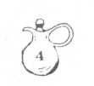
VEGETABLE
SALADS
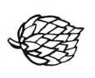
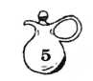
ARTICHOKE SALAD
- package Chicken Rice-a-Roni
- green onions, thinly sliced
1/2 cup green pepper, chopped
8 stuffed olives, sliced
2 jars marinated artichokes, drained (save juice)
1/3 tsp. curry powder
1/3 cup mayonnaise
Cook Chicken Rice-a-Roni as directed. Cool to room temperature. Combine juice, curry powder, mayonnaise. Add to rice mixture and mix lightly. Refrigerate overnight.
If you cannot find marinated artichokes, drain juice from plain ones and replace with the same amount of Italian dressing.
Virginia Corn
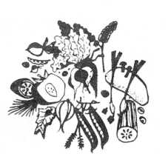
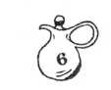
ASHEVILLE SALAD
1 can tomato soup
- pound cottage cheese
- Tbsp. gelatin 1/2 cup cold water
- cups chopped vegetables, (onions, celery, and green pepper)
1 cup mayonnaise
- can shrimp and/or crabmeat
Dissolve gelatin in 1/2 cup cold water Bring soup to boil and add cheese and gelatin. When cooled slightly, add:
- cup mayonnaise, 2 cups chopped vegetables, and 1 can shrimp and/or crabmeat .
Cam Lawry
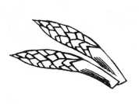
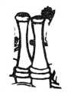
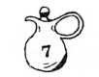
ASPARAGUS SALAD
Mix and bring to a boil:
3/4 cup sugar
- cup water
1/2 cup vinegar, white 1/2 tsp. salt Add and cool until thickened:
- envelopes Knox gelatin dissolved
in 1 cup cold water
Few drops green coloring Mix and add:
1/2 cup chopped pecans
- cup diced celery
- teaspoons onion salt 8 green olives, diced
Arrange on top:
1 - 14-1/2 oz. can green asparagus
Calla Evans
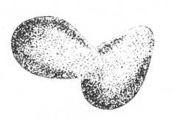
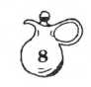
AVOCADO SALAD
Halve 3 avocados, remove seeds, and pare. Fill with mixture of:
1/2 pound cottage cheese 1 cup chopped pecans 1/2 tsp. salt 1 tsp. minced parsley
- cup shredded ripe olives
Press two halves together, wrap in waxed paper, twisting ends firmly in place.
Chill thoroughly. Unwrap and slice crosswise. Serve on bed of lettuce,and sprinkl with French dressing.
Edna Criscuolo
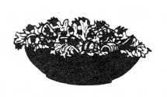

BEAN SALAD
1 can English peas 1 can French green beans 1 medium onion, chopped 1 small jar pimiento Salt and pepper to taste 1/4 -bunch celery, chopped 1/4 cup oil
- cup vinegar 1-1/2 cup sugar
- Tbsp. water
1/2 teaspoon paprika
Combine, cover, and let stand overnight.
Dollie Abrigo

BEET AND NUT SALAD
1 - 20-oz. can sliced beets, cut in strips.
1 - 20-oz. can crushed pineapple 1/4 cup white vinegar
- Tbsp. lemon juice
1 Tbsp. sugar _
- - 3-oz. package raspberry gelatin 1/2 cup chopped walnuts ”
1/4 cup water
Drain liquid from beets and pineapple. Heat with rest of liquids and sugar. Dissolve gelatin in liquid. Stir in beets, pineapple- and walnuts. Pour into mold and chill.
Frances Worstall
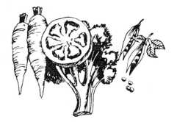
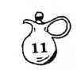
BEET SALAD MOLD
1 package lemon Jello 1 cup boiling water
1 #2 can Julienne beets, drained, (save 1iquid)
3/4 cup beet juice
- Tbsp. vinegar (or a little more)
1/2 tsp. salt
- tsp. horseradish, if average strength
- tsp. grated onion
Combine lemon Jello with boiling water; stir until dissolved. Add beet juice, vinegar, salt, and horseradish. Pour in 2 quart mold and chill until thickened. Add beets and grated onion, and chill until firm. This salad is especially good with beef or chicken. Serves 6-8.
Mrs. Harold Gulliver, Sr.
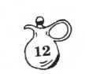
CALICO STRAW
1 can (1 pound, 4 oz.) sauerkraut 1 medium onion, chopped 1 jar (4 oz.) pimientos, chopped 1 medium bell pepper, chopped 1/2 cup celery, chopped
Dressing:
1/2 cup vinegar
1/2 cup sugar
1/4 cup salad oil
1 tsp. salt
1/2 tsp. garlic salt
1 tsp. celery seed
Wash sauerkraut in colander well. Cut in small pieces. Add remaining chopped ingredients. Pour dressing over this mixture and let stand overnight. Better after two or three days.
Sally Black

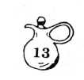
CARROT DATE SLAW
1/2 cup plain yogurt 1 Tbsp. lemon juice 1/4 tsp. salt 1/2 cup chopped dates 1/4 cup milk
1 teaspoon sugar (or honey)
- cups shredded carrots
Combine all ingredients; stir well. Chill thoroughly.
Sally Black
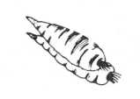
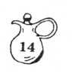
CARROT DELIGHT SALAD
1 small package orange Jello
- 1/3 cups boiling water
1/4 cup lemon juice
1/3 cup sugar
1/3 cup mayonnaise
1 small can crushed pineapple
- cup grated carrots
- package Dream Whip
1/4 cup chopped pecans
Mix gelatin with boiling water. Add lemon juice, sugar, and mayonnaise. Chill until mixture begins to congeal. Add pineapple, carrots, Dream Whip, and nuts. Chill until firm.
Betty Greenhaw
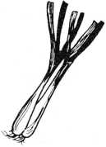
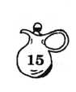
CAULIFLOWER-BROCCOLI MEDLEY
- head cauliflower
- small onions, sliced and separated into
rings
- bell pepper cut into strips
1/3 cup vegetable oil
1/4 cup sugar
1/2 tsp. salt
1/4 tsp. pepper
- bunch broccoli
1/2 cup mayonnaise
1/3 cup vinegar
- slices bacon, cooked and crumbled
Wash cauliflower and remove green leaves.
Separate into flowerets, slicing the large
ones to bite size. Wash broccoli and cut
into bite sizes pieces. Combine vegetables
in a large bowl. Mix together remaining
ingredients, except bacon, and add to
vegetables, tossing gently. Chill several
hours or overnight. Garnish with bacon.
Edna Jones
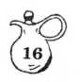
CAULIFLOWER-BROCCOLI SALAD
1 head cauliflower
- bunch broccoli
- small onions, sliced into rings 1/2 cup mayonnaise
1/3 cup vegetable oil 1/3 cup vinegar 1/4 cup sugar 1/2 tsp. salt 1/4 tsp. pepper
- slices bacon, cooked and crumbled
Wash cauliflower and broccoli and separate into flowerets of bite size. Combine vegetables in a large bowl. In another bowl stir together remaining ingredients and add to vegetables. Toss gently Chill several hours or overnight. Garnish with bacon before serving. Serves 8.
Clare Martin
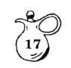
COLE SLAW a la Creme
- medium head cabbage, shredded
- carrots, scraped and grated
- cup mayonnaise 1/4 cup light cream or milk 1/3 cup onion, finely minced Salt and pepper to taste
Combine cabbage and carrots in large salad bowl and refrigerate. Mix together mayonnaise, cream or milk, and onion. Let stand in the refrigerator at least 20 minutes. Pour dressing over vegetables, toss lightly, and season to taste. Refrigerate immediately. The cooler the salad, the better it tastes.
Ann Trice-Daughdrill
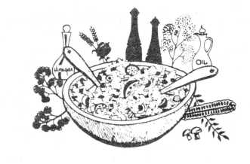
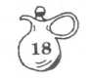
CONCEALED SALAD (Hidden Delights)
- large head lettuce, chopped
- large cans LeSeur peas, drained 6 to 8 stalks chopped celery
6 green onions mixed with 1 can water chestnuts - chop onions
- Tbsp. sugar 1 pint mayonnaise
- medium can parmesan cheese
Place in large casserole, layering ingredients as listed. Cover tightly with plastic wrap. Chili at least 6 hours before serving.
Naomi Hale
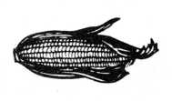

CORN RELISH SALAD
- - 12-oz. can whole kernel corn, drained 1/2 cup coarsely chopped green pepper 1/2 cup diced celery 1/4 cup chopped onion
- - 4-oz. jar chopped pimientos, drained 1/3 cup salad oil
- Tbps, vinegar
- tsp. salt
3/4 tsp. dry mustard 1/4 tsp. pepper
Combine all. Cover and chill at least overnight. Keeps well in tightly covered jar. Great with cold sliced ham. Serves 4 to 6.
Lucile Griffin

CREAMY POTATO SALAD
6 large Irish potatoes
- hard-cooked eggs
1/2 tsp. salt —
1 Tbsp. flour
1 Tbsp. butter _
- egg, beaten
1/4 cup mayonnaise 6 green onions 1/4 cup sugar
- Tbsp. vinegar
- Tbsp. water
1/2 tsp powdered mustard —
- cup whipping cream
Cook potatoes in jackets until tender (20-3(1. minutes). Meanwhile, make dressing: Combine sugar, salt, vinegar, flour, water, mustardj- and beaten egg. Cook over low heat until creamy and thick, stirring frequently. Add “ butter, whipping cream (not whipped) and mayonnaise. Blend well and cool. Remove skins from potatoes. Slice potatoes and eggs into “ large bowl. Cut onions into small pieces, including tops. Add to potatoes. Carefully fold in dressing. Allow salad to stand in _ refrigerator at least 5 hours to blend flavc 'S Garnish as desired. Serves 6 to 8.
Dollie Abrigo
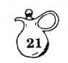
CREOLE SALAD
- package elbow macaroni
- medium size tomatoes
- onion
- bell pepper
- small jar stuffed olives
- small jar pimiento, if desired for color French dressing, garlic flavored Mayonnaise, salt, and pepper
- hard boiled eggs
Cook macaroni until tender; wash thoroughly in cold water. Marinate in French dressing with seasonings. Add other ingredients Do not peel tomatoes, but cut in large cube Add enough mayonnaise to bind ingredients together.
This salad is better if made in the morning and used at night, so that all flavors may blend well.
Virginia Corn
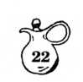
CUCUMBER MOUSSE
6 medium size cucumbers
- envelopes unflavored gelatin
- tsp. salt
- Tbsp. lemon juice
1/4 tsp. Worcestershire sauce —
1/2 cup heavy cream, whipped
- Tbsp. pure vegetable oil _
- Tbsp. vinegar 1/2 tsp. salt 1/8 tsp. pepper
Pare, seed, and dice 4 cucumbers. Whirl in blender until puree is smooth. Strain puree through fine sieve into saucepan. Reserve pulp. Stir gelatin into juice in saucepan. Dissolve over hot water, stirring constantly. Re move from heat. Add cucumber pulp, two tsp. salt, lemon juice, and Worcestershire; mix _ well. Chill until thickened. Fold in whipped cream. Pour into 4-cup mold. Chill until set.
Score rind of remaining 2 cucumbers; slice. — Combine remaining ingredients. Pour over the cucumbers. Toss gently. Unmold mousse onto serving plate. Surround with sliced cucumbers^ Makes 6 to 8 servings.
Dollie Abrigo
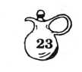
CUCUMBER RING SUPREME
- oz. package lemon Jello 1 cup boiling water 3/4 cup water 1/4 cup lemon juice 1 cucumber
Dissolve Jello in hot water. Add water and lemon juice. Pour into ring mold. Chill until partially set. Arrange overlapping slices of cucumber, pressing into Jello. Chill until firm. Second Layer:
- Tbsp. Knox gelatin 8 oz. cream cheese
- Tbsp. sugar 3/4 tsp. salt 3/4 cup water
- Tbsp. lemon juice
- cucumbers
1 cup salad dressing
- Tbsp. grated onion 1/4 cup parsley
Mix Knox gelatin, sugar, and salt in saucepan. Add 3/4 cup water. Stir over low heat until dissolved. Stir in 2 Tbsp. lemon juice. Beat hot gelatin mix into softened cream cheese until smooth. Pare cucumbers and halve lengthwise.Remove seeds. Grate. Add cucumber, mayonnaise, parsley, and onion to cream cheese mixture. Pour over Jello. Chill until firm.
Cam Lawry
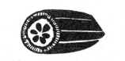
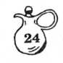
CUCUMBER SALAD
1 package lime Jello 1 cup cottage cheese 1 cup mayonnaise 1 pinch salt
- tablespoons lemon juice
- large cucumbers (a lot), chopped
- small onion, grated
Dissolve Jello in 1/2 cup boiling water. Add all other ingredients and chill.
Dean Brooks
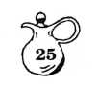
DILLED CARROTS AND GREEN BEANS
1 can (.1 pound) sliced carrots, drained
- can (1 pound) cut green beans, drained 1/4 cup finely chopped onion (1 small)
- Tbsp. pure vegetable oil
- Tbsp. lemon juice
1 tsp. chopped fresh dill weed 1 clove garlic, halved 1/2 tsp. salt
1/4 tsp. leaf basil, crumbled 1/4 tsp. black pepper
Combine all ingredients in mixing bowl. Cover; chill thoroughly 3 to 4 hours or overnight, if possible. To serve, discard garlic clove, arrange vegetables on serving dish. Makes 6 servings.
Dollie Abrigo
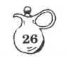
FOUR BEAN SALAD
1 can cut green beans 1 can yellow wax beans 1 can red kidney beans 1 can chick peas (Garbanzos)
1 green pepper, sliced in rings
1 purple onion, sliced in rings
Marinade :
1/2 cup sugar 1/2 cup white vinegar 1/w cut vegetable oil 1 tsp. salt
1/2 teaspoon dry mustard
1/2 tsp. crumbled tarragon leaves
1/2 tsp. crumbled basil leaves
Drain cans of beans, Mix marinade and dry ingredients first. Pour over other ingredients in large bowl. Store in refrigerator overnight or longer to develop full flavor.
Bonnie Rainey
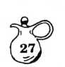
FROZEN COLESLAW
1 large head cabbage, shredded 1 green pepper, chopped 1 large carrot, shredded 1 tsp. salt 1 cup vinegar 1 cup sugar 1/4 cup water 1 tsp. dry mustard
- tsp. celery seeds
Combine vegetables and sprinkle with the salt let stand one hour. Drain. Combine remaining ingredients in a saucepan, bring to a boil, and boil one minute. Cool. Pour over cabbag mixture and stir well. Freeze in plastic freezer containers or bags. To serve, thaw in refrigerator. Serves 8 to 10.
Elaine Bullock
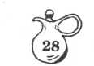
FROZEN COLE SLAW
- qts. (12 cups) chopped cabbage 1 large green bell pepper, chopped
- large red bell pepper, chopped
- medium onions
Dressing:
1 pint apple cider vinegar
- 1/2 cups sugar
1-1/2 tsp. celery seed
1 tsp. mustard seed
1/2 tsp. tumeric
1 tsp. salt
Bring dressing ingredients to boil. Pour over vegetable mixture and stir thoroughly. Let stand 12 hours or overnight. Pack in freezer containers and freeze. Makes 6 1/2 pints.
Thera Hambrick
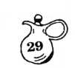
GERMAN SLAW
1 medium cabbage, shredded
- medium onion, thinly sliced 1/2 cup sugar 1/2 cup vinegar 1/2 cup salad oil
- teaspoon salt
- teaspoon celery seed 1-1/4 tsp. prepared mustard
- tsp. sugar
Arrange layers of cabbage and onion in bowl. Top with 1/2 cup sugar. Boil together vinegar, oil, salt, celery seed, mustard, and 1 teaspoon sugar. Pour hot mixture over vegetables. Cool at least four hours. Better made day before. Will keep in refrigerator 2 weeks.
Hazel Durrenberger

GREEN AND GOLD SLAW
- cups shredded cabbage
- cup shredded carrots 1/2 cup sour cream
- Tbsp. vinegar
- Tbsp. sugar 1/4 tsp. salt
Combine cabbage and carrots in salad bowl. Blend sour cream, sugar, vinegar and salt.... gently mixing with vegetables Chill and serve
Debbie Yarbrough
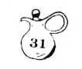
HEARTS OF PALM SALAD
- avocados, peeled and chopped coarsely Lemon juice
- - 14-oz. can hearts of palm, drained
and sliced
- 14 oz. can artichoke hearts, drained, chopped coarsely
- large tomatoes, coarsely chopped
- cucumbers, thinly sliced
2/3 cup vegetable oil 1/4 cup vinegar
- Tbsp. water
- package Italian Salad Dressing powdered mix
Sprinkle avocados with lemon juice, tossing to coat. Combine avocados with next
- ingredients and toss gently. Refrigerate until serving time. Combine last 4 ingredients, mix well and chill. Toss salad with dressing at serving time.
Serve on leafy lettuce.
Elaine Bullock
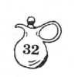
INSTANT MASHED POTATO SALAD
Combine in preheated mixing bowl:
- 1/2 tsp. salt 1/4 tsp. papper
- cup cold milk
- 1/2 cups boiling water
Add:
- cups instant mashed potato flakes and stir gently. Set aside.
Comb ine:
- hard-cooked eggs
- green onions, chopped 1/2 cup chopped celery 1/2 cup chopped pickle 1/2 cup mayonnaise 1 Tbsp. prepared mustard Mix lightly with mashed potatoes. Garnish and serve hot or chilled. Serves 8.
Elaine Bullock
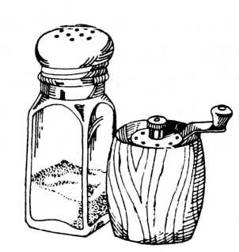
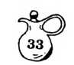
KRAUT SALAD
1 large can Kraut (shredded, draine 1 medium onion, chopped 1 medium bell pepper, chopped 1 small can pimiento 1/2 cup vinegar 1/2 cup sugar
1/4 cup oil (Wesson or Mazola)
1/2 tsp. each of salt, garlic salt, celery salt, and black pepper
Mix, chill, serve.
Calla Evans
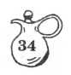
LEMON MUSHROOMS
- pound medium mushrooms Juice of 1 lemon (2 tsp.)
1/2 lemon, cut in thin slices 1/4 cup salad oil
2 Tb | sp. | water
1-1/ | 2 tsp. | soy sauce
1/4 | tsp | . salt
1/4 | tsp | . sugar
1/4 | tsp | . rubbed sage
Rinse and trim mushrooms; slice thinly with egg slicer. Cook in hot oil in
- qt. saucepan, stirring frequently until mushrooms are well coated with oil. Stir in other ingredients, heat to boiling, then reduce heat. Stir and cook until mushrooms are tender. Serve, chilled, on lettuce wedges.
Lucile Griffin
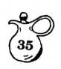
LETTUCE LAYER SALAD
- head lettuce, shredded
- small onions, thinly sliced
- or 4 carrots, grated
1 package frozen peas, cooked and cooled
- ro 4 pieces of celery, chopped
- bunch radishes, thinly sliced
Arrange a layer of one-half the lettuce in a large, flat bowl. Then a layer of 1/2 the onions, celery, carrots, peas, and radishes. Put drops (about 1 tsp.) of mayonnaise on top of peas, and sprinkle with 1 Tbsp. of sugar. Arrange the other half of the vegetables in the same way.
Top with mayonnaise and sugar. Sprinkle with bacon crumbs.
Karrie Yeatman
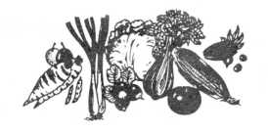
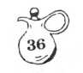
MACARONI SALAD
1-1/2 cup elbow macaroni
- cup chopped celery
- medium carrots, shredded
- fresh green onions, diced 1 bell pepper, cut in rings 1/4 cup French's mustard 1/8 tsp. black pepper
1 cup mayonnaise 1/4 cup milk
- tsp. sugar
Make a sauce of last five ingredients, shake well, and pour over macaroni. Mix thoroughly. Refrigerate for one or two hours. Even better after a couple of days
Debbie Yarbrough
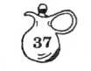
MAKE-AHEAD ORIENTAL SALAD
1 - 17 oz. can tiny peas, drained
- - 16 oz. can bean sprouts, drained
1-12 oz. can whole kernal corn, drained
- - 5 oz. cans water chestnuts, drained
and sliced
1-4 oz. jar pimientos, drained and sliced 1 large green pepper, thinly sliced 1 large onion, thinly sliced 1 cup celery, sliced
Combine vegetables in large bowl, stir.
Mix: 1 cup salad oil, 1 cup sugar,
and 1/2 cup vinegar
Pour over vegetables, stir and refrigerate covered 24-36 hours or longer. Drain well before serving. Serves 12
Pam Elkins

MARINATED VEGETABLE SALAD
1-16 oz. can french style green beans 1-16 oz. can small peas 1-16 oz. can Chinese vegetables 1 6 oz. can water chestnuts 1 small jar pimento chopped Drain above, well.
1-1/2 cup sliced celery
- medium onions chopped
Combine above well drained ingredients and pour the folloiwng sauce over and marinate for 24 hours:
1 cup sugar 3/4 cup vinegar 1/2 cup oil 1 tsp. salt pepper to taste Serve on a bed of lettuce or lettuce lined bowl for a buffet. Serves 12.
Joan Bailey
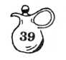
MARINATED VEGETABLE SALAD
1 can French style green beans
1 can LeSeur peas
1 can fancy Chinese vegetables
1 - 6-oz. can water chestnuts
- 1/2 cups thinly sliced celery
Pepper to taste
- medium onions thinly sliced
1/2 cup sugar
3/4 cup vinegar
1 tsp. salt
1/2 cup salad oil
Drain vegetables. Slice water chestnuts thinly. Mix all ingredients in large bowl and cover. Refrigerate several hours or overnight. Will keep several weeks in refrigerator. Makes 3 pints.
Hazel Durrenberger
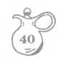
MARINATED VEGETABLE SALAD I
1 small can pimiento including juice 1 bell pepper, chopped 1 medium onion, chopped coarsely 3 stems of celery, sliced 1 can English peas 1 can small Blue Lake green beans
Dressing:
1 cup sugar
1/2 cup vinegar
1/2 cup oil
1 tsp. salt
Combine dressing ingredients, heating enough to melt all. Pour over ingredient well mixed, and let set in the refrigerator at least overnight. Flavor increases with time.
Thera Hambrick
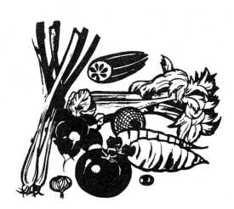
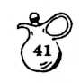
MARINATED VEGETABLE SALAD II
- quarts vegetables cut into bite-size pieces - cauliflower, celery, onions, pepper, cabbage, carrots or whatever you have.
Marinade:
- cups apple cider vinegar
- 1/2 cups water
- Tbsp. salt, slightly rounded 1/2 cup sugar
Combine marinade, heating enough to melt.
Pour over vegetables and allow to stand
at least overnight. Keeps well.
Thera Hambrick
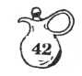
MARINATED VEGETABLE TOSS
1 - 1-1/2 lb. bunch broccoli
- medium head cauliflower
- carrots, scraped and sliced
- large mushrooms, sliced
1 - 4-1/2 oz. jar pimiento-stuffed olives, — drained
- - 3.2 oz. can ripe olives, drained
- - 8-oz. bottle Italian salad dressing
Cut broccoli and cauliflower into bite size ™ pieces. Cook with carrots in boiling water ^.or
- minutes. Plunge vegetables into ice water _ immediately. When cool, drain well. Combine them with remaining ingredients and chill, covered at least 3 hours. 12 servings.
This is a Southern Living recipe that is perfect for outings or family reunions because it contains nothing that needs constant re- ” frigeration.
Elaine Bullock
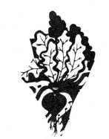
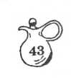
MOLDED BEET SALAD
- #2 can chopped beets (save juice)
- Tbsp. white vinegar
1-6 oz. package lemon gelatin 1/2 cup finely chopped celery
- small onion, chopped fine 1/4 cup chopped green pepper 1/2 cup grated carrots Dash of salt
Measure beet liquid; add vinegar and water as necessary to make 1-3/4 cups. Bring to a boil and dissolve gelatin in it. Cool to partly thicken and add vegetables and salt. Pour into mold. Chill until firm. Unmold. Serve on lettuce with dressing made with equal parts mayonnaise and sour cream; add horseradish if desired.
Virginia Culpepper
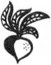
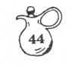
MOLDED BEET SALAD
- packages lemon Jello
- cup boiling water
- cups liquid (beet juice and water)
- #2 can shoe-string beets
1-1/2 Tbsp. vinegar
1/2 cup chopped celery
- cup diced green pepper
1/2 cup onion, minced
- teaspoons salt
Mix Jello with hot water to dissolve. Add beet juice and water and chill until slightly thickened. Combine the other ingredients and add to thickened mixture. Pour into mold and chill to set.
This is a gorgeous red color and is very pretty for holiday use.
Calla Evans

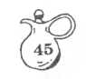
PEA SALAD
3 cans LeSeur peas
1-1/2 cups celery, chopped
1/2 cup onion, chopped
1-1/2 cups cheese, grated
Salt and pepper to taste
Tabasco, 2 drops
Shake or two or Worcestershire
Mix all ingredients with mayonnaise and chill.
Dean Brooks
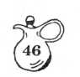
RED AND WHITE BEAN SALAD
- cans (15 oz. ea.) red kidney beans, drained, or 4 cups cooked kidney beans, drained
- cans (1 pound ea.) white kidney beans,
drained, or 4 cups cooked white beans, drained
- small onions, thinly sliced 1/2 cup diced celery
1/3 cup | pure vegetable oil
1/2 cup | cider vinegar
1/2 tsp. | dry mustard
1/2 tsp. | garlic salt
1/4 tsp. | crushed black peppercorns
Combine beans, onions, and celery in large bowl. Combine remaining ingredients in small bowl; blend thoroughly. Pour dressing over bean salad; toss lightly. Cover; chill thoroughly. Makes 8 servings.
Dollie Abrigo
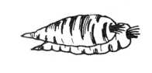
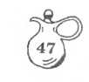
RICE SALAD
1 cup raw rice, cooked and drained Add:
1/2 cup salad dressing 1 Tbs. mustard 1 tsp.salt
dash Worcestershire Sauce dash Tobasco (or to taste)
1 cup frozen green peas, slightly cooked
1 cup sliced carrots, slightly cooked
1/2 cup fresh sliced celery 1/2 cup sweet pickle relish
Combine and serve on lettuce.
Joan Bailey
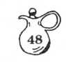
SAUERKRAUT RELISH SALAD
1 can #303 sauerkraut, well drained (run water over it once)
1 cup celery, cut
1 green pepper, chopped
1 small jar pimiento, chopped and drained
- to 6 green onions and tops, chopped
1/2 cup Wesson oil
1/4 cup vinegar
1/2 to 3/4 cup sugar
Combine Wesson oil, vinegar, and sugar in small sauce pan. Bring to boil, then cool. Pour cooled brine over vegetables and mix well. Put in jar with tight fitting lid. Refrigerate overnight. Will keep a week.
Do not add salt as kraut is salty.
Dollie Abrigo
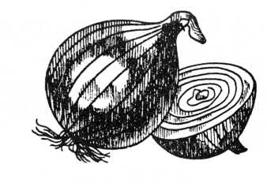
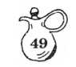
SAUERKRAUT SALAD
I - #2 can sauerkraut washed,rinsed and drained
1 medium onion, minced
1 bell pepper, chopped fine
1 can Chinese bean sprouts, drained
Mix well and add marinade of:
1-1/4 cup salad oil 1-1/4 cup sugar 1-1/3 vinegar
Add 1 small jar pimento for color.
Keeps well.
Joan Bailey
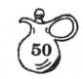
SPAGHETTI-BEAN SPROUTS SALAD
- ozs. uncooked vermicelli
3/4 cup mayonnaise or salad dressing
1 Tbsp. soy sauce
1 tsp. salt
1 tsp. prepared mustard —
1/4 tsp. garlic powder
Dash white pepper _
1 cup bean sprouts, drained 1 cup sliced mushrooms, drained 1 medium stalk celery, sliced 1/3 medium green pepper, chopped 1 small onion, chopped
- cup frozen green peas, rinsed under cold
water to separate _
1/2 cup cashews or peanuts, coarsely choppe( (optional)
Break vermicelli into 2-inch pieces; cook a: directed on package. Rinse in cold water;
drain. Mix next 6 ingredients. Stir in vege^
tables. Refrigerate at least 3 hours. Stir i nuts. Serve in bowl lined with spinach leavt.. This is a dish with a different, slightly Oriental flavor. —
Sally Black
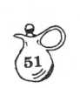
SPINACH SALAD
- 4 cups spinach, chopped coarsely
- hard cooked eggs, finely chopped
1 tomato, unpeeled, finely chopped
- slices bacon, fried crisp
1 cup fresh mushrooms, uncooked, chopped fine
Crumble bacon and combine all ingredients
and mix with the following dressing:
1 medium onion, finely chopped
1/4 cup white vinegar
4-6 Tbsp. granulated sugar
Saute onion in bacon fat. Drain. Add vinegar and sugar. Pour over salad while still warm; toss lightly. Serve immediately. Dressing should not be refrigerated because it hardens. As this dressing is a high saturated fat dressing, it is not recommended for heart patients. Use instead a light Italian dressing or imitation blue cheese. It will still be good but not as delicious as the high saturated fat dressing.
Phyllis Daniel
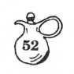
SPINACH SALAD
- package of fresh spinach
- hard boiled eggs, chopped
- slices of crisp bacon crumbled
- green onions, chopped
- -2-1/2 oz. package slivered almonds — Salt and pepper to taste
Wash and remove the stems of 1 package of fresh spinach. Place in bowl, covered with a damp paper towel, and chill. Toss the remaining ingredients with the spinach at serving time. Add croutons, if desired. Serve with dressing.
Dressing:
1/2 cup oil __
1/2 cup red wine vinegar or Tarrago vinegar
1/2 cup sugar
- Tbsp. lemon juice
Karrie Yeatman
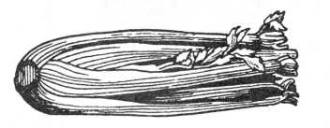
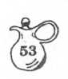
STUFFED CELERY
1 - 8-oz. package cream cheese 1 package ranch style powdered salad dressing mix
Celery
Combine first two ingredients until creamy. Wash celery and cut into 3-inch pieces. Stuff and serve. This cream cheese mixture is excellent on crackers, as it tastes like an expensive herbed soft cheese.
Elaine Bullock
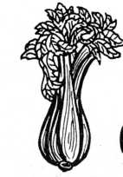

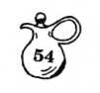
STUFFED TOMATO SALAD
6 ripe tomatoes
3/4 cup diced cumber
1/4 cup mayonnaise
1/2 cup diced celery
- tablespoons chopped nuts
Pepper to taste
6 lettuce cups
Combine cucumber, mayonnaise, celery, nuts, and pepper. Stuff tomatoes and serve in lettuce cups.
Hazel Durrenberger
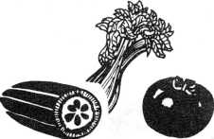
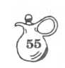
SUMMER SALAD (Vegetable)
1 bell pepper, chopped in small squares
- stalks celery, sliced diagonally in 1/4" pieces
1 jar whole pimientos, cut in small squares
- medium onion, cut in small squares
- medium tomatos, seeded, and cut in
small squares - not peeled
- medium cucumbers, seeded and cubed
Mix above with any Itlian dressing and
refrigerate at least 2 hours before
serving. Serves 4.
Edi Shepherd
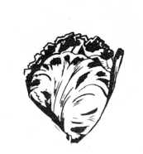
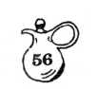
SUMMER SALAD II
- head of bibb or Boston lettuce, torn
1/2 bunch of water cress, cut with scissors
- package of sliced almonds
Toss and serve with following dressing on the side. Any left over may be held in refrigerator, covered,for 3 days.
(Be sure salad greens are clean and dry before use.)
Dressing: Sour Honey Dressing
(See dressing section)
Edi Shepherd
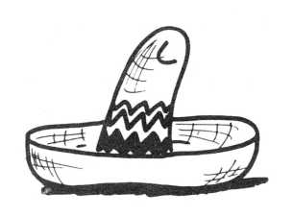
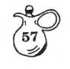
TACO SALAD
1-1/2 lbs. hamburger (ground chuck or round)
- heads lettuce 1 bunch scallions
- can black olives, pitted
- - 8-oz. pkgs. shredded cheddar cheese 1 pkg. cherry tomatoes (cut in half)
1 lg. bag Dorrito Chips 1 lg. jar Catalina dressing
- can kidney beans.
Brown, drain and cool hamburger. In large bowl, cut up or shred lettuce.Add: kidney beans, washed and drained, scallions or green onions, black olives, drained and cut in half, Cherry tomatoes, cut in half, the cheddar cheese, Dorrito chips, large jar Catalina dressing. Toss well and refrigerate overnight. Just before serving, garnish with fresh crumbled Dorrito chips. Serve with taco sauce.
Pam Elkins
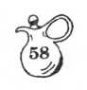
TOMATO ASPIC
1 quart tomato juice 1 bunch celery, chopped
- envelopes gelatin, (unflavored) —
1 small jar olives, (sliced), green 1 teaspoon Worcestershire sauce _
- tablespoon onion, (grated)
- tablespoon sugar
- teaspoons salt
1/8 teaspoon pepper (black)
1/2 cup cold water
Heat tomato juice. Dissolve gelatin in cold
water. Gradually add to the tomato juice. Add vegetables and seasonings. Pour into mold that has been rinsed in cold water.
Beth McRae
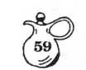
TOMATO AND ZUCCHINI SALAD
1-1/2 pounds zucchini squash 1-1/2 pounds tomatoes 6 Tbsp. olive oil
- Tbsp. vinegar Pinch of salt
- Tbsp. herbs: parsley, thyme
Slice zucchini; place in saucepan with a little boiling water, return to boil, and cook just a minute or two, or until crisp- tender. Drain and plunge into cold water to chill quickly and stop cooking.
On a large platter or individual plates, alternate slices of zucchini and sliced, peeled tomatoes. Make a vinaigrette dressing by combining olive oil, vinegar, salt, and fresh herbs. Beat with a fork to mix. Pour over the sliced vegetables. You may garnish with anchovy strips or hard-boiled eggs. Makes 4 servings.
Edna Criscuolo
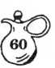
THREE BEAN SALAD
1 can green beans, drained 1 can wax beans, drained 1 can kidney beans, wash and drain Onion rings and minced onion Green pepper and minced pepper
Sauce:
1/2 cup vinegar 1/2 cup oil 3/4 cup sugar 1 tsp. salt 1/8 tsp. pepper
Beat well with egg beater. Pour over beans, etc. Mix and let stand for 24 hours or more.
Nancy Wilkerson
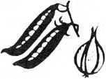
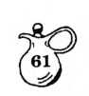
THREE P'S SALAD
1 small jar pimiento
1/2 cup peanuts
1 can LeSeur English peas, drained
1/4 cup mayonnaise
- tsp. minced onion
Salt to taste
Chop pimiento and nuts. Mix with
drained peas. Blend in mayonnaise and
minced onion. Chill.
Edna Jones
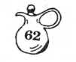
24-HOUR SLAW: Yield: 12 servings
- large head cabbage, shredded
- onions, chopped Salt and pepper 3/4 cup sugar
1 tsp. celery seed 1 tsp. prepared mustard 1-1/2 cups vinegar 1 cup salad oil
Sprinkle cabbage and onion with salt and pepper. Bring sugar, celery seed, mustard and vinegar to a boil and boil for 1 minute. Add salad oil. Put cabbage in a large bowl. Pour liquid mixture over cabbage-onion mixture. Cover bowl and refrigerate for at least 24 hours before using. Slaw will stay crisp for nearly a week.
Sally Black
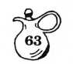
VEGETABLE SALAD MOLD
1 - 3-oz. package lemon Jello
1/2 cup boiling water
1 envelope gelatin
1/2 cup juice from drained peas
1/4 cup white vinegar
1 cup small green peas (canned)
1-1/4 cups chopped celery 1 Tbsp. chopped green pepper 1 Tbsp. chopped onion 1 tsp. salt 1 tsp. sugar 1 tsp. prepared mustard
- cup mayonnaise
Dissolve Jello in boiling water. Add gelatin softened in juice from peas.
Add vinegar. When cool, add remaining
ingredients. Pour into 1 quart mold and
refrigerate.
Mary Beth Watkins

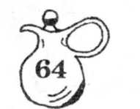
SEAFOOD
SALADS
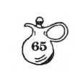
AVOCADO CRAB SALAD
4 ripe avocados
- large cans crab meat Lettuce
1/2 cup mayonnaise, or to taste
Slice unpeeled avocados in half, lengthwise, cutting through to the seed. Place both hands over avocado and twist in opposite directions to release from seed. Remove seed. Toss flaked crab meat with mayonnaise and seafood seasonings of your choice, and fill avocado halves. Serve on lettuce or arrange on platter that is decorated with lettuce leaves, miniature tomatoes and black olives.
Serves 8.
Margaret Compton
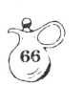
HEARTY TUNA SALAD
1 - 6-1/2 or 7 oz. can tuna, drained and flaked
1 - 10-oz. package frozen Italian green beans
1 cup thinly sliced celery 1/2 cup mayonnaise 1 Tbsp. lemon juice 1-1/2 tsp. soy sauce Dash garlic powder
- cup chow mein noodles Lettuce cups
Cook Italian green beans according to package directions; drain and cool. Combine green beans, flaked tuna, sliced celery, mayonnaise, lemon juice, soy sauce, and garlic powder; chill. Before servings, add chow mein noodles to tuna mixture; toss together lightly. Serve in lettuce cups. Makes 4 servings.
Bonnie Rainey
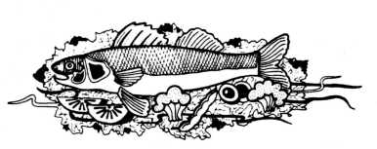

HEARTY SALMON/MACARONI SALAD
3/4 cup uncooked elbow macaroni
- - 7-3/4-oz. can salmon, drained and flaked 3/4 cup chopped celery
- Tbsp. chopped onion
3/4 cup mayonnaise or salad dressing
1/4 tsp. liquid smoke
Parsley
Cook macaroni following package directions. Drain. Combine macaroni, salmon, celery and onion. Blend liquid smoke, mayonnaise (or salad dressing) and 1/4 tsp. salt. Toss lightly with fish mixture. Chill. Garnish with sprigs of parsley. Serves 3 or 4.
Edi Shepherd
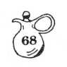
PINK SHRIMP MOUSSE
- envelope unflavored gelatin 1/2 cup cold water
- - 8-oz. package cream cheese —
- - 8-oz. bottle Thousand Island Dressing 1/2 tsp. horseradish —
- Tbsp. lemon juice 1/2 tsp. salt
- cups cooked shrimp, finely chopped 1/2 cup sliced celery
1/4 cup chopped green pepper
Soften gelatin in cold water, heating slowly” until dissolved. Soften cream cheese with spatula and gradually stir in bottled salad _ dressing; mix well until completely blended. Add gelatin mixture, horseradish, lemon juice, and salt. Cut shrimp into small pieces, reserving a few whole shrimp for garnish. Fold in chopped shrimp, celery, and green pepper. Pour into 1 quart mold; chill until firm. At~ serving time, turn mold out on platter; gar-“ nish with whole shrimp. Surround base of mold with toasted thins. —
Do Hie Abrigo
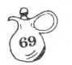
SHRIMP BOATS
1/4 cup vinegar
- Tbsp. catsup
- Tbsp. horseradish mustard 1/2 tsp. tarragon
1-1/2 tsp. paprika
1/2 tsp. salt
1/4 tsp cayenne pepper
1/2 cup salad oil
1/4 cup finely chopped celery
1/4 cup finely chopped green onion
- pounds cleaned, cooked shrimp
- ripe avocados
Combine first seven ingredients adding oil slowly and beating constantly. Add celery and onions. Pour over shrimp and refrigerate four hours or overnight. Halve and peel each avocado lengthwise, cutting thru to the seed. Place both hands over avocado and twist in opposite directions to release seed. Remove seed. Arrange shrimp on each half. Serve chilled on lettuce leaves with chilled asparagus, carrot curls, sliced boiled eggs and extra marinade.
Margaret Compton
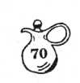
SHRIMP § MELON BALL SALAD
- pounds cooked cleaned shrimp
- Tbs. lemon juice
- tsp. grated onion 1-1/2 cup chopped celery 1-1/2 tsp. salt 1 cup mayonnaise
- 1/2 Tbs. curry powder 6 Tbs. sour cream
1 lg. honeydew melon, cut into balls
- lg. canteloupe, cut into balls Bibb lettuce or Romaine lettuce Shredded coconut (optional)
Mix curry powder into sour cream. Combine shrimp, lemon juice, onion, celery, salt and mayonnaise. Add sour cream mixture. Mix well and chill several hours Add melon balls shortly before serving. Serve on lettuce and top with coconut. Serves 6 to 8.
Julia Connell
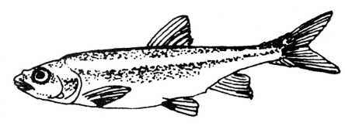

TUNA MOLD
1 lemon Jello 1 cup hot water 3/4 cup canned milk 1/4 cup lemon juice 1/3 cup mayonnaise salt
1 tsp. Worcestershire Sauce 10 drops Tabasco 1/2 cup diced celery 1 Tbs grated onion
- - 7 oz. can tuna
- Tbs. pimiento
Dissolve Jello and cool. Add remaining ingredients and chill. Unmold on serving plate/tray, surround with parsley and ring with crackers. Serves 6 to 8.
Joan Bailey
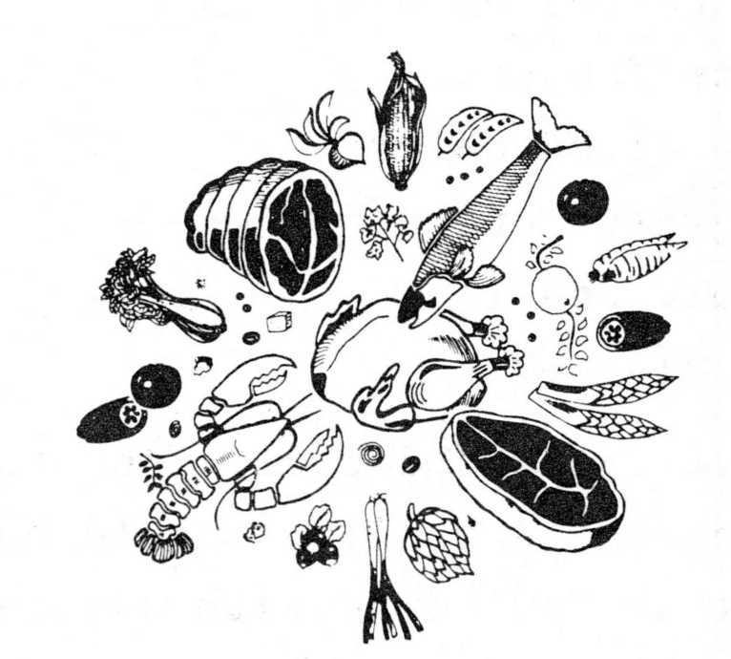
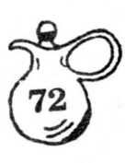
MEAT SALADS
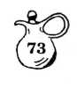
CHICKEN FRUIT SALAD
- - 16 oz. can pineapple chunks
- apple, cored and sliced
- cup seedless grapes
- cups diced, cooked chicken Whipped Cream Dressing Lettuce
1/3 cup toasted almonds
Drain pineapple chunks. Keep juice. Dip apple slices in pineapple juice. Combine fruit and chicken, and chill. Add Whipped Cream Dressing. Toss lightly. Serve on lettuce and top with almonds.
WHIPPED CREAM FRUIT DRESSING
- Tbsp. margarine or butter
- Tbsp. all purpose flour 1/4 cup sugar
- teaspoon salt
1/3 cup lemon juice 1/3 cup pineapple juice
- egg yolks, slightly beaten 1/2 cup whipped cream
Melt butter over low heat. Blend in flour. Add sugar, salt, lemon juice and pineapple juice. Cook until thickened, stirring constantly. Put some of hot mexture into egg yolks and stir this into remaining hot mix. Cook 2 minutes. Chill, Fold in whipped cream.
Frances Worstall
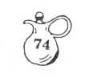
CHICKEN MOUSSE SALAD
2 envelopes unflavored gelatin 2 cups cold chicken broth, divided 1-1/4 tsp. salt
1-1/'4 teaspoon dried leaf tarragon 2 Tbsp. lemon juice 1/4 tsp. hot pepper sauce 2 tsp. grated lemon peel
- 5 oz. can water chestnuts, drained,
and chopped
- 1/2 cups cnicken, cooked, chopped 1/2 cup chopped pecans
1 cup whipping cream, whipped
Sprinkle gelatin over 1 cup chicken broth in sauce pan. Stir over low heat until gelatin dissolves (4 or 5 mm.). Remove from heat; stir in remaining 1 cup chicken broth, salt, tarragon, lemon juice, hot pepper sauce and lemon peel. Chill, stirring occasionally until consistency of unbeaten egg white. Stir in water chestnuts, chicken, and pecans. Fold in whipped cream. Turn into six-cup mold. Chill until firm. Unmold, Garnish with salad greens. Serves 6.
Margaret Compton
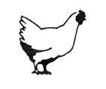
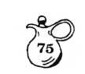
CHICKEN SALAD
- large broiler/fryer
boiled, boned and cut into small pieces
- large pork chop
boiled, boned and cut into small pieces Take skin of cooked chicken and place in blender with 1 Tbs. broth from chicken and puree To above ingredients add:
Sweet pickle to taste
Celery
Salt
- boiled eggs chopped Salad dressing
Combine and serve on lettuce.
Joan Bailey
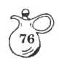
CHICKEN SALAD
- cups cooked chicken, cut in chunks
- Tbsp. salad oil
- Tbsp. orange juice
- Tbsp. vinegar 1 tsp. salt
- cups cooked rice
1-1/2 cups small, green grapes
1-1/2 cups chopped celery
1 - 13-1/2 oz. can pineapple tidbits, drained.
1 - 11 oz. can mandarin oranges, drained
- cup slivered, toasted almonds
1-1/2 cup mayonnaise
Combine chicken, salad oil, orange juice, vinegar, and salt. At this point salad may be refrigerated and completed next day Gently toss together remaining ingredients to complete. Serves 12. p
Margaret Compton

CHICKEN SALAD BALLS
1 cup chopped cooked chicken
- Tbsp. chopped onion
- Tbsp. pimiento
1/2 cup salad dressing
- cup chopped pecans Dash of hot sauce
Combine all ingredients. Mix well. Chill several hours. Shape into one inch balls. Makes 2 dozen.
Frances Worstall
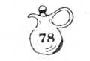
CHUNKY CHICKEN SALAD
- cups cold cooked diced chicken
1/2 cup nuts
1/2 cup diced pineapple
- cup diced celery
2/3 cup diced apples
2/3 cup raisins
Mayonnaise and lettuce
Steam raisins until plump. Combine with chicken, celery, nuts, apples, and pineapple. Moisten with mayonnaise. Mix lightly.
Serve in crisp lettuce cups.
For a special touch, sprinkle with sliced toasted almonds. Serves 6.
Julia Connell


CLUBHOUSE SALAD
- cups cooked elbow macaroni
- hard cooked eggs, finely chopped
1 cup finely diced celery
6-8 pimiento-stuffed Olives,• chopped
1 sweet or dill pickle, chopped
1 Tbsp. grated onion
Salt, pepper, paprika to taste
Mayonnaise or salad dressing
Combine all ingredietns, adding just
enough dressing to moisten. Serve on
crisp lettuce and garnish with quartered
tomatoes. Serves 5 to 6.
Hazel Durrenberger
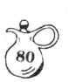
COLD CHICKEN SALAD PIE
1 - 8-inch pie shell, baked
1/4 cup shredded sharp cheddar
1-1/2 cups cubed cooked chicken
1 - 8-3/4 ounce can pineapple tidbits drained (2/3 cup)
1/2 cup celery, sliced
1/2 cup walnuts, chopped
3/4 cup dairy sour cream
1/2 cup mayonnaise
Bake pie shell. Cool.
Combine chicken, pineapple, celery, and nuts. Blend sour cream and mayonnaise.
Add 2/3 cup south cream mixture to chicken mixture. Mix well. Spoon into pastry shell. Spread remaining sour cream mixture over. Sprinkle with shredded cheese." Chill. Trim with sliced pitted ripe olives. Serves 6. f
Edi Shepherd
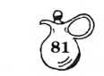
CORNED BEEF SALAD MOLD
1 envelope unflavored gelatin 1-1/2 cups tomato juice 1 cup mayonnaise or salad dressing 1 tsp. lemon juice
1 - 12-oz. can corned beef, finely flaked 1 cup celery, chopped 1 hard-cooked egg, chopped
- Tbsp. finely chopped onion Spinach leaves or lettuce leaves Hard-cooked egg slices, (optional)
Celery leaves (optional)
Soften gelatin in 1/4 cup cold water. Meanwhile, in saucepan bring tomato juice to boil add softened gelatin, stirring until gelatin is dissolved. Gradually stir mixture into mayonnaise. Stir in lemon juice. Chill until partially set. Fold in corned beef, celery, chopped egg, and onion. Turn into 9X5X3 inch loaf pan. Chill until firm. Unmold onto spinach or lettuce lined plate. Garnish with egg slices and celery leaves.
Slices of this inexpensive salad may be served as an appetizer or a light main dish.
Ruth Lindauer
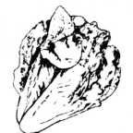
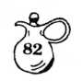
DELICIOUS TOSS SALAD
Spinach, romaine or watercress
1-1/2 cups mushrooms
- can water chestnuts, sliced
- can bean sprouts, drained
Combine in salad bowl, pouring over them the
following dressing, mixed well:
Dressing:
3/4 cup | peanut oil
1/4 cup | slivered on
1/4 cup | soy sauce
3 Tbsp. | lemon juice
1 Tbsp. | sugar
1 tsp. | pepper
1 Tbsp. | sesame seed
Cam Lawry

EDI SHEPHERD'S HOT BAKED HAM SALAD
- pound ham , chopped 1 cup diced celery
- teaspoon minced onion
1/4 cup slivered almonds (I used 1/2 cup)
- hard cooked eggs, chopped
12 to 15 pimiento-stuffed olives, sliced
1/2 cup sliced fresh mushrooms (I used 1 cup because I like mushrooms)
Salt and pepper to taste (I leave out salt)
1/2 cup mayonnaise
1/8 cup (1 oz.) prepared mustard
TOPPING:
- cups grated medium sharp cheddar cheese
- package crushed potato chips
Combine mustard mayonnaise. Fold into the combined other ingredients. Pour into glass casserole. Top with grated medium cheese and put crushed potato chips over that. Bake in 350 degree oven until cheese melts and it is hot through. Serves 6 for main course. (This recipe fits 9X13" pyre* dish)
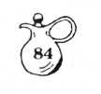
ELBOW MACARONI SALAD
1-1/2 cups diced celery 1/2 cup French dressing
1/2 cup mayonnaise
- Tbsp. chopped pimiento
- Tbsp. minced onion
1/8 tsp. salt Dash pepper
1-8 oz. package macaroni, cooked, drained and chilled
Combine celery, mayonnaise, French dressing, pimiento, onion, and seasoning. Toss well wit1- macaroni. Arrange on lettuce leaves on a platter. Garnish with tomato wedges, sliced _ Spanish olives, and parsley. Sprinkle paprika on top.
Ann Trice-Daughdrill
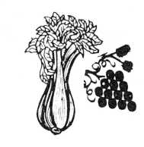
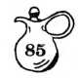
FRUITED CHICKEN SALAD
1 quart cut-up chicken (2 small or 1 large)
1 cup sliced celery 1 can white seedless grapes
- - 10-oz. can water chestnuts, chopped and
drained
1-1/2 cups toasted slivered almonds
- cups (large can) pineapple chunks, drained
- Tbsp. soy sauce
- Tbsp. lemon juice
- tsp. curry powder
- 1/2 cups mayonnaise
Mix all ingredients together. Refrigerate for several hours before serving .... Yummy!
Bonnie Rainey
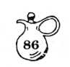
HOT CHICKEN SALAD
- cup mayonnaise
- Tbsp. lemon juice
- tsp. scraped onion
- cups diced chicken
- cups chopped celery 1/2 cup chopped salted almonds
- small can chopped pimiento 2/3 cup crushed potato chips 1/2 cup sharp grated cheese
Mix together all except the last two ingredients. Put in casserole. Cover with crushed potato chips and grated cheese. Bake for 30 minutes at 350 F.
Margaret Compton
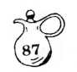
HOT HAMMY-CHEDDAR SALAD
- cups ham, cubed
1 cup cheddar cheese, cubed
1 small green bell pepper, diced
- hard-boiled eggs, sliced
1 package (7-1/2 oz.) macaroni-cheese mix
- cup real mayonnaise
Dash paprika
Dash white pepper and cayenne pepper
- tablespoon pimiento, chopped
Prepare macaroni-cheese mix according to directions. Combine mayonnaise, bell pepper, hot peppers, ham, cheese, pimiento. Add to macaroni-cheese mixture. Place in serving dish, with sliced eggs placed around sides of dish. Sprinkle with paprika and serve warm.
Betty Sloan
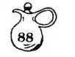
JACQUE'S CHICKEN SALAD
- large chicken breasts, cooked and chilled
1/2 cup mayonnaise
1/4 cup whipping cream, whipped
- cup diced celery 1/2 tsp. salt Dash pepper
Crisp lettuce cups
- tsp. drained capers
- - 10-oz. package frozen, cooked French
style green beans, drained and chilled or 1 lb. can
1/4 cup Italian dressing
6 tomato slices
6 ripe olives
- hard-cooked eggs, quartered
Cut 3 thin slices from chicken breasts; reserve for garnish. Cube remaining chicken. Fold mayonnaise into whipped cream. Fold in diced chicken, celery, salt, and pepper; chill.
To serve, spoon salad into 3 crisp lettuce cups. Top with reserved chicken slices and a dollop of mayonnaise. Sprinkle with capers. Toss green beans with Italian dressing; arrange on plate with salad. Garnish with toma to slices, ripe olives, and hard-cooked eggs Makes 3 servings.
Frances C. Allen
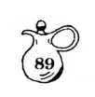
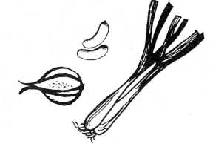
LET'S-HAVE-A-PICNIC SALAD
1/2 pound Kielbasa sausage, sliced (or
other Hillshire Farms sausage)
- cups cubed cooked potatoes
- hard cooked eggs, diced
1 cup cooked green peas
1/3 cup onion, diced fine
1/2 large green pepper, chopped
1/2 teaspoon salt
1 cup mayonnaise
Combine all ingredients. Chill until
ready to serve. Garnish with tomatoes and
serve on lettuce, if desired. Happy
picnicking!
Virginia Culpepper


MEXICAN SALAD
Chop: 1 green onion
- tomatoes 1 head of lettuce
Toss with: 4 oz. grated cheddar cheese
8 oz. Thousand Island or French dressing
Hot sauce to taste: Tomato and Green
Pepper Sauce
Chill salad.
Crunch and add: 1 bag of Doritos
Slice: 1 avocado, peeled
Brown: 1 pound of hamburger,
with 1/4/tsp. of salt.
Add 1 - 15-oz. can Mexican style kidney beans.
Simmer 10 minutes. Arrange taco style on each plate.
Karrie Yeatman

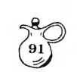
RED, WHITE, AND BLUE SALAD FOR JULY FOURTH
1 - 3 oz. package cherry gelatin
1 - 3 oz. package blackberry gelatin
1 package Cool Whip or Dream Whip
- small box dry cottage cheese curds (I use 99% fat free)
Mix cherry gelatin according to package directions, and place in refrigerator. In separate bowl mix blackberry gelatin in same manner. In another bowl, mix Dream Whip by package directions. Fold in cottag cheese; place in refrigerator. Allow ingredients in three bowls to gel partially. Fill individual molds 1/3 full of Cool Whip cottage cheese mixture, and 1/3 full of blackberry gelatin. Return molds to refrigerator until congealed. Serve on lettuce leaves. Top with red cherry.
Ann Trice-Daughdrill
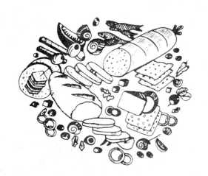
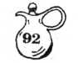
RICE SALAD
- to 3 cups cooked rice
17 oz. can small English peas
1/2 to 1 cup pickles (sweet or dill)
1 to 2 cups meat (ham, chicken, bologna, or hot dogs)
1 cup chopped pecnas
Salt, pepper, onion salt
Mayonnaise (just enough to coat lightly) Combine. Serve.
Sally Black
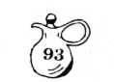
SPICY MEXICAN SALAD
1 large head of lettuce, torn into bite size pieces
- medium tomatoes, finely chopped
1/2 pound cheese, grated
1 pound hamburger meat or ground round
1 small can tomato sauce
1 large onion, chopped
Salt to taste
1 package commercial taco mix (optional) or
- teaspoon oregano
Brown meat until well done. Remove from pan. Saute onions until done but not brown. Drain fat. Add meat, tomato sauce, and spices. Simmer until done but not dry. Mix well in large salad bowl with rest of the ingredients. Add Russian, Italian or French dressing. This may be served with broken taco shells or corn chips if desired. A good meal for summer supper. D<3 not mix ahead.
Phyllis Daniel
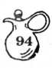

TACO SALAD SUPREME
1 pound ground beef 1 small diced onion 1 package Taco seasoning mix 1 - 16 oz. can red kidney beans Lettuce, shredded Fresh spinach, shredded 8 oz. shredded cheddar cheese
- cup sour cream Crushed Taco chips
- medium ripe tomatoes, cubed Taco sauce (bottled)
Toss lettuce and fresh spinach together
in large salad bowl. Set aside. Brown
beef in heavy skillet, drain fat, add
seasoning mix, salt and pepper to taste,
and simmer on low for 20 minutes. Lay-
er tomatoes on top of lettuce and spin-
ach combo. Spread beef over tomatoes,
and sour cream over beef. Sprinkle
cheese and Taco chips on top. Serve
with additional Taco sauce. Ooo-la!
Betty Sloan
FRUIT SALADS

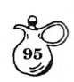
AMBROSIA
- to 10 juicy oranges, peeled and diced
1 cup moist coconut
1/2 cup chopped pecans
1/2 cup cherries, halved
1/4 cup sugar
- cup or orange juice
Combine all ingredients. Chill.
Yield: 4 to 6 servings.
Margie Tedders
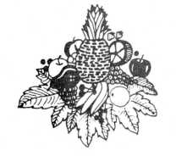

AMBROSIA SALAD
1 - 13-1/2 oz. can pineapple tidbits, drained 1 cup sour cream
1 - 13-1/2 oz. can flaked coconut “
- - 11 oz. can Mandarin oranges
- cup miniature marshmallows _
- bananas, sliced
Combine first five ingredients; toss lightl . Pour into casserole; smooth top. Cover; refrigerate for 8 to 12 hours. Serve salad on lettuce, topped with bananas. Makes
- servings.
Thera Hambrick
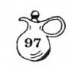
APRICOT SALAD - MOLDED
- cans apricot halves Dash of salt
- 3 oz. packages orange Jello
- Tbs. lemon juice
- - 6 oz. can frozen orange juice concentrate 1-6 oz. bottle 7-Up
Drain apricots and save syrup.
Puree apricots. Combine syrup, Jello and salt. Heat to boiling. Stir and cool. Add puree, orange and lemon juice. Stir until melted. Slowly pour 7-Up down side of pan, fold in and pour into mold.
Chill until firm. Serves 6.
Joan Bailey
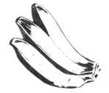

APRICOT SALAD
1 - 15-1/2 oz. can crushed pineapple 1 - 12-oz. can apricot nectar 1/2 cup water
1 - 6 oz. package lemon gelatin
- cup miniature' marshmallows
- large bananas, sliced
- small package cream cheese
Drain pineapple, reserving liquid for topping. Combine apricot nectar and water in saucepan and bring to boil.
Stir in gelatin until dissolved. Add pineapple, marshmallows, and bananas. Pour into shallow 2 quarter dish and chill.
Topping:
Mix cream cheese with pineapple juice until smooth, adding a few pecans, if desired. Spread over salad when firm.
Clare Martin
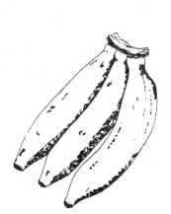

BANANA-NUT SALAD
- or 8 bananas
- cup sugar
- Tbsp. flour
- egg, well beaten
- Tbsp. butter, melted 1/4 cup mild vinegar 3/4 cup water
1/2 cup chopped nuts
Combine sugar and flour; add egg, mixing thoroughly. Add butter, vinegar and water Mix thoroughly. Cook over hot water, stir ring constantly until thick and smooth. Cool. Dip bananas into dressing; roll in nut s.
Margie Tedders

BEST ORANGE SALAD
1/2 cup warm water
- packages unflavored gelatin
1/2 cup granulated sugar
- small container frozen orange concentrate
Sprinkle gelatin over warm water in bottom of large blender container. Let set for about 5 minutes or until soft. Add sugar and blend until dissolved. Add frozen orange juice. Blend sugar and juice mixture. Add 3 large ice cubes, one at a time.
Quickly pour mixture into ring mold, greased with mayonnaise. It is ready to serve immediately. This will stay molded at room temperature except in extremely hot weather.
Phyllis Daniel

BLACK CHERRY SHERRY SALAD
- packages cherry gelatin 1-1/3 cups boiling water 1/2 cup dry sherry wine
- can Bing cherries
- 1/3 cups juice from cherries
- 1/2 cups seedless grapes
- cup nuts
Dissolve gelatin in boiling water. Add cherry juice and sherry. Put in cool place to allow slight thickening. Lightly brush 8 to 10 molds, according to size, with salad oil and partly fill with grapes, cherries, and nuts. Finish filling molds with liquid and put in refrigerator to chill.
Hazel Durrenberger
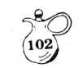
BLENDER CRANBERRY DREAM SALAD
1 cup heavy cream
- cup crushed pineapple, drained
- - 1-lb. can whole cranberry sauce, cut up
- Tbsp. mayonnaise
- Tbsp. sugar
- - 3-oz. pkg. cream cheese, quartered 1/4 cup walnuts
Blender-whip cream and remove to large bowl, add drained pineapple. Liquify cranberry sauce until smooth, add mayonnaise, sugar, and cheese and process till well blended. Add nuts § process only till chopped. Fold mixture into cream § pineapple. Pour into try § freeze. Let stand at room temperature § turn out on lettuce and slice. Serves 8.
Dave Shepherd

BLENDER SALAD
20-oz. can fruit cocktail 8 oz. carton sour cream
- cups boiling water
- small packages Jello, (lime, lemon, or orange)
Blend fruit cocktail and sour cream in the blender. Add boiling water to Jello, stirring until smooth. Combine Jello mixture with first mixture in blender, and blend until well mixed. Cool. Place in refrigerator to congeal. Serve on lettuce leaves. Serves 8.
Lucile Griffin
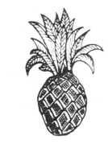
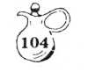
BLUEBERRY SALAD
1 small pakcage blackberry Jello
- small can crushed pineapple, drained
- cup blueberries
Prepare Jello according to package directions, using drained pineapple juice to make up part of the liquid. When Jello mixture is partially set, fold in pineapple and blueberries. Top with one small package cream cheese mixed with 1 small cup sour cream.
Calla Evans

BLUEBERRY SALAD
- - 3-oz. packages blackberry gelatin
- cups boiling water
1 can or 2 cups blueberries, drained
1 can crushed pineapple, draned
1/2 cup sugar
- cup sour cream
1/2 tsp. vanilla
- small package cream cheese
1/2 cup chopped nuts
Dissolve gelatin in boiling water. Drain blueberries and pineapple and measure the liquid. Add enough water to make one cup and add to the gelatin mixture. Stir in the blueberries and pineapple. Pour into a flat 2 quart pan and refrigerate until firm. Blend softened cream cheese, sugar, sour cream, and vanilla. Spread over the congealed salad, sprinkling nuts on top. Makes 10 to 12 servings. Delicious!
Edna Jones

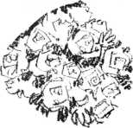
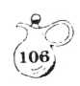
BRIDES RIBBON SALAD
1 - 8*5 oz. can crushed pineapple, drained (reserve liquid)
3-oz. package lime gelatin 8-oz. package cream cheese 1/2 cup sugar
1 cup evaporated milk, undiluted t tsp. vanilla, (optional)
1 envelope unflavored gelatin 3-oz. package strawberry gelatin 1 cup boiling water
1 - 10-oz. package frozen strawberries, thawed
STEP ONE:
Place drained pineapple in individual molds or in 12 X 7-1/2 X 2 inch baking dish. Combine pineapple syrup with enough water to make 1-1/4 cups and heat to boiling. Dissolve lime gelatin in hot syrup. Pour over pineapple. Chill until firm.
STEP TWO:
Beat cream cheese with 1/2 cup sugar until soft and smooth. Blend in undiluted
evaporated milk and vanilla. .Soften 1 envelope
(over)

BRIDES RIBBON SALAD (continued)
unflavored gelatin in 1/4 cup cold water. Heat to dissolve. Blend into cheese mixture. Pour over lime layer. Chill until firm.
STEP THREE:
Dissolve strawberry gelatin in 1 cup boiling water. Stir in frozen, thawed strawberries. Cool to room temperature. Pour over cheese layer. Chill until firm. Turn out on lettuce.
Note: This salad, more trouble than
some, is rewarding in that it is pretty and delicious.
Mrs. Harold Gulliver, Sr.
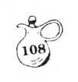
BUTTERMILK SALAD
- packages orange Jello
- can pineapple, drained
- cups buttermilk
1 cup chopped pecans 1 large carton Cool Whip
Mix and bring to a boil pineapple juice and two packages dry Jello powder. Cool at least 30 minutes. Add 2 cups buttermilk and the drained pineapple. Fold in
- cup of chopped pecans and a large carton Cool Whip. Mix thoroughly. Refrigerate several hours or overnight.
Edna Jones

BUTTERMILK SALAD
1 large can crushed pineapple
- large package strawberry Jello
- cups buttermilk
- - 8-oz. container Cool Whip
Drain pineapple. Add water to juice, if needed to measure 1 cup, and heat. Add Jello to dissolve. Add pineapple Cool; then add buttermilk and Cool Whip. Pour into 1-1/2 quart flat pan or into individual molds. 10 to 12 servings.
Mary Beth Watkins

CHERRY JELLO SALAD
1 large (6 oz.) package cherry Jello 8 oz. package cream cheese 1 package frozen strawberries
- cup pecans
- cups boiling water
Dissolve Jello in boiling water. Mash softened cream cheese. (Add a little hot Jello mixture to make it smooth and creamy.) Combine cream cheese mixture with hot Jello. Add nuts and partially thawed frozen strawberries and mix until strawberries are completely thawed. Serve on lettuce.
Nancy Wilkerson, from Becky De Loach
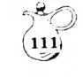
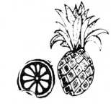
CHILLED FRUIT SALAD
1 cup orange sections 1 cup pineapple chunks 1 cup miniature marshmallows 1 cup flaked coconut
- cup sliced fresh peaches
- cup sour cream
Drain fruits. Combine all ingredients. Chill thoroughly. Yield: 6 servings.
Margie Tedders
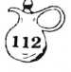
CHRISTMAS CRANBERRY SALAD
- orange
- tablespoons grated orange peel
- cup cranberries, measure before
grinding
- apples, chopped finely, not ground
1/2 cup grapes, chopped
1 small can crushed pineapple, with juice
1/2 cup sugar
- cup hot water
- package lemon or orange Jello (3 oz.) 3/4 cup pecans, chopped fine
Grind orange and cranberries in food chopper. Add chopped apples and grapes. Add 1/2 cup sugar and let stand while other ingredients are being prepared. When Jello is cool, add all ingredients. After it begins to thicken, put into individual molds. Top with a dab of salad dressing or mayonnaise and serve on lettuce leaves.
Ann Trice-Daughdrill
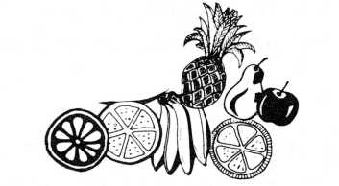
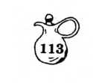
CITRUS SALAD
- can grapefruit slices
- can mandarin oranges
1/2 cup white raisins
1/2 cup or more of chopped pecans
- - 6 oz. package lemon gelatin
Drain fruits and use proper amount of juice in gelatin. Mix fruit and nuts in dissolved gelatin. Place in refrigerator to congeal. Serve with a droplet of mayonnaise on each square.
Clare Martin
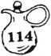
CONGEALED SALAD (fruit)
- boxes apricot or peach Jello
- cups cold water
1 or 2 bananas
- cup miniature marshmallows
- cups hot water
1 - #2 can crushed pineapple, drained
(save the juice)
Chill this mixture until firm. Mix the
following and bring to boil until thick:
1/2 cup pineapple juice
- cup sugar
- Tbsp. butter
- beaten egg
- Tbsp. cornstarch
1 small package cream cheese
When thick ... cool.
Put cheese into blender and add cooled
mixture. Whip a package of dream whip
according to pkg. (or use Cool Whip). Pour
mixture into topping and smooth onto con-
gealed mixture. Put into a 9 X 13 X 2" or
- quart oblong pan. Serves 24.
Naomi Hale
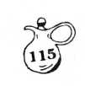
CRANBERRY SALAD
1 cup ground, raw cranberries 1 cup sugar
1 package cherry Jello 1 cup hot water stirred into Jello 1 Tbsp. lemon juice 1 orange, peeled and ground 1 cup pineapple 1 cup chopped celery
- cup nuts
Mix and chill.
Dollie Abrigo
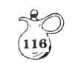
CRANBERRY SALAD
- Tbsp. unflavored gelatin 1/4 cup cold water
- cups boiling water
1 - 6-oz. box raspberry (or orange) Jello 1 pound fresh cranberries 1 cup water
1/2 to 3/4 cup sugar (optional)
Grated rind two oranges
- oranges sectioned and chopped
1 large can (20-0z.) crushed pineapple unsweetened and undrained
1 cup pecans chopped
- cup celery finely chopped (optional)
Soften unflavored gelatin in 1/4 cup cold water. In large bowl, pour boiling water over flavored gelatin. Stir in unflavored dissolved gelatin until all dissolved. Chop in blender using 1 cup water, or use food processor adding 1 cup water to mixture. Add to gelatin along with remaining ingredients. Pour into large mold. Chill until firm. Serves at least 12.
Virginia Culpepper
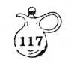
CRANBERRY SALAD
- Family size raspberry Jello
- cups boiling water 1 can cranberry sauce
1 can whole cranberry sauce
1 package Knox gelatin, dissolved in 1/4 cup water
Dissolve raspberry Jello in boiling water. Combine with cranberry sauces. Add to thi
1 large can crushed pineapple 1 cup chopped celery
- cup chopped pecans
- cups seeded Tokay grapes (or green grape Pour into mold and congeal in refrigerator
Virginia Corn
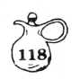
CRANBERRY SALAD
1 pound cranberries 1 orange
- 1/4 cups sugar 1 cup chopped nuts (fine)
- cup chopped celery (fine)
- large or 2 small apples
- small packages red Jello (I use wild
strawberry)
- 3/4 cups water
Grind cranberries; add grated rind and juice of orange. Add sugar and let stand at least one hour, overnight is o.k. Mix Jello with only amount of water listed. When cool, combine all ingredients and let stand until it begins to harden. Then pour into molds. Makes a large
amount. This is a favorite of the library
staff for Christmas dinners.
Thera Hambrick
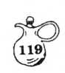
CRANBERRY SALAD
- - 17-oz. can cranberry sauce
- cups hot water
- packages lemon gelatin
- cup diced celery
- cup cherries
Lettuce
Mayonnaise
Nut meats
Slip cranberry sauce from can; cut jelly
into small pieces. Pour hot water over
lemon gelatin and stir until dissolved.
Puur into mold, and chill until firm. To
serve, turn out on lettuce and decorate
with spoonful of mayonnaise mixed with
nut meats. Variations of this recipe:
Place salad square on slice of pineapple. Tod with cream cheese, colored with cherrv iuice or cake coloring. Or. congeal in ring mold, turn out. and fill center with cottage cheese and toooing. Decorate with large white grat>es.
Mrs. Harold Gulliver Sr.

CREAM CHEESE RING WITH CLING PEACHES
6-1/2 inch ring mold
- - 3-oz. packages cream cheese 1/2 cup orange juice 1 can cling peaches (reserve juice)
- cup syrup from peaches
- tsp. grated orange rind 3/4 tsp. salt
- cup cold water
- Tbsp. gelatin
Curly endive, for garnish Red Currant jelly
Cream the cheese, blending into it the orange juice and peach juice. Add 2 tsp. grated orange tind and 3/4 tsD. salt. In 1 cud of cold water soften gelatin; dissolve over hot water. Cool. Add to cream cheese mixture. Blend well. Pour into ring mold, chill until firm. Unmold on round chop plate. Fill center and outer edges with endive. Surround with canned peach halves, cut side up, and filled with.red currant jelly.
Mrs. Harold Gulliver, Sr.
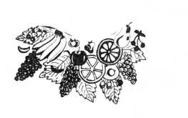
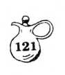
CREAMY FRUIT SALAD
- can (8-1/3 oz.) fruit cocktail, drained
- bananas, peeled, and sliced crosswise 1 small unpared apple, diced
1/2 cup seedless green grapes, halved
- maraschino cherries, halved 1/2 cup whipping cream, whipped 1/4 cup miniature marshallows Strawberries
Combine fruit cocktail, bananas, apple, grapes, cherries, and marshmallows in large bowl. Fold in whipped cream. Refrigerate. Just before serving, garnish salad with strawberries, Makes four to six servings.
Debbie Yarbrough
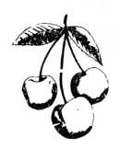
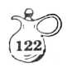
DELIGHTFUL APPLE SALAD
- medium apples, peeled and diced
1-1/2 cups miniature marshmallows
1 - 20-oz. can sliced pineapple, drained and chopped
1 - 6 oz. jar maraschino cherries, cut up
Make a dressing of the following:
1/2 stick margarine, melted in saucepan
- Tbsp. flour, blended with 1 Tbsp. sugar
- cup pineapple juice
Cook until thick. Add 1/2 cup mayonnaise
Combine fruit and dressing. This is better made a day before serving time. This salad stays good for several days in refrigerator.
Ruth Lindauer
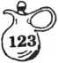
DOT’S CRANBERRY SALAD
1 can whole cranberry sauce 1 large can crushed pineapple (save juice]
1 cup boiling water 1 package raspberry Jello 1 envelope plain gelatin 1/2 cup cold water
Dissolve Jello in 1 cup boiling water. Soften gelatin in 1/2 cup cold water, and add to hot mixture. To reserved pineapple juice, add water to equal 1 cup, and add to Jello mixtur* Mash sauce and stir in, along with crushed pineapple. Put in flat 2 quart pan and conge; When firm, add topping.
TOPPING:
1/2 cup mayonnaise
- - 3-oz. package cream cheese
- Tbsp. pineapple juice 1/2 cup chopped pecans
Blend together mayonnaise, cream cheese, and pineapple juice. Add pecans and spread over cranberry salad. Cut in squares and serve on lettuce leaves.
Mary Beth Watkins
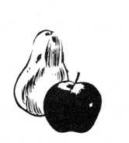
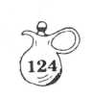
EASY FROZEN SALAD
1 small can whole cranberry sauce 1 small can crushed pineapple
- small package Cool Whip
- or 3 bananas, sliced
Mix together and freeze. One recipe fills one ice tray.
Virginia Corn
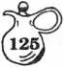
EASY THREE LAYER SALAD
1 package each of strawberry, lime and orange Jello
1 can fruit cocktail, drained
1 large cream cheese
1/2 cup chopped pecans
1 medium can crushed pineapple, drained
First Layer:
Drain syrup from can of fruit cocktail, using syrup in preparing strawberry Jello accroding to directions on package Pour into mold and chill until firm, then add:
Second Layer:
Prepare lime Jello according to package directions. Cream the cream cheese with small portion of Jello mixture, gradually adding portions until all Jello mixture has been used. Mix in pecans. Cool Pour into mold over first firm mixture. Chill until firm, then add:
Third Layer:
Drain crushed pineapple, using syrup to prepare orange Jello according to packag directions. Stir drained pineapple into Jello mixture. Cool and pour over second layer. Refrigerate until congealed. Serv on lettuce leaves.
Margie Tedders
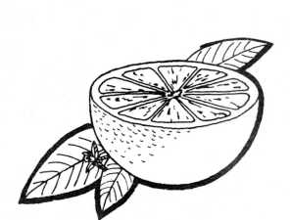
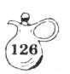
FIVE CUP SALAD
1 can mandarin oranges, drained 1 can chunk pineapple
1 can angel flake coconut 1 cup miniature marshmallows 1 cup sour cream
Mix the day before you expect to use it.
Calla Evans
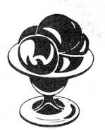
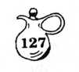
FRESH FRUIT SALAD
1 fresh pineapple 1 banana, sliced 1 cup watermelon balls 1 cup cantaloupe balls 1 cup seedless grapes, white 1 cup flaked coconut 1 - 16-oz. carton sour cream 1/4 cup chopped pecans
Chill pineapple overnight. Peel and core pineapple, and cut into bite size chunks. Combine all fruit. Add flaked coconut, and toss gently. Combine sour cream and pecans. Spoon over fruit. Chill at least two hours before serving.
Ann Trice-Daughdrill
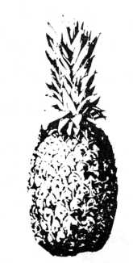
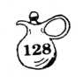
FROZEN CRANBERRY SALAD
1 - 16 oz. can whole cranberry sauce 1 flat can crushed pineapple, drained 1-8 oz. carton sour cream 1/2 cup chopped pecans
Mix ingredients and place in a loaf pan. Place in freezer.
Serves 6 to 8.
Joan Bailey
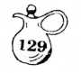
FROZEN FRUIT SALAD
1 pkg. (3-oz.) Jello lemon gelatin
Dash of salt 1 cup boiling water
1 can (8-3/4 oz.) pineapple tidbits, drain and save liquid
1/4 cup lemon juice
1/3 cup mayonnaise
1 cup whipping cream or 2 cups sour cream
- medium banana, diced
1/2 cup seeded halved grapes
1/4 cup diced maraschino cherries
1/4 cup chopped nuts
Dissolve Jello and salt in boiling water.
Drain pineapple, measuring syrup; add water to make 1/2 cup, if necessary. Stir into gelatin with lemon juice. Blend in mayonnaise. Chill till very thick. Whip cream. Fold fruits, nuts and whipped cream or sour cream into gelatin. Pour into 9X5X3 loaf pan. Freeze until firm - at least 3-4 hours.
Serves 8 to 12.
Pam Elkins
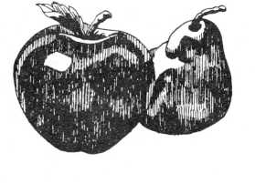
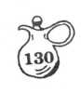
FROZEN SALAD
- - 8-oz. package cream cheese 1/2 pint cream, whipped 12 maraschino cherries, cut fine
- small can crushed pineapple
- cup mayonnaise 8 marshmallows, cut fine
Mix mayonnaise with cream cheese. Mix fruit with whipped cream. Combine fruit mixture with cream cheese mixture and freeze.
Virginia Corn
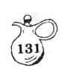
FROZEN CRANBERRY SALAD
- - 3-oz. packages cream cheese
- Tbsp. sugar
- Tbsp. mayonnaise
- pound can cranberry sauce
- small can drained crushed pineapple
1/2 cup chopped pecans
1/2 cup whipped cream or 1 package of Dream Whip
Cream cheese and sugar, stir in mayonnaise. Cut up cranberry sauce and fold in. Fold in pineapple, pecans, and whipped cream. Freeze. Thaw slightly before servings.
Betty Greenhaw
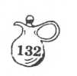
FROZEN FRUIT SALAD
- Tbsp. flour 1 cup pineapple juice 1 stick butter 1/4 cup sugar
- egg -
1/8 teaspoon salt
- Tbsp. lemon juice —
Marshmallows
- to 8 slices pineapple 1/4 cup chopped nuts
- ro 20 maraschino cherries
- sliced bananas 1 can fruit cocktail
- pint cream, shipped, or 1 pkg. Dream Whip “
In top of double boiler, make a paste of floux.
and pineapple juice. Add butter, sugar, and s It Cook about 10 minutes. Add beaten egg and 3 marshmallows. Cook a few minutes more. Cool. Then add lemon juice, 6 to 8 slices pineapple” 1/4 cup chopped nuts, 15 to 20 maraschino che - ries, 15 to 20 marshmallows, bananas, fruit cocktail, and whipped cream. Freeze. —
Betty Greenhaw
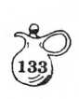
FROZEN FRUIT SALAD
- packages cream cheese
3/4 cup mayonnaise
1/2 pint whipping cream, whipped
1/2 cup chopped cherries
1 cup fruit salad
1/2 cup nut meats
Blend cheese and mayonnaise. Add whipped cream and other ingredients. Freeze. Serves 8.
Mrs. Harold Gulliver, Sr.

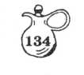
FROZEN SALAD
1 - 14 oz. can sweetned condensed milk
1 - 9-oz. carton frozen whipped dessert
topping, thawed
1 - 20-oz. can crushed pineapple, drained
1 - 21-oz. can cherry pie filling
Mix all ingredients. Place in a shallow container, preferably one with a top. Cover and freeze for several hours. Keeps for two weeks in a freezer.
Nancy Wilkerson
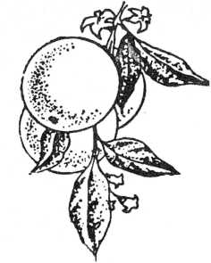
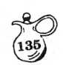
FRUIT SALAD (OVERNIGHT)
1 can chunk pineapple, drained
1 can Mandarin oranges, drained
1 jar cherries
1 pound green seedless grapes, halved
- can sliced peaches, chopped
- large or 2 small packages instant
vanilla pudding
- or 4 bananas, sliced
Mix thoroughly 2/3 cup pineapple juice
and 1/3 cup Mandarin orange juice with
the instant pudding. Add pineapple and
oranges and chill overnight. Next morn-
ing add the other fruits.
Edna Jones
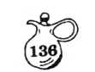
GEORGIA PINK SALAD
1 small box pineapple gelatin (3 oz.)
1 small box orange gelatin (3 oz.)
1 package Dream Whip or Cool Whip 1 small box dry cottage cheese curds
Mix gelatin according to package directions. Refrigerate until partially set. Make Dream Whip by package directions. Add cottage cheese to gelatin and fold in Dream Whip. Return to refrigerator until completely jelled. Cut into squares and serve on lettuce leaves. Top with a dab of mayonnaise or salad dressing.
Ann Trice-Daughdrill
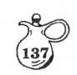
GRAPEFRUIT SALAD
- grapefruit, (reserve 3 shells)
- packages lemon Jello 1 large cream cheese
- small cream cheese 1/2 cup mayonnaise
- cups hot grapefruit juice
Cut grapefruit in halves. Remove pulp and drain it. Dissolve 2 packages lemon Jello in 3 cups hot grapefruit juice. (Put aside 1/2 cup Jello mixture.) When thickened add grapefruit pulp. Cream together 1 large and 1 small cream cheese, 1/2 cup mayonnaise, and 1/2 cup Jello. Combine with Jello mixture. Fill 3 grapefruit shells with Jello mixture and congeal. Spread topping over congealed salad in shells.
Topping: 3/4 cup sugar Juice of 1 lemon
- eggs, beaten 1/2 pint cream
(whipped)
Beat sugar, eggs, and lemon juice together.
Cook in top of double boiler until thick.Cool. Fold in whipped cream and spread over salad. After topping becomes firm, cut grapefruit halves into quarters and serve on lettuce leaves. Serves 12.
Sally Black
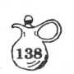
GRAPEFRUIT SALAD
- or 4 small grapefruit 1 large (6 oz.) pkg. lemon Jello 1-1/2 cup hot water
- small can (8-1/2 oz.) crushed pineapple
- - 3-oz. pkgs. cream cheese, softened —
- Tbsp. Half and Half
Mayonnaise _
Maraschino cherries
Cut grapefruit in halves lengthwise. Scoop out interior with spoon. Separate and peel sections. Save shells. Dissolve Jello in hot water. Add pineapple and grapefruit (coarsely chopped) to gelatin. Using half of gelatin mixture, fill grapefruit shells half full. Place in refrigerator to congeal. Keep remainder at room — temperature. Combine cream cheese and Half and Half. Blend. Spread over congealed mixture. Pour remaining gelatin mixture over cream cheese mix. Chill. Cut each grapefruit in half again, making each serving to be 1/4 grapefruit. Garnish with mayonnaise and a cherry. A very pretty (and good) salad.
Virginia Culpepper
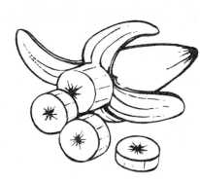
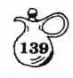
GREEN GRAPE SALAD
1-1/2 cups seedless green grapes, washed and stems removed
- can (13-1/2 oz.) pineapple chunks, drained
3/4 cup sliced bananas
- package (3 oz.) soft cream cheese
1/4 cup mayonnaise
- lettuce cups
Combine green grapes, pineapple, and bananas. Toss lightly. Refrigerate, covered, until well chilled. Combine cream cheese and mayonnaise, mixing well. Fold gently into fruit. Serve in lettuce cups. Serves 4.
Edna Criscuolo
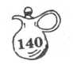
HARVEST PEAR SLAW
2 fresh Bartlett pears
2 cups shredded cabbage
1 cup raisins
1/3 cup chopped walnuts
1/3 cup mayonnaise
1/3 cup dairy sour cream
- tablespoon lemon juice
- tsp. sugar 1/4 tsp. salt Parsley for garnish
Core pears and cut several wedges for garnish. Dice remaining pears. Toss diced pears with cabbage, raisins, and nuts. Combine remaining ingredients, except parsley and toss lightly but thoroughly with slaw. Garnish with pear wedges and parsley. Makes 6 servings.
Frances C. Allen
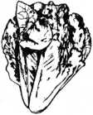

HEARTS OF PALM SALAD
1 head lettuce
1 can hearts of palm
1 small can pineapple chunks
1 small can peach or apricot chunks
1/2 cup chopped dates
Be sure all ingredients are cold. Shred lettuc and hearts of palm. Add drained canned fruit and dates. Toss together with dressing.
DRESSING:
1 cup mayonnaise
1 rounded tablespoon peanut butter
- Tbsp. juice from drained pineapple
- drop green food coloring (optional)
Mix above ingredients in blender. Refrigerate and use amount desired in salad.
Mary Beth Watkins
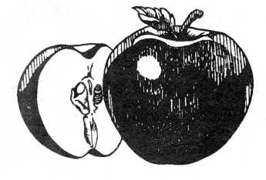
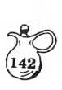
HEAVENLY APPLE SALAD
- packages lemon Jello
- cup hot water
- large marshmallows, diced, or 3/4
cup small ones
- cup cold water
- can (9 oz.) crushed pineapple, drained
- large apples, diced
1/2 cup chopped nuts
Dissolve Jello in hot water. Add marsh-
mallows and still until dissolved. Stir
in cold water and chill until partially set.
Add remaining ingredients and chill until
firm.
Sally Black
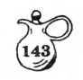
HOLIDAY SALAD
- eggs
- Tbsp. vinegar
- Tbsp. sugar
- Tbsp. oleo
1 medium can chunk pineapple, drained 1 can fruit cocktail, drained 1 small jar cherries, drained
- package miniature marshmallows
- cups chopped nuts
- pint whipping cream, whipped
Beat eggs, (not in mixer or blender).
Add vinegar, sugar, and oleo. Cook in top of double boiler until thick. Let cool. Combine well drained fruit cocktail, pineapple, and cherries. Add nuts and marshmallows. Mix with cooled sauce. Fold in whipped cream. Hint: Make ahead and let it stay in refrigerator overnight.
Margie Tedders
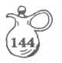
HOT FRUIT SALAD
1-16 oz. can peach halves 1-16 oz. can pear halves 1 - 8 oz. can mandarin oranges 1-16 oz. can sliced pineapple 1 jar red apple rings
Drain fruit well savings 1 cup of mixed juices.
Make a sauce of:
- Tbs. cornstarch 1/2 cup sugar 1 cup cooking sherry
- cup mixed juices Cook until thickened while stirring over a low fire. Layer fruit in casserole, spooning sauce over each layer. Bake at 350F for 45 minutes. Serve hot. Serves 6.
Joan Bailey
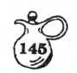
LEPRECHAUN SALAD
- marshmallows 1 - 3-0z. package lime Jello
- 1/2 oz. can crushed pineapple 1 cup whipping cream, whipped
- cup milk
- - 3-oz. packages cream cheese 2/3 cup mayonnaise
Heat marshmallows with milk in double boiler until marshmallows are melted.
Add Jello; stir until dissolved. Add cream cheese and stir until blended. Cool. Blend in pineapple and its juice, whipped cream, and mayonnaise. Chill until firm. Serves 12.
Karrie Yeatman
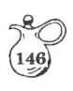
LIME ASPIC
1 (6 oz.) package lime Jello
1 cup hot water
1 cup India Relish
1 cup celery, chopped fine
- fresh grapefruit or 2 cans, drained.
Horseradish, for zip, if desired.
Dissolve Jello in boiling water. Cool. Add relish, celery, and grapefruit. Pour into mold and congeal.
Margaret Compton From
Frances Compton
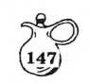
LIME-WALNUT SALAD
1 cup boiling water
- - 3-oz. package lime gelatin
- cup crushed pineapple with syrup 12-oz. carton creamed cottage cheese
- stalks celery, cut into 1 inch pieces 1/2 cup walnuts
Put boiling water and gelatin in blender container. Cover and run on speed 1 (or low) until gelatin is dissolved. Add remaining ingredients, except walnuts. Cover container and run on high, just until celery is chopped. Add walnuts, cover container and run on high, just until all nuts go through the blades. Pour into a 9 X 9 X 2 inch pan. Chill until set. Makes 6 ample servings.
Bonnie Rainey
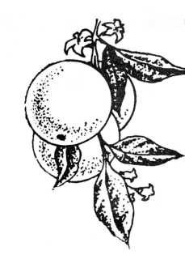
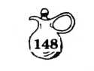
ORANGE AND ONION SALAD
- large purple onions (or Vidalia)
- large oranges
- Tbsp. olive or salad oil 1 Tbsp. orange juice 1 Tbsp. lemon juice Salt and pepper to season Pinch of rosemary
Peel oranges and onions and cut into thin slices. Arrange sliced oranges alternately with the sliced onions on a large platter or salad plate. Mix all fruit juices, and seasonings, and pour over salad.
Bonnie Rainey
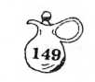
ORANGE SALAD
1 small package orange Jello 1 - 8 oz. package cream cheese 1 large can crushed pineapple
Combine and place over low heat until cream cheese blends in with the other ingredients. Let cool.
Mix one small package of dream whip according to package directions. Beat until stiff.
Stir into above mixture. Add 1 cup chopped nuts, if desired. Chill until firm.
Naomi Hale
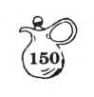
ORANGE SHERBET GELATIN
1 cup orange juice 1 cup buttermilk
- - 3-oz. pkg. peach or apricot Jello
Boil orange juice, add Jello - Beat in buttermilk til smooth.
- recipe X 4 = 9 X 13" pyrex and serves 12 easily.
Optional topping:
Sour cream, sugar, orange juice and grated orange rind. Spoon on top before serving.
Pam Elkins
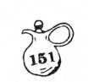
ORANGE SHERBET MOLD
- packages lemon Jello
- cups liquid (including fruit juice)
1 tsp. lemon flavoring 1 can Mandarin oranges 1 pint orange sherbet
Combine drained juice plus enough water to make 2 cups and bring to boiling point. Dissolve Jello in hot liquid. Add sherbet and flavoring. Stir until melted. Add fruit, mix, and pour into mold. (Not necessary to wait for this to set before adding fruit as the cold sherbet sets the Jello.)
Nancy Wilkerson
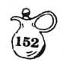
PEACH ASPIC
1 envelope plain gelatin 1-1/2 cups water 1 cup orange juice
- tablespoons lemon juice 1/4 cup sugar
- (3-oz) packages peach flavored gelatin Grated rind of 1 lemon
- 1/2 cups mashed fresh Georgia peaches
Soften plain gelatin in 1/4 cup cold water. Dissolve both plain gelatin and peach flavored gelatin in 1-1/4 cups boiling water. Add orange juice, rind of lemon and lemon juice. Add mashed peaches, sweetened to taste. Pour into 6-cup ring mold and chill until set. Serve with Cream Cheese Dressing.—
CREAM CHEESE CRESSING
1 3-oz. pkg. cream cheese 1 peach, mashed 1 Tbs;, mayonnaise
Cream the cream cheese until smooth. Add the mayonnaise and mix well. Add peach and mix thoroughly. Unmold aspic and fill center of mold with dressing. Garnish salad with mint.” leaves.
Frances C. Allen
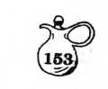
PEACH PICKLE SALAD
- 3 oz. package lemon gelatin 1 - 3 oz. package orange gelatin
- 1/2 cups boiling water
1/2 envelope plain gelatin soaked in 2 Tbsp.
cold water 1/2 cup peach pickle juice 1 22 oz. jar peach pickles 1/2 cup chopped celery 1/2 cup chopped pecans
Drain pickles, reserving 1/2 cup juice. Pour boiling water over lemon and orange gelatin. Stir until gelatin is dissolved. Add soaked plain gelatin and pickle juice. Cut peaches into bite size pieces and add to gelatin.
Stir in celery and pecans. Pour into mold to congeal. Serves 8 to 10.
Connie Christie
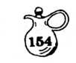
PEACH PICKLE SALAD
1 - 3-oz. package orange gelatin 1-1/2 cups hot water 1 - 28-oz. jar pickled peaches 1/2 cup peach pickle juice 1 - 3 oz. package cream cheese Ground nuts
Dissolve gelatin in hot water and juice. Cool. Remove seeds from peaches. Roll cream cheese into tiny balls then roll in nuts. Stuff whole peaches with cream cheese balls and place one in each mold. Pour gelatin mixture over each and congeal.
Frances Worstall
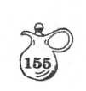
PICKLED PEACH SALAD
1 can pickled peaches, cut up and drained
- medium sized can white cherries, pitted and drained 1/2 cup ginger marmalade
- package each lemon and orange Jello 1/2 cup pecans - chopped coarsely
Use the juice from the peaches and cherries. Add water to make 3-1/2 cups liquid. Heat 2 cups and dissolve Jello. Add 1-1/2 cup of liquid to make 3-1/2 cups. Chill till soft. Add peaches, cherries, marmalade and nuts. Chill till firm. Serves 6.
Joan Bailey
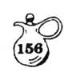
PINEAPPLE BUTTERMILK SALAD
Large package lemon Jello
Large can crushed pineapple, undrained
- cups buttermilk
8 oz. carton Cool Whip
Put dry Jello and pineapple in pan; heat until dissolved. Cool. Add 2 cups buttermilk and Cool Whip. Mix well. Put into 9 X 13 inch container and chill until firm.
Betty Greenhaw
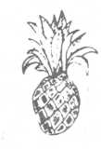
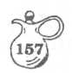
PINEAPPLE JELLO
Pour off juice from a No. 2 can of sliced pineapple. Replace with gelatin made with half the water in package directions, in flavor of your choice. Chill until set. Run a little warm water on can sides to loosen. Cut bottom from can and use to push mold out. Cut between pineapple slices and serve.
Edna Criscuolo
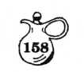
PINEAPPLE IN KIRSCH
- medium-size pineapples
- cup water
- cups sugar
- cup kirsch
Quarter each pineapple with large, heavy sharp knife. Core each piece. Remove pineapple from shells in one piece with sharp knife. Reserve shells. Cut pineapple into thin slices; place in large bowl. Combine water, sugar, and kirsch. Bring to boiling; cool. Pour over pineapple slices. Refrigerate several hours To serve, arrange pineapple slices in pineapple shells zigzag fashion. Chill until ready to serve. Makes 12 servings
Dollie Abrigo
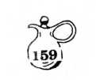
PINEAPPLE-MARSHMALLOW SALAD
1 large can sliced or chunk pineapple
1/2 pound marshmallows, cut in 3 or
- pieces
1 cup chopped pecnas
Dressing:
1/2 pint whipping cream Juice of 1 lemon
- egg
- Tbsp. water Pinch of salt
On low heat, cook beaten egg and water until it thickens, pour in juice of lemon. Cool and add to stiffly whipped cream. Combine marshmallows, nuts, and cubed pineapple. Add to dressing.
Leave in refrigerator overnight before serving.
Betty Greenhaw

PINEAPPLE ORANGE SALAD
1 small carton whipped topping 1 small carton sour cream 1 small can crushed pineapple 1 small can Mandarin oranges 1 - 3-oz. box orange Jello
Combine topping, sour cream, and dry orange Jello. Drain pineapple and oranges, and fold into sour cream mixture. Chill in a covered container until firm. Serves 6 to 8.
Lucile Griffin
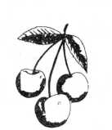
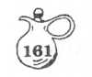
PINK FROZEN SALAD
1 can condensed milk 1 quart cool whip 1 #2 can cherry pie filling 1 #2 can crushed pineapple
Mix and freeze in an 8 X 12" pan. in squares and serve.
Cut
Naomi Hale

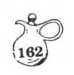
PINK PEAR SALAD
1 package lemon Jello
1 package cherry jello
1 large can pear halves
1 large package cream cheese
1 pint whipping cream
Juice of 1/2 lemon
Drain juice from pears. Heat to boiling and pour over Jello, mixing both colors. Press pears through strainer. Soften cream cheese with small amount of mayonnaise (about 1 Tbsp.). Whip cream until stiff. Add lemon juice. Fold into pears, cream cheese, then into Jello mixture which has cooled thoroughly and is beginning to congeal. (You may also add 1/2 cup nuts and a cup of crushed pineapple, if desired). Chill until firm.
Naomi Hale
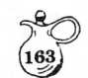
PISTACHIO SALAD
1 small Pistachio instant pudding 1 large (13-oz.) Cool Whip 1 can crushed pineapple, drained 1 can Mandarin oranges, drained 1 cup miniature marshmallows 12-oz. carton cottage cheese
Fold pudding mix into Cool Whip. Fold remaining ingredients into pudding mixture. Chill thoroughly.
Cam Lawry
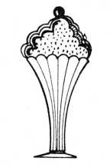
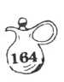
PISTACHIO CONGEALED SALAD
1 medium Cool Whip
1 can crushed pineapple (8 oz.)> with juice
1 cup miniature marshmallows 1 cup nuts
1 box Jello-brand Pistachio instant pudding
Stir together. Chill for one hour.
Debbie Yarbrough
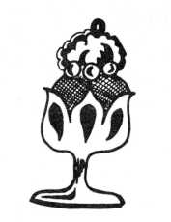
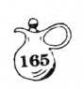
PISTACHIO SALAD
1 package pistachio pudding 1 can crushed pineapple, with juice 1 cup miniature marshmallows
- cup white seedless grapes 1-13-1/2 oz. carton Cool Whip 1/2 cup nuts (optional)
Blend dry pudding powder into Cool Whip. Mix well, then add pineapple, with juice. Fold in other ingredients. Chill and serve.
Karrie Yeatman
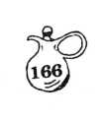
RED RASPBERRY RING
- - 10-oz. package frozen red raspberries
- - 6-oz. package red raspberry gelatin
- cups boiling water 1/4 cup chopped nuts
- pint vanilla ice cream
1-6 oz. can pink lemonade concentrate
Drain raspberries and set aside. Dissolve gelatin in boiling water. Add ice cream, a spoon at the time, stirring until melted. Stir in lemonade concentrate.
Chill until partially set. Add raspberries and nuts. Put into 6-cup ring mold. Chill until firm. Six to eight servings.
Sally Black
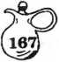
RUSSIAN CREAM
Yield: 10 servings
1 Tbsp. unflavored gelatin 1 cup cold water
- pint half and half 1-1/2 cups sugar
- tsp. vanilla
- pint sour cream, beaten until smooth
- cup strawberries or raspberries
Sprinkle gelatin on top of cold water. Do not stir. Combine half § half and sugar. Heat in double boiler until lukewarm. Add gelatin mixture to warm cream and heat over moderate heat until sugar and gelatin are dissolved. Remove from heat and cool. When cool and beginning to thicken, fold in vanilla and beat in sour cream. Pour into sherbet glasses and refrigerate. When firm and well chilled, serve with fresh or thawed berries.
Sally Black
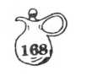
SALAD SUPREME
STEP #1
- boxes (or 1 large box) orange Jello One #2 can crushed pineapple, drained (save juice)
Mix Jello according to directions on box; pour into 8 X 12 inch dish. Refrigerate.
When mixture is partially congealed, add pineapple. Sprinkle chopped nuts over Jello, and return to refrigerator to gel completely.
STEP #2
1 large box Dream Whip (or 2 small)
1 (8-oz.) package cream cheese Set out cream cheese to soften. Mix Dream Whip according to package directions. When cream cheese is softened, blend with Dream Whip and spread this mixture on congealed Jello.
STEP #3
Use 1 cup of juice saved from crushed pineapple, and add to it the following:
- tablespoon lemon juice 3/4 cup sugar
- tablespoons plain flour
- eggs, well beaten
Cook over low heat until thick. Chill. When thoroughly chilled, spread over Jello and Dream Whip. Sprinkle top with nuts. Refrigerate .
Debbie Yarbrough
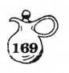
SPICED PEACH SALAD
1 cup diced canned peaches
3/4 cup peach syrup
1/4 cup vinegar
6 whole cloves
1 (inch) stick cinnamon
1 (3 oz.) package peach Jello
1 cup boiling water
1/4 cup sugar
Combine peach syrup, vinegar, sugar, cloves and cinnamon. Simmer 10 minutes. Remove from heat and take out whole spices. Add water to make 1 cup.
Dissolve gelatin in boiling water. Stir in spiced peach syrup. Chill until slightly thickened and add peaches. Put in 3-cup mold. Serves 6.
Very good with cold baked ham.
Virginia Culpepper

TROPICAL FRUIT SALAD
1 can (15-1/2 oz.) pineapple, in its juice 1 mango, peeled and cubed 1 kiwi fruit, peeled and cubed
- banana, sliced
- orange or 1 small can mandarin oranges Sour cream or whipped topping (optional) Chopped nuts (optional)
Mix all fruits in salad bowl. If using canned mandarins, use juice. Allow to marinate in the fruit juices at least one hour in refrigerator before serving. A little lemon juice over the banana slices before mixing with other fruit will keep bananas from darkening. Serve in lettuce cups in individual salad dishes. Use a dollop of sour cream or topping for added flavor. If desired, sprinkle with nuts.
Betty Sloan
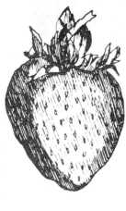

VALENTINE STRAWBERRY SALAD (or Christmas I)
- large can crushed pineapple
- regular packages of strawberry Jello
- cups buttermilk
1 - 10-oz. bowl of whipped topping
- cup nuts, chopped
Melt Jello in pineapple over low heat. Cool some and add buttermilk. Stir well and allow to partially congeal. Beat with mixer and add whipped topping. Beat again and then stir in nuts. Pour into molds and refrigerate until firm. Diners will declare it is filled with fresh strawberries.
Thera Hambrick
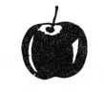
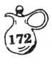
WALDORF SALAD
- large apples, cored but not peeled
- cup coarsely chopped nuts
- cup miniature marshmallows (optional)
1/2 cup mayonnaise
Chop apples into medium small pieces; add
other ingredients. Mix well and refrigerate
for one hour. Make sure that apple pieces
are well coated to prevent turning brown.
Best served same day it is prepared.
Phyllis Daniel
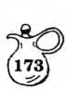
WATERGATE SALAD
- can crushed pineapple (large, in its own juice)
- bag small marshmallows
- box instant pistachio pudding
- medium size frozen whipped topping
1/2 cup chopped nuts (optional)
Mix pineapple, with its juice, with pudding. Add frozen topping. Stir in marshmallows. Let stand, convered, in refrigerator, for one hour or longer. Makes a lot. You can freeze it in whipping container. Good up to 3 months
Phyllis Daniel

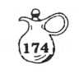
WATERGATE SALAD
- - 15-1/2 oz. can pineapple
1-3 oz. package pistachio instant pudding
- cup miniature marshmallows 1/2 cup chopped nuts
- cups Cool Whip
Mix together and chill.
Nancy Wilkerson
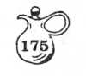
YUMMY FRUIT SALAD
- eggs, beaten
- Tbsp. vinegar
- Tbsp. sugar
- Tbsp. butter
- cup whipping cream, whipped
- cups white cherries, halved (white
grapes can be used)
- cups pineapple chunks
- fresh or canned oranges, cut up
- cups miniature marshmallows
Put eggs in top of double boiler; add vinegar and sugar. Cooking over hot water on medium to low heat, beat constantly until thick and smooth. Remove from heat, add butter and let cool. When cool, fold in whipped cream, fruit, and marshmallows. Refrigerate for 24 hours.
Frances Worstall
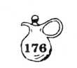
BLENDER MAYONNAISE
- egg
1/4 tsp. dry mustard 1/2 tsp. salt
- tsp. lemon juice or wine vinegar
1/3 cup vegetable oil or equal amounts of olive and vegetable oil
Combine whole egg, mustard and salt in container of electric blender. Cover and blend at top speed for 30 seconds. Pour in lemon juice or wine vinegar and, still blending at high speed, pour in oil as slowly as possible. If mayonnaise thickens' too much at any point, add a few more drops of lemon juice or vinegar. Yield: Approximately 1 cup.
Margaret Compton
DRESSINGS

BLUE CHEESE AND PECAN SALAD DRESSING
- cups sour cream 1-1/2 cups mayonnaise 1/2 cup milk 1/2 tsp. salt 1/4 tsp. pepper
1/2 cup toasted pecans, finely ground 4-oz. blue cheese, crumbled
In a medium bowl blend sour cream, mayonnaise, milk, salt, and pepper until smooth. Mix in pecans and cheese. This dressing will keep a week or more if it is kept in a tightly capped jar in the refrigerator. Shake before servings. Makes 4-1/2 cups.
Lucile Griffin
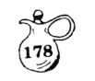
DRESSING FOR FRUIT SALAD
1/2 cup sugar 1 tsp. salt
- tsp. dry mustard
- tsp. paprika
- tsp. grated onion
- tsp. celery seed
- Tbsp. wine vinegar 3/4 cup oil
Mix first seven ingredients. Add oil gradually. Serve with any combination of fresh or canned fruits.
Connie Christie
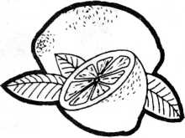

CITRUS SALAD DRESSING
6 Tbsp. salad oil
- Tbsp. lime juice
1/2 cup red currant jelly (may substitute plum or any tart jelly)
Few drops of onion juice
Paprika
1 teaspoon celery seed
Put all ingredients in blender. Blend well Serve over fresh grapefruit or any citrus salad. Keep in refrigerator.
Virginia Culpepper
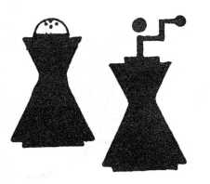

COLD MARINADE
- Tbsp. oil
6 Tbsp. lemon juice or vinegar
- tsp. salt
1/2 tsp. pepper
1/2 tsp. onion juice
Mix ingredients in order given. For fish, use three tablespoons vinegar and three tablespoons lemon juice.
Margaret Compton

HERB DRESSING
- cup white vinegar
- Tbsp. sugar 1 tsp. salt
1 tsp. paprika
1 Tbsp. Worcestershire sauce
- Tbsp. salad herbs
Blend all of these ingredients over a low flame for 8 minutes. Let cool and add 1/2 cup salad oil and 3 cloves of garlic put through a garlic mincer.
This Herb Dressing yields 1 cup and can be used ro 3 to 5 salads. Keep in the refrigerator.
From St. Marks Tasters Luncheon, 1978, Dalton
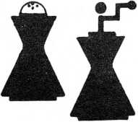

HERB DRESSING
- cup white vinegar
- Tbsp. sugar 1 tsp. salt
1 tsp. paprika
- Tbsp. Worcestershire sauce
- Tbsp. any salad herbs
Blend all of these ingredients over a low flame for 8 minutes. Let cool and add 1/2 cup salad oil and 3 cloves of garlic put through a garlic mincer. Yield: 1 cup. Approx. 5 servings. Keep in refrigerator.
Edi Shepherd From her sister Marti Smith, Chicago

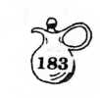
LEMON AND SOUR CREAM DRESSING
- cup sour cream
- Tbsp. lemon juice
- tsp. sugar
- tsp. salt
Freshly ground black pepper
Pour sour cream in mixing bowl. Using a wooden spoon, stir in lemon juice, sugar, salt and pepper. Beat ingredients thoroughly to blend. Yield: 1-1/4 cups.
This is an excellent dressing for fresh cucumbers or delicate salad greens such as Boston lettuce.
Margaret Compton

SOUR HONEY DRESSING 1 Quart
(Note: This will keep in refrigerator for 21 days. Discard when oil starts to separate)
- cups mayonnaise
1/2 cup vegetable salad oil
1/2 cup honey
1/4 tsp. onion salt
(or use 1/8 granulated onion and 1/8 salt)
1/2 cup any yellow prepared mustard l-l/2 tsp cider vinegar
®lend in blender until smooth. Refrigerate Serve with all green salads. A very nice tart-sweet dressing. Great for green salads
Edi Shepherd
From Her Son-In-Law Rev. Craig Cleland

VINAIGRETTE DRESSING
- Tbsp. sugar 1 tsp. salt 1 tsp. dry mustard 1/4 tsp white pepper 1/2 tsp onion juice 3/4 cup salad oil 1/4 cup white vinegar Pinch each of basil, chervil, dill, oregano, savory, tarragon
Combine all ingredients in a screw-top jar. Cover and shake. Chill. Shake again just before serving. Serve with vegetable salads.
Makes 1 cup.
Edi Shepherd

SALAD TIPS
Vegetables, fish or meats may remain in marinade an hour or more to enhance flavor.
Where several vegetables are used in a salad, marinate each kind separately.
Fold dressing into salads just before serving, except for those made with potatoes and similar vegetables that improve with soaking.
Chicken salad will have a more pleasing look if dark meat is diced small and white meat is cut in larger cubes.
Veal or pork may be used as extenders of chicken salads. They will not be detected if they are diced in smaller pieces than the chicken.
Parsley keeps well in the refrigerator if if is washed and placed stems down in a covered jar.
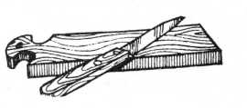

SALAD TIPS
Thoroughly wash watercress, shake and place in a squat jar or large mouthed glass with water covering the stems. This green bouquet will last for use at least 7 days. Do not cover.
Never wash mushrooms until ready to use, and only wash as many as needed in recipe.

TABLE OF CONTENTS
Introduction 1
Table Grace 3
VEGETABLE SALADS
Artichoke 5
Ashevil le 6
Asparagus 7
Avocado 8
Bean 9
Beet § Nut 10
Beet Mold... 11
Calico Straw 12
Carrot Date Slaw.. 13
Carrot Delight 14
Cauliflower-Broccoli Medley 15
Cauliflower-Broccoli 16
Cole Slaw a la Creme 17
Concealed (Hidden Delights) 18
Corn Relish 19
Creamy Potato 20
Creole ... 21
Cucumber Mousse 22
Cucumber Ring Supreme 23
Cucumber 24
Dilled Carrots and Green Beans 25
Four Bean 26
Frozen Coleslaw 27
Frozen Cole Slaw 28
German Slaw 29
Green § Gold Slaw 30
Hearts of Palm 31
Instant Mashed Potato 32
Kraut 33
Lemon Mushrooms 34
Lettuce Layer 35

Macaroni 36
Make-Ahead Oriental 37
Marinated Vegetable 38
Marinated Vegetable 39
Marinated Vegetable I 40
Marinated Vegetable II 41
Marinated Vegetable Toss 42
Molded Beet 43
Molded Beet 44
Pea 45
Red § White Bean 46
Rice 47
Sauerkraut Relish 48
Sauerkraut 49
Spaghetti-Bean Sprouts 50
Spinach 51
Spinach 52
Stuffed Celery 53
Stuffed Tomato 54
Summer 5 5
Summer II 56
Taco 57
Tomato Aspic 58
Tomato § Zucchini 59
Three Bean 60
Three P's 61
Twenty-Four Hour Slaw 62
Vegetable Mold 63
FISH SALADS
Avocado Crab 65
Hearty Tuna 66
Hearty Salmon/Macaroni 67
Pink Shrimp Mousse 68
Shrimp Boats 69
Shrimp § Melon Ball 70
Tuna 71

MEAT SALADS
Chicken Fruit 73
Chicken Mousse 74
Chicken 7 5
Chicken 76
Chicken Balls 77
Chunky Chicken 78
Clubhouse 79
Cold Chicken Pie 80
Corned Beef Mold 81
Delicious Toss (nuts) 82
Edi ' s Hot Ham 83
Elbow Macaroni 84
Fruited Chicken 85
Hot Chicken 86
Hot Hammy-Cheddar 87
Jacque's Chicken 88
Let's-Have-A-Picnic 89
Mexican 90
Red, White § Blue (July 4) 91
Rice 92
Spicy Mexican 93
Taco Supreme 94
FRUIT SALADS
Ambrosia 9 5
Ambros ia 96
Apricot - Molded 97
Apricot - Molded 98
Banana- Nut 99
Best Orange 100
Black Cherry 101
Blender Cranberry Dream 102
Blender Fruit 103
Blueberry 104
Blueberry 105

Brides Ribbon 106
Buttermilk 108
Buttermilk 109
Cherry Jello 110
Chilled Fruit Ill
Christmas Cranberry 112
Citrus 113
Congealed Fruit 114
Cranberry 115
Cranberry 116
Cranberry ' 117
Cranberry 118
Cranberry 119
Cream Cheese Ring w/Cling Peaches 120
Creamy Fruit 121
Delightful Apple., 122
Dot's Cranberry 123
Easy Frozen 124
Easy Three Layer 125
Five Cup 126
Fresh Fruit 127
Frozen Cranberry 128
Frozen Fruit 129
Frozen Fruit 130
Frozen Cranberry 131
Frozen Fruit 132
Frozen Fruit 133
Frozen Fruit 134
Fruit (Overnight) 135
Georgia Pink 136
Grapefruit 137
Grapefruit 138
Green Grape 139
Harvest Pear Slaw 140
Hearts of Palm 141
Heavenly Apple 142
Holiday 143
Hot Fruit 144

Leprechaun 145
Lime Aspic 146
Lime-Walnut 147
Orange § Onion 148
Orange Mold 149
Orange Sherbet Gelatin 150
Orange Sherbet Mold 151
Peach Aspic 152
Peach Pickle 153
Peach Pickle 154
Pickled Peach Mold » 155
Pineapple Buttermilk 156
Pineapple Mold 157
Pineapple in Kirsch 158
Pineapple-Marshmallow 159
Pineapple Orange 160
Pink Frozen 161
Pink Pear 162
Pistachio 163
Pistachio Congealed 164
Pistachio w/Nuts 165
Red Raspberry Ring 166
Russian Cream 167
Salad Supreme 168
Spiced Peach 169
Tropical Fruit .170
Valentine Strawberry (Or Christmas!) 171
Waldorf 172
Watergate 173
Watergate 174
Yummy Fruit 175
DRESSINGS
Blender Mayonnaise 176
Blue Cheese and Pecan 177
Dressing for Fruit 178
Citrus Dressing 179
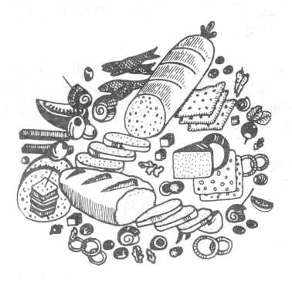
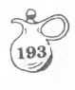
Cold Marinade 180
Herb 181
Herb 1.82
Lemon and Sour Cream 183
Sour Honey.. 184
Vinaigrette 185
SALAD TIPS 186
TABLE OF CONTENTS 18 8
ACKNOWLEDGEMENTS 192

ACKNOWLEGEMENTS
- VSC Woman's Club Members for their recipes.
- Margaret (Mrs. Dwight) Compton for reading and typing first drafts.
- Pam (Mrs. Chauncy) Elkins for proofreading .
- Margaret Compton for proofing.
- Julia Connell for her beautiful cover, divider pages, and numbering system art work.
- Kathy Poppell, Philip Frasier and the staff of the VSC Print Shop for their expertise in printing.
- Virginia Culpepper, Joan Bailey and Annetta Copeland who inspired the editor to greater heights than she believed possible.
- And to all the good cooks that will use our publication.
I THANK YOU ALL - EACH AND EVERY ONE.
Edi Shepherd
VSC Printing Services

