Homework: Ch. 11

- What is the difference between gauge and absolute pressure? Give an example when each of these are useful in the real world.

- Discuss the differences between a compressible and an incompressible liquid.

- Below is a table of pressures. Fill in the missing values by using the appropriate conversion factor.
Pascal (Pa) | atm | Torr | lb/in²
4320
 |  | 3.25 × 10³
 | 1.45
 |  |  | 22.5

- Why does your weight appear to differ between when you are standing on the side of a pool and when you are completely submerged in the pool?

- How tall must a water filled manometer be in order to measure blood pressures as high as 300.0 mm Hg? Note that ρ_{blood} = 13,600 kg/m³ and ρ_{water} = 1,000 kg/m³.

- On a clearly sunny day, the atmospheric pressure is measured at 1.2 atm at the surface of a chocolate syrup filled pool. A 150 cm tall woman is standing completely submerged in the syrup. What is the difference in the pressures acting on the woman’s head and her feet? Assume that the density of the syrup is about 1180 kg/m³ and that the woman’s head is just under the surface of the syrup.

- Both a gage and a manometer are attached to a gas tank to measure the pressure, see the figure to the right. If the reading on the gage is 80.0 kPa, determine the distance between the two fluid levels of the manometer if the fluid is mercury (ρ = 13,600 kg/m³)? Assume atmospheric pressure is 100 kPa.

- Calculate the hydrostatic difference in blood pressure between the brain and the foot in a person of height 1.83 m if the density of blood is 1.06 × 10³ kg/m³.

- A hollow spherical iron shell floats completely submerged in water. The outer diameter of the shell is 60.0 cm and the density of iron is 7.87 g/cm³. Find the inner diameter.

- A hollow sphere of inner radius 8.0 cm and outer radius 9.0 cm floats half-submerged in a liquid of density 800 kg/m³. What is the mass of the sphere?
- Pressure in the spinal fluid is measured as shown below. If the pressure in the spinal fluid is 10.0 mmHg and the density is 1.05 g/mL, how many cm of water would be read on the water manometer? What is the reading if the person sits up, placing the top of the fluid 60.0 cm above the tap?
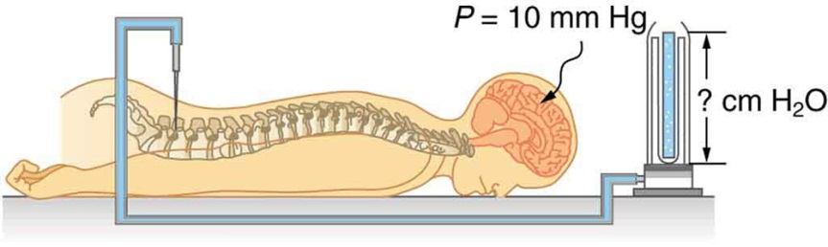

- You can chew through very tough objects with your incisors because they exert a large force on the small area of a pointed tooth. What pressure can you create by exerting a force of 500.0 N with your tooth on an area of 1.00 mm²?

- Calculate the maximum force exerted by the blood on an aneurysm, or ballooning, in a major artery, given that maximum blood pressure from a person is 150.0 mm Hg and the effective area of the aneurysm is 20.0 cm².

- A certain man has a mass of 80.0 kg and density of 955 kg/m³.
  - Calculate his total volume.
  - Find the buoyant force air exerts on him.
  - What is the ratio of the buoyant force to his weight?

