Ch. 12 Worksheet

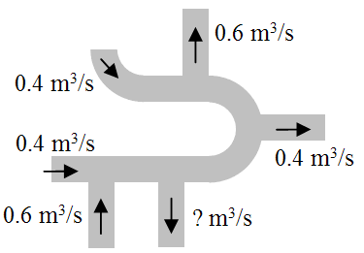
- The drawing shows a section of a pipe system in which an incompressible fluid can either flow in or flow out various channels. All of the pipes have the same diameter. The direction and flow rates are indicated on the drawing. What is the mass flow rate and direction of flow for the unknown pipe?
  - 0.2 m³/s
  - 0.4 m³/s
  - 0.6 m³/s
  - 0.8 m³/s
  - 1.0 m³/s

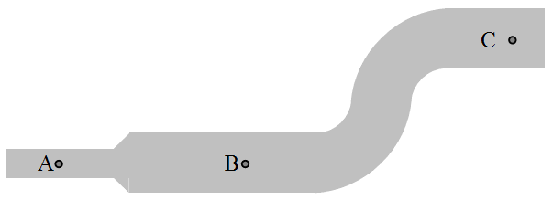
- Fluid is flowing from left to right through the pipe shown in the drawing. Points A and B are at the same height, but the cross-sectional areas of the pipe are different at the two locations. Points B and C are at two different heights, but the cross-sectional areas of the pipe are the same at these two locations. Rank the pressures at the three locations in order from lowest to highest?
  - P_{A} > P_{B} > P_{C}
  - P_{B} > P_{A} = P_{C}
  - P_{C} > P_{B} > P_{A}
  - P_{B} > P_{A} and P_{B} > P_{C}
  - P_{C} > P_{A} and P_{C} > P_{B}

- At the site of a burning building, a firefighter is using a hose with a radius of 0.032 m that has water flowing through it at a rate of 0.032 m³/s. At the end of the hose, there is a nozzle with a radius of 0.013 m. First, calculate the speed of the water exiting the nozzle and use that to determine the range, the maximum horizontal distance the water can reach, if it is directed at an angle of 45° with respect to the horizon.

- An intravenous system (IV) is supplying saline solution to a patient at the rate of 0.120 cm3/s through a needle of radius 0.150 mm and length 2.50 cm. What pressure is needed at the entrance of the needle to cause this flow, assuming the viscosity of the saline solution to be the same as that of water? The gauge pressure of the blood in the patient’s vein is 8.00 mmHg.

